**Assignment 2**

**CS 455/555**

Maitri Mangal

[mmangal1@binghamton.edu](mailto:mmangal1@binghamton.edu)

Fall 2018

**Purpose:**

To understand and implement different ways to enhance an image given the following concepts:

* Unsharp Mask
* Blurring Effect -Image Smoothing
* Edge Detection
* Sobel Operation
* Laplacian of Gaussian
* Gaussian Mask
* Canny Edge Detection

**To Run:**

On command line type: make (This will make the executable file assign2)

Next type: ./assign2 (All the images presented in this file will then be displayed)

**To Remove Executable File:**

On command line type: make clean

**Notes:**

**Methods to obtaining Images**

Method for Calculating XGradient and YGradient:

Create mask 3x3 that consists of:

-1 -2 -1

0 0 0

1 2 1

Apply matrix to the given image by multiplying according coordinates and summing all

Method for Unsharping Imgae:

Create a new Image, and initialize all pixels to 0

Create Gaussian Filter

1/16 2/16 1/16

2/16 4/16 2/16

1/16 2/16 1/16

For each row, go through each column and apply Gaussian Filter to each according pixel

Subtract the new image from the original image, and then add this difference to the original

Method for Sobel Operator:

Create a new Image, and initialize all pixels to 0

For each pixel of original image, calculate the horizontal and vertical gradient.

Add these two gradients together to find the total gradient

If total gradient > 255, then total gradient = 255

If total gradient < 0, then total gradient = 0

Replace each pixel in new image with the total gradient

Method for Laplacian of Gaussian:

For each pixel, apply the Laplacian Gaussian Mask by using the formula:

(1/sqrt(2*PI)*sigma)2((x2+y2)/sigma2 - 2)e-(x2+y2)/(2*sigma2)

Create Mask by taking above value and multiplying by scaling factor depending on sigma

Print Mask Matrix

Apply Mask to a new image who’s pixel values were all initialized to 0

**Results**

Original Ant and Basel Image:

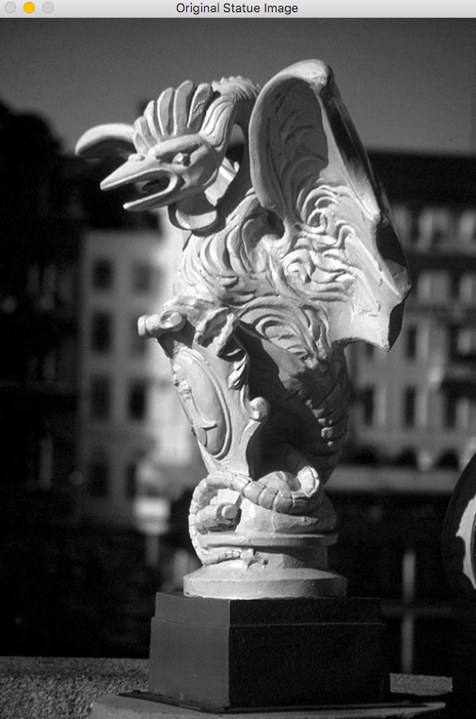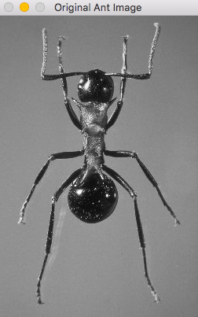

Blurred Images

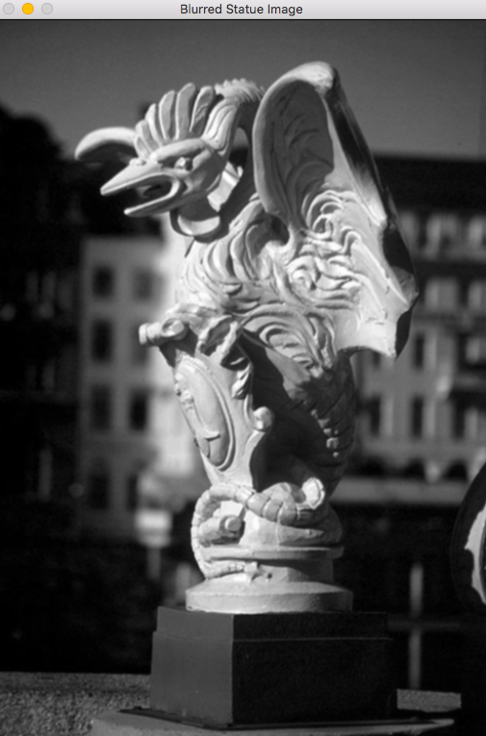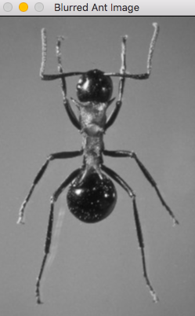

Unsharp Enhanced Images

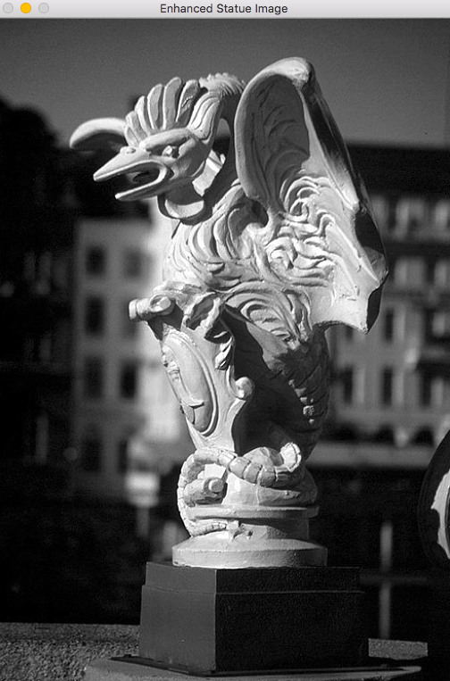

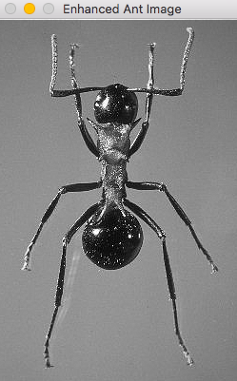

Sobel Operator

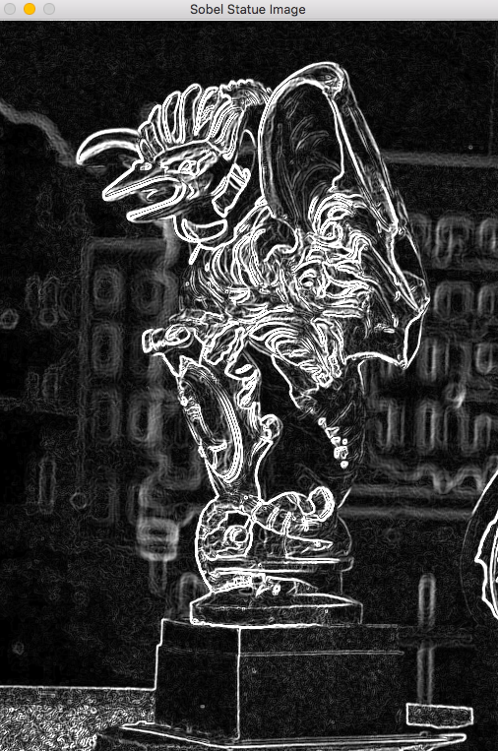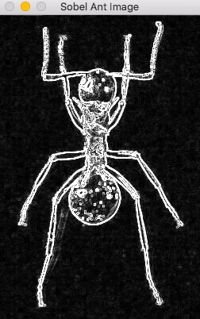

LoG Mask 7x7 Sigma 1.4:

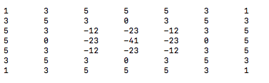

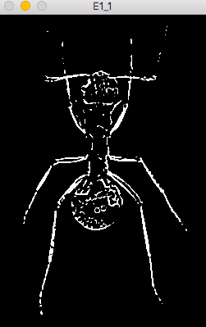

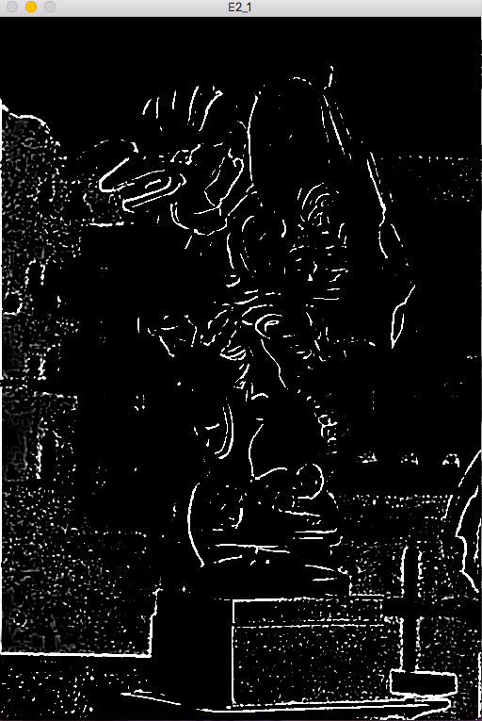

LoG Mask 11x11 Sigma 5.0:

