CS555/455 Fall 2018
CS555/455 Assignment 3
(Due on October 17, 2018 by 11:59pm)

Part A: Questions (27%)

(1) Q6.5 (p457) [9%] In the simple RGB image, the R, G and B component images have the intensity for each line as shown in the following diagram. What color would a person see in the middle column of this image?
Color Intensity
Color Intensity
Color Intensity

Blue
1.0

Red
1.0

Green
1.0

0.5
0.5
0.5

0
N/2
Position

N-1
0
N/2
Position

N-1
0
N/2
Position

N-1

Red(R) = 0.5
Green(G) = 1.0
Blue(B) = 0.5
0.5R + G + 0.5B = 0.5(R + G + B) + 0.5G

Hence, resultant color will be green.

- Q6.16 (p459) [9%] The 8-bit images shown in Q6.16 (page-459) are (left to right) the H, S, and I component images. The numbers indicate gray-level values. Answer the following questions, explaining the basis for your answer in each. If it is not possible to answer a question based on the given information, explain the reason.
(a) Give the gray level values of all regions in the hue image.
(b) Give the gray level values of all regions in the saturation image.
(c) Give the gray level values of all regions in the intensity image.

- Q6.25 (p460) [9%] Consider the following 500×500 RGB image, in which the squares are fully saturated red, green and blue, and each of the colors is at maximum intensity [e.g., (1, 0, 0) for the red square]. An HSI image is generated from this image.
- Describe the appearance of each HSI component image.
- The saturation component of the HSI image is smoothed using an averaging mask of size 125×125. Describe the appearance of the result (you may ignore image border effects in the filtering operation).
- Repeat (b) for the hue image.

Green

Red

Blue

Green

Part B: (47%) DCT based image compression

Description: DCT transformation refers to the transform between image spatial domain and frequency domain. In the first part of the assignment, you are required to realize a simplified version of DCT based compression.

- (15%) Consider the following sequence of values:

  - 11 12 11 12 13 12 11
10 -10 8 -7 8 -8 7 -7

- (5%) Transform each row separately using an eight-point DCT. Plot the resulting 16 transform coefficients
- (5%) Combine all 16 numbers into a single vector and transform it using a 16-point DCT. Plot the 16 transform coefficients
- (5%) Compare the results of (a) and (b). For this particular case would you suggest a block size of 8 or 16 for greater compression? Justify your answer

(32%) 2D image compression:
- Obtain image f1 (“basel3.bmp”) and display;
- (5%) Convert image f1 from RGB to HSI, obtain intensity image I.
- (6%) Apply 8*8 DCT transform to image I, obtain frequency domain image F;
- (6%) In each 8*8 frequency block, keep DC component and remove all other frequency components from F, obtain frequency domain image D1;
- (6%) Similar to (4), in each 8*8 frequency block, keep first 9 low frequency components and remove all other high frequency components from F, obtain frequency domain image D2;
- (9%) Apply IDCT on D1 and D2, obtain image R1 and R2. Explain which image is more blurred, and why.

Part B: (20%) Color based image segmentation

Image segmentation can be realized based on the color information processing. In this assignment, you are required to design an algorithm to use the HSI model to detect the regions of interest (ROI).

Implement your algorithm to segment the regions in “Bulding1.bmp” and “Plate.bmp”. Outline the boundaries of each ROI. Describe your algorithm and the results in your report. (Hint: You may consider the HSI model and Hough transform)

Part C: (Extra 15 points) Design and implement your algorithm to count the number of flowers for five images in “Images.rar”.

Part D: (Extra 15 points) Design and implement your algorithm to get the eigen-images (base-images) by the five training data in “Images.rar” using the Principle Component Analysis (PCA).

Basel3.bmp
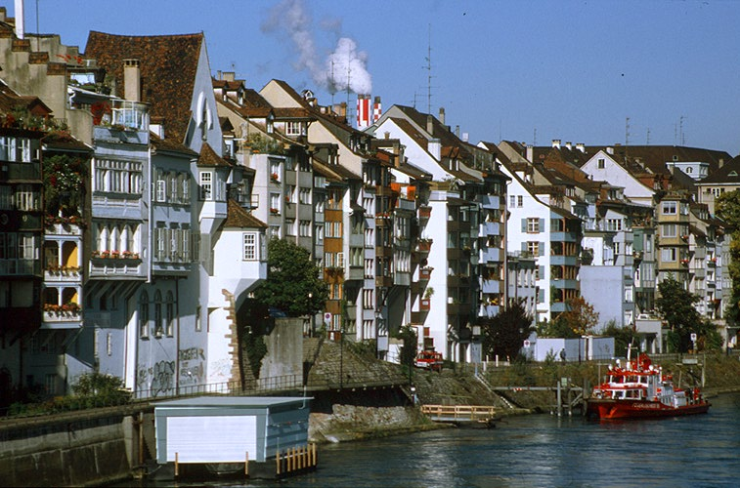

Building1.bmp
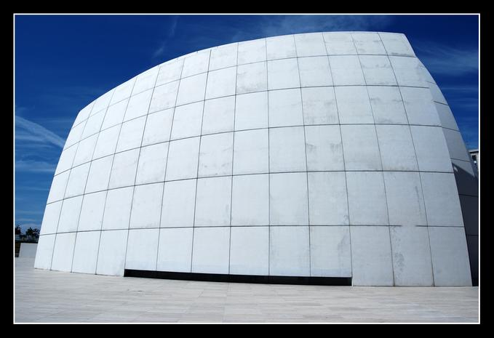

Plate.bmp
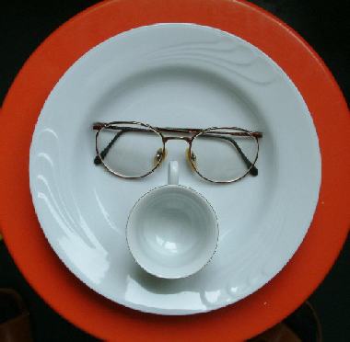

Note (Hand-in)
- Code package: Your program package includes all the files that can be re-compiled, executed, and demoed.
- Write-up (6%): Report the experimental results along with figures and your description of the algorithms you designed and implemented, so that the reader can understand the method you used. Note: in the report, you should include following sections:
- Author’s Name and Email.
- Purpose of the project
- Method
- Results
- Bug report (if any), which includes “PARTS THAT ARE NOT COMPLETE” indicating any uncompleted parts of the project and any BUGS in your program that you are aware but have no idea why they exist.
- Report extra work for extra credit (if any)
- References (if any): Document here any sources, books, internet resources you have benefited from.
- Submit your code and report (in a .ZIP file) through blackboard on/before the due date.

