WAF can be attached to resource type

* Application Load Balancer
* API Gateway
* CloudFront
* GraphQL Api
* Cognito user pool
* App runner
* Verified Access

AWS WAF 🡪 ALB

2 types of rules

1. Pre built maanges policies - SQL injection , cross site scripting (XSS) and more
2. AWS WAF custom rules 🡪 IP address , HTTP headers , URI strings and HTTP body content.
3. Create funnel filter for web- application traffic

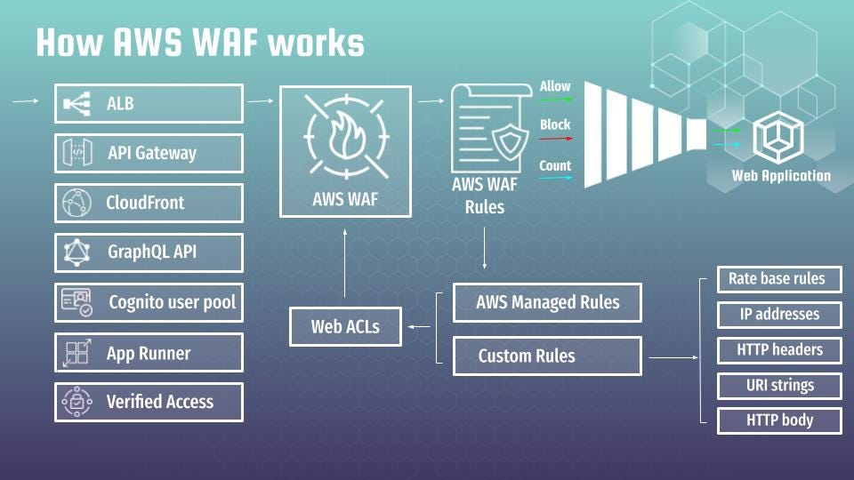

XSS

Unvalidated input

SQL injection

Deny of service attacks

Cookie poisoning

Web scraping

Programming language related vulnerabilities

