Amazon Elastic Cloud Compute: EC2

What is EC2?
- Used to develop and deploy applications faster.
- Used to launch the virtual server, configure security, network, and storage.
- Scale up and down to handle the spikes in popularity.
Features?
Instance creation.
Secure the login information for the instances in key pairs

Best Practices.

SECURITY:
Manage the access using the IAM Roles and IAM Users
Implement least permissible rules for the security group
Regularly patch, update and secure the OS and application on the instances
RESOURCE MANAGEMENT:
Use custom tags to better identify resources
View current usage of resources and increase the limit is required.
BACKUP and RECOVERY
Regularly backup the elastic block store volume using Amazon EBS snapshots and create amazon Machine Images (AMI) to save the config as a template.
Deploy critical components of application across multiple available zones

Handle dynamic IP address when the instance restarts
Monitor and respond to the events
Handle failover using Autoscaling
Regularly test the process of recovering your instances.

NETWORKING
Set the Time to Live for the application to 255. If the time is set short then it may cause reachability issues for the instances.

Amazon – S3

What is Amazon S3? - Amazon Simple Storage Service
- It’s an object storing service that offers industry -leading scalability, data availability,security and performance
S3 Glacier for Archival of Data
S3 provides features for auditing and managing acess to buckets and objects and made as PRIVATE .

For Data Processing
S3 Object Lambda : Filter rows , dynamically resizing images.
Event Notification :
Amazon Simple Notification Service and Amazon Simple Queue Service for triggering work flows

Storage Logggin and monitoring

Automated Monintoring tools
Amazon cloud watch metrics for Amazon S3 - - check the operational health and configure billing alters when user defined threshold is reached.
AWS Cloud Trail
Manual Manitoring tools :
Server access Loggging
AWS Trusted advisor

How it works

Creats a bucket → bucket Name → specify the region→ each object has a key (unique identifier)
S3 versioning can be used to place the same objects. Easy for recovery in case of accidental delete

Permission is provided by AWS (Identity and Access Management) Access Control List (ACL) ,S3 Access Point to manage access.

Step Functions:
It is a serverless orchestration service that allows combining AWS Lambda + AWS Services to build business-critical applications.
- Graphical – Workflow as a series of event-driven steps
State Function = state machines + tasks
State Machine is workflow
The task is state in a workflow that represents a single unit of work to be performed by other AWS services
Each Step-in workflow is a state.
We can have step function call one of the AWS services (AWS Lambda)
We can also create long-running, automated workflow for application that require human interaction.

AWS – Glue is a service for data processing cleansing, transform and load (ETL) workflows

AWS – SQS

It offers secure ,durable and available hosted queue that helps to integrate and decouple sistributed system and compoenents

It supports Standard and FIFO queues
Provides generic service API , can be accessed using the programming language supported by AWS SDK

Benefits of SQS :
- Security – Using Amazon key manangement service , we can decide who can send and receive messages to Amazon SQS
- Durability – It stores the message in mulriple servers and it support alleast once delivery type and exactly once delivery type.
- Availability – Uses redundant infrastructure for concurrent access to producing and consuming messages.
- Reliability – Locks your message while processing . So producing and comsuming messages at the same time.
- Scalability – Can handle buffered request independently to handle any load increase or spikes without any instruction
- Customization If the message size is larger 256 MB it can be splited into smaller size chunks

Amazon SQS / Amazon SNS / Amazon MQ

Highly scalble and simple to use. No need to setup any message brokers

SQS is a queue service

SNS is topic service

Amazon MQ is a managed Service provides compatibility with message brokers like JMS or protocols like AMQP ,MQTT, OpenWire and STOMP

AWS – Lambda :

Lambda is compute service which runs the code without managing the server .
It runs the code on high availability compute infrastructure , automatic scaling ,code monitoring and logging

It runs only when needed and scales automatically .from few request per day to thousand per second

Used in data processing trigger for AWS Service (Amazon S3 and Amazon Dynamo DB )
- Process Streamed data stored in Amazon Kenesis.
Features :

Concurrency and scaling controls
Database access
File system access
Amazon Elastic Container Service : ( AWS – ECS )
Highly scalable ,fast container management service makes it easy for run stop and manage container on a cluster .

Task and services on a serverless infrastructure is manged by AWS Fargate .
- It enable s to stop and start the container baed application using simple API calls.
- Used for continuous build and deploy experience.

Application Load Balancer
It helps to distribute the incoming traffic across multiple targets like Ec2,instances ,containers , and IP address , in any one of the available Zones.
- Routes the traffic to the healthy targets.
Components :

Single point of contact for clients which distributes the incoming traffic to the available zones.

Listeneer checks the coneection request from the client using the protocol and port that you configure .

Health check is performed on all the target registered to a target group that are specified in the listener rule.
Operates in Application layer of (Open System Interconnection )OSI Model

Route – S3
Cloud DNS webservice .
Its fully compliant with IPV6.
Extremely cost effective and reliable way to route the end users to the Internet application by resolving the domain names.
Helps to connect the user request to the infrastructure running AWS – Ec2 ,Elastic load balancing ,or Amazon S3.
DNS Health checks and continuously monitor your application .
Ability to recover from failures and control application recoverywith Route 53 Application recovery Controller .

AWS – Cloud Watch

It Monitors the application and the resources you run on AWS in real time .
We can create a alarm that watch metrics and send notification or automatically make changes to the resources you are monitoring when threshold is reached.
Visibility to the resource utilization,application performance and operational health.

Cloud watch can be accessed by the below methods
Amazon Cloudwatch Console
AWS CLI
Cloudwatch API
AWS SDK

AWS – EKS – Elastic Kubernetes Service is a managed service that you can run Kubernetes on AWS without need to install , operate and maintain our own Kubernetes control plane or nodes .
Kubernetes is open source system for automating the deployment ,scaling , management of containerized application

Kubernetes vs Docker - GeeksforGeeks

Best Practices for REST API
- Use Nouns and No verbs ( action words )
- GET method and query parameters should not alter the state
- Use plural nouns instead of singular nouns
- Use sub-resource for releations
- Use HTTP headers for serialization formats ( Accept Type Content Type )
- Use HATHEOAS – Hypermedia As The Engine Of application state is a principle that hypertext links should be used to create better navigation.
- Provide Filtering ,sorting , field selection and paging for collection
GET /cars?sort=-manufactorer,+model
GET /cars?fields=manufacturer,model,id,color
GET /cars?offset=10&limit=5
- Version you API
- Handle errors using HTTP Status Codes
- Allow Overriding HTTP Method
HTTP Header X-HTTP-Method-Override to overrider the POST Method.

REST is API design architecture ( Representational State Transfer )
-implementatin webservice using HTTP to perform various operation ( GET POST PUT DELETE ) -JSON format – allows json format for better and faster parsing of data.

Disadvantage :

Fetches all Data , whethere required or not .
It makes multiple network request to get multiple resources
Resources are dependent and cause waterfall network request .

GRAPHQL:

What ?
To overcome these facebook developed GraphQL ,
- Open source data query and manipulation language for API’s
- Became new standard for API development
- GraphQL is syntax for requesting data
Why GraphQL
- Strongly typed Schema - support Boolean ,String ,Int ,Float ,ID , Scalar are defined in Graphql schema definition language .
- Less error prone , more validated and provide auto – completion for support IDE / Editors
- No over fetching and under fetching
- Allows multiple resources in single request call
- Versioning is not required as we can mentioned the field as depreceated field
- Its not limited to backend . It can be used for Frontend as well
When ?
- Using laptop ,mobile wher band width matters.
- If nested data to be fetched in single call
- Proxy pattern on client side . End user can specify the response structure based on their needs

Disadvantage
- GraphQL query complexity. While defining the query ,maximum query depth ,query complexity weighing ,avoid recursion , persisitant queries to stop inefficient request from clinet side
- GraphQL caching is not easy
- Rate limiting is not possible as like REST API calls can be rate limited.

GRpc is framework implemetating RPC ( invoking a function avaialbe on on another system ) through HTTP/2 Comparing SOAP vs REST vs GraphQL vs RPC API | AltexSoft

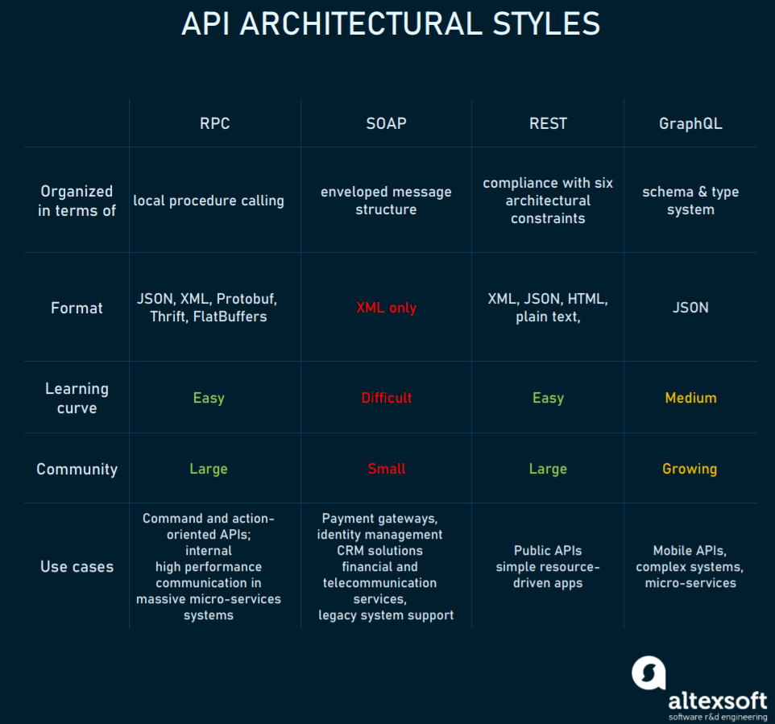

Advantage
Straightforward and simple Interaction
Easy to add functions
High performace

Disadvantgae - gRPC :
- Tight coupling to underlying system – no abstraction layer for reusability . Server function naming are hidden
- Low discoverability on the action taken in server side
- Easy to add new endpint instead of modifiying the existing one .

SOAP – Simple Object Access Protocol

Adv :
Language and Platfor m agnostic
Bound to variety of transport protocols
Buildin Error handling

Dis adv :
XML only
Heavy wright
Complex message updating

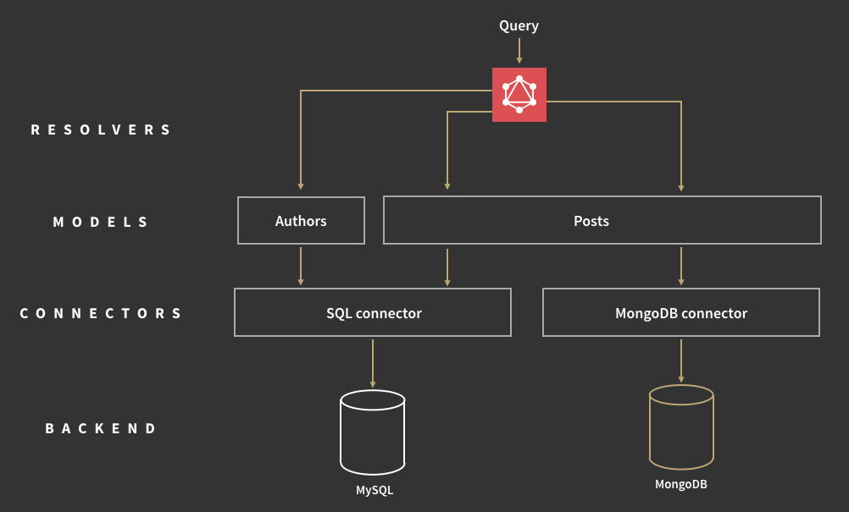

- Improved Scalability
- Better Fault Isolation and more resilient application
- Programming Language and TEchnolgy Agnostic
- Better data security and compliance
- Faster time to Market
- Support for Dev-ops and Greater Business Agility

Disadvantage
- Difficult to maintain large number of services
- Complexity of testing over distributed environment
- Higher change of getting failure during communication between other microservices

AWS Microservices Architecture Introduction (React + SpringBoot) | by Joannefromtw | Medium

Three- Tier Architecture

- Client - React Application using Redux
- Web/App Server - run springboot application on tomcat within docker container.
- Database server - MySQL RDS

Frontend Development Overview
- Upload a React template to GitHub
- Create login UI and add authentication to the React template with Amplify, using AWS Cognito as the authentication provider
- Upload your React website to public S3 Bucket
- Using Route 53 registers new domain name, and creates a DNS A record to redirect <new domain name> to S3 Bucket
- Request SSL certificates from AWS ACM
- Using CloudFront to create distribution with alternate domain names and custom SSL settings (Upload SSL certificates to CloudFront)
- Using Route 53 to create a DNS A record to map <new domain name> to CloudFront distribution URL

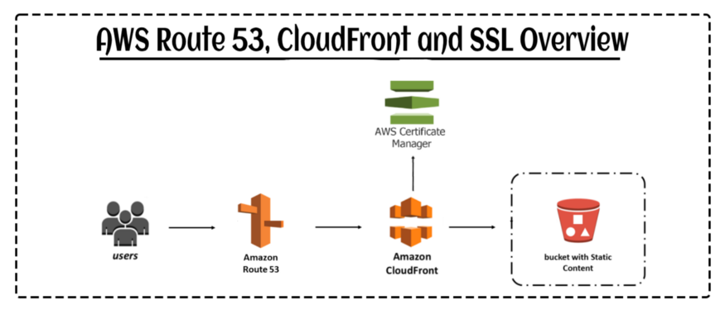
Backend Development Overview
- Using Python Boto3 setup script to build your SpringBoot projects and create backend infrastructure

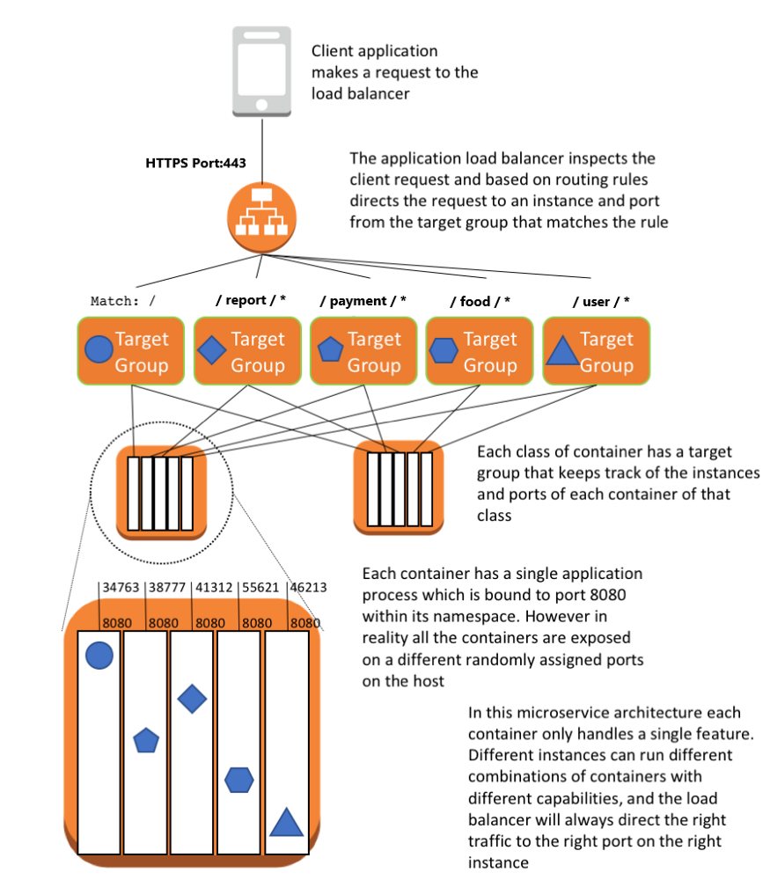
CICD Setups (Continuous Delivery)
- Upload Your SpringBoot Project to CodeCommit
- Upload AWS CloudFormation Template to S3, then use AWS CLI to read the template and setup the AWS CloudFormation Stack like AWS CodePipeline, AWS CodeBuild, ECS Cluster with ALB and RDS.

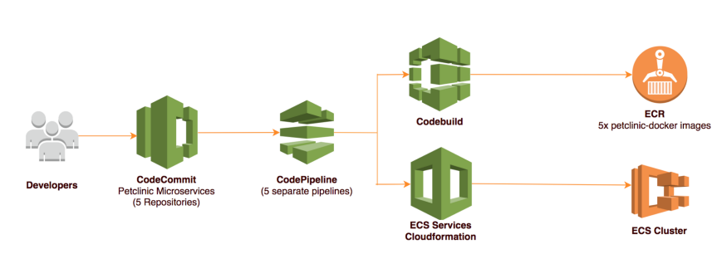
Security Setups
- [Login] Setup AWS Cognito to create login UI and authentication service
- [RDS] Use EC2 parameter store for RDS Database password
- [RDS] (Optional) Setup MySQL RDS Multi-AZ deployments for high availability and failover support
- [Security Group] Use ECS Cluster with Security Group to control both inbound and outbound traffic at instance level
- [HTTPS] Use SSL certificates , provided by AWS ACM, to create HTTPS listener for ALB and add HTTPS to my website for protecting data in flight
- [Subnet] Put ECS Cluster and RDS in private subnet

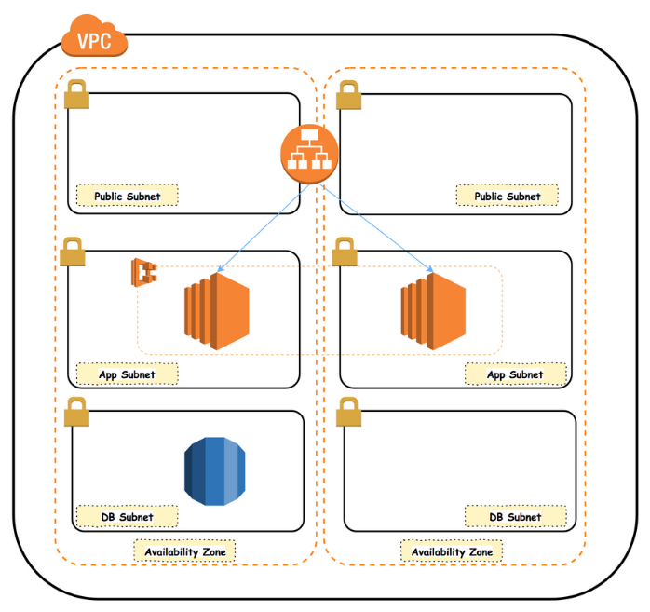
Bastion host Setups
- Use Bastion host to (1) access DB in the private subnet via SSH from public subnet and (2) login EC2 instances of your ECS cluster by EC2 SSH Key Pair
- Enter URL: https://aws.amazon.com/tw/quickstart/architecture/linux-bastion/
- Select “How to deploy”
- Click “Deploy into an existing VPC”
- Follow the steps in the new tab page
DNS A record
- Using AWS Route 53 to setup DNS A record for mapping <new domain name> to IPv4 address

SOA | Microservices
SOA model has a single data storage layer which shared by all of the services in that application. | Microservices apps mostly dedicate a database or other type of storage to services that need it.
Communication between different services in an SOA app uses simple and straight forward approaches. | Microservices use complex APIs.
Focused on maximizes application service reusability. | More focused on decoupling.
A systematic change requires modifying the monolith. | A systematic change helps you to create a new service.
DevOps and Continuous Delivery are becoming popular but yet not become mainstream. | Strong emphasis on DevOps and Continuous Delivery
Monolithic in nature | Full-stack in nature
Supports multiple message protocols. | Uses lightweight protocols like HTTP, REST, or Thrift APIs.
It is designed to share resources across services. | It is designed to host services that can function independently.
Frequently involves component sharing | Typically, it does not include component sharing
Involves sharing data storage between services | Each service can have independent data storage.
Better for large scale integrations | Better for small and web-based applications.
Communicates through an ESB | Communicate through an API layer
Relies on sharing resources | Relies on the bounded context for coupling.
Less flexibility in deployment | Quick and easy deployment.
The technology stack of SOA is lower compared to Microservice. | Microservice technology stack could be very large.
Business units are dependent. | Business units are independent of each other.
An SOA app comprised of two or three services. | A Microservices app could have dozens of services.
SOA applications are built to perform numerous business tasks. | They are built to perform a single business task.
Deployment is a time- consuming process. | Deployment is straightforward and less time-consuming.
Business logic components are stored inside of single service domain simple wire protocols(HTTP with XML JSON) API is driven with SDKs/Clients. | Business logic can live across domains enterprise service bus like separate layers between services.
Uses enterprise service bus (ESB) for communication | It uses the less elaborate and straightforward messaging system
Software size is larger than any conventional software | The size of the Software is small in Microservices
Multi-threaded with multiple overheads to handle I/O | Single-threaded mostly use with Event Loop features for non-locking I/O handling
A systematic change needed for modifying the monolith | In Microservices, systematic change is to create a new service
Focus on maximizing application service reusability. | Emphasis on decoupling.
Common governance and standards. | Relaxed governance, as is more focused on people’s collaboration and freedom of choice.
The deployment process is time- consuming. | Deployment is easy and less time-consuming.
Less scalable architecture. | Highly scalable architecture.

Advantages of SOA
Here, are pros/benefits of SOA
- Editing and updating any service is easy
- Services have the same directory structure, which allows consumers to access the service data from the same directory every time.
- Services communicate with other applications using a common language which means it is independent of the platform
- Services are usually small size as compared to the full-fledged application. Therefore, it is easier to debug and test the independent services.
- SOA allows reusing the service of an existing system, alternately building the new system.
- It offers to plug in new services or to upgrade existing facilities to place the new business requirements.
- You can enhance the performance, functionality of a service, and easily makes the system upgrade.
- SOA can adjust or modify the different external environments
- The companies can develop applications without replacing existing applications.
- It offers reliable applications in which you can test and debug the independent services as compared to a large number of code.

Advantage of Micro-services
Here, are pros/benefits of using Micro-services:
- Easier architecture pattern which is easy to understand for developers
- The IDE is faster making developers faster and productive
- The web container starts faster; this helps to speed up the process of deployments and developments.
- It allows the team to develop, deploy, and scale their service independently of all of the other teams.

Disadvantages of SOA
Here, are cons/disadvantages of using Service Oriented architecture:
- All inputs should be validated before it is sent to the service
- SOA is a costly service in terms of human resources, development, and technology.
- Some web service needs to send and receive messages and information frequently, so it reaches a million requests per day easily.
- SOA requires high investment cost
- There is bigger overhead when a service interacts with another service this will increases the response time
- SOA service is not suitable for GUI (graphical user interface) applications that so it will become more complicated when the SOA needs heavy data exchange.

Disadvantages of Micro-services
Here, are cons/drawback of Micro-services:
- It is developed for building monolithic applications, so it doesn’t provide explicit support for developing distributed applications.
- Testing is more difficult
- Developers must implement the inter-service communication mechanism.
- Implementing use cases that span multiple services requires coordination between the teams.
- Microservice is costly, as you always need to maintain various server space for different business tasks

Which Architecture is Better?
SOA is an ideal architecture method for large and complex business applications. It is 0most suited for environments that require integration with many diverse applications.
However, workflow-based applications that have a well-defined processing flow are challenging to implement with the help of SOA architecture patterns. Therefore small applications are also not ideal for SOA as they don’t require middleware messaging components. On the other hand, the microservice pattern is well suited for smaller and well partitioned web-based systems.

Github → AWS Code Pipeline → AWS Elastic Beanstalk
- https://www.youtube.com/watch?v=NwzJCSPSPZs
- Git hub repository
- Signin – aws.amazonn.com
- Elastic Beanstalk – Give application name , Platform , create application
- Developer Tools → Code Pipeline → Pipeline Name → arcfact Sore
- Source Provider → connect to Gihub and configure Github webhooks
- Add Build stage (optional)
- Add deploy stage
- Deploy to elastic beanstalk

- React Js with redux
- CI / CD pipe line using AWS
- React Hooks
- CSS
- litElement
- wepack
- nodejs
- debugging cloud native application in AWS

18 Jan 2022

Dynamo DB :

  - What is Dynamo DB

NoSQL database service provides performance and seamless scalability.
Enables the user to offload the distributed database to AWS

AWS help on this items
Configuration
Hardware provisions
Replication
Throughput
Capacity planning
Cluster scaling
Software patching

Allows dynamic table creation.

- Non relational Database are categorized into 4 groups

Key-value stores
Graph stores
Column stores
Document stores

Pricing is done according to the usage.

- Dynamo DB Mapper Class
Dynamo Mapper class provides access to dynamo DB endpoint.
Enables the user to access the data in various tables
- Execute queries
- Scan against tables
- Perform CRUD operation

Table is collection of Items

Items – Rows

Attributes – Columns

Partition Key + Sort Key = Composite Key

Secondary Index - Alternate key for query optimization.

Global Secondary Key – Partion+sort key different from table level
Local Secondary Key - same as partition key in table + differenct sort key

List the data types supported by Dynamo DB
Number ,String Binary Boolean

Collection datta types
Number Set String Set
Binary Set
Heterogenous List
Hetrogeneous Map

Also supports Null values

- Dynamo DB functionality
GET , PUT , POST, DELETE
Querying using secondary global index and local seconday index

Quick reads & writes associated with single attribute partition primary key

- Cpnditional Operators
ATTRIBUTE_EXIST , CONTAINS, BEGINS_WITH
BETWEEEN , IN – comparsion operatoir
NOT , AND and OR

- Dynamo DB / Simpole DB
Simple DB is for smaller work loads

- List of API provided Amazon Dynamo DB

Created Table,Update Table ,DeleteTable,Describe Table , List Tables, PutItem,BatchWriteItem,Update Item, Dleete Item, GetItem,BatchGetItem,Query and Scan

- Batch Write Item ?
Inserts ,deletes replaces multiple items across multiple tables in just one request but not in one transaction.Max request size of 16 MB. 25 Items Batch for insert and delete .

- DynamoDB auto sacling
- 5 global seconday index and 5 local seconday index can be created
- Query and Scan – API calls supported by global secondary index
- WE can delete the global seconday indes using API call or through console
- Projections → Attributes copied from Table to the Index

Local seconday index cant be deletes

