RPC🡪 SOAP 🡪 REST🡪 gRPC

RPC

SOAP

1. Heavy payload

REST :

1. Bunch of Servers with HTTP protocol
2. Only json.
3. HTTP only understand only Text. – Performance down
4. Support CRUD – GET,PATH ,PUT , POST.
5. No strict Interface Types

gRPC – 2015. For builing Microservices. Robust , faster

1. Works with HTTP2 – inter process communication
2. Binary Protocol . ProtoBuf – Interface definition Language
3. Define strict interfaces
4. Strongly typed – parsing issues are addressed .
5. Client and Server stubs can be generated in different languages
6. Both can send stream of messages
7. Authenticate and Error messages are bundled
8. Integrates with Cloud native platforms
9. Cisco , Docker and Netflix

Disadvantage

Limited support by Browser

Machine Readable

HTTP2 Protocol

Interface definition Language – Proto Bufs

HTTP 1

Text based Protocol

No Pipelining(New TCP connection )

Multiple request in one connection.( Rate Limiter can be set)

Responses are dependent on each other

Solves in HTTP -2

Stream – Bidirectional flow of data(set of messages)

Message – Sequence of frames - HTTP Message

Frame – has header and body

Many request from client and multiple response from server .

Data Streaming 🡪 Client and server can emit multiple request and response .

Compress HTTP headers.

Protocol Buffers

Structural Data ,language agnostic

Develop gRPC

1. Service Definition
2. Generate Stubs
3. Implement Server methods and run gRPC server Java Service.
4. Write a Client with Go
5. Go Client 🡪 Java Server

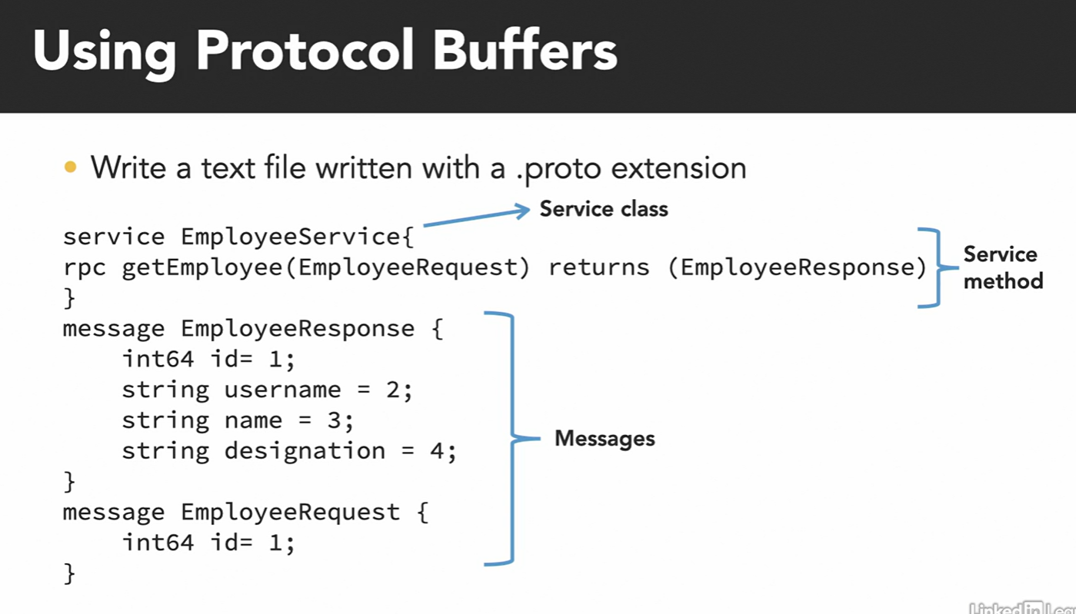

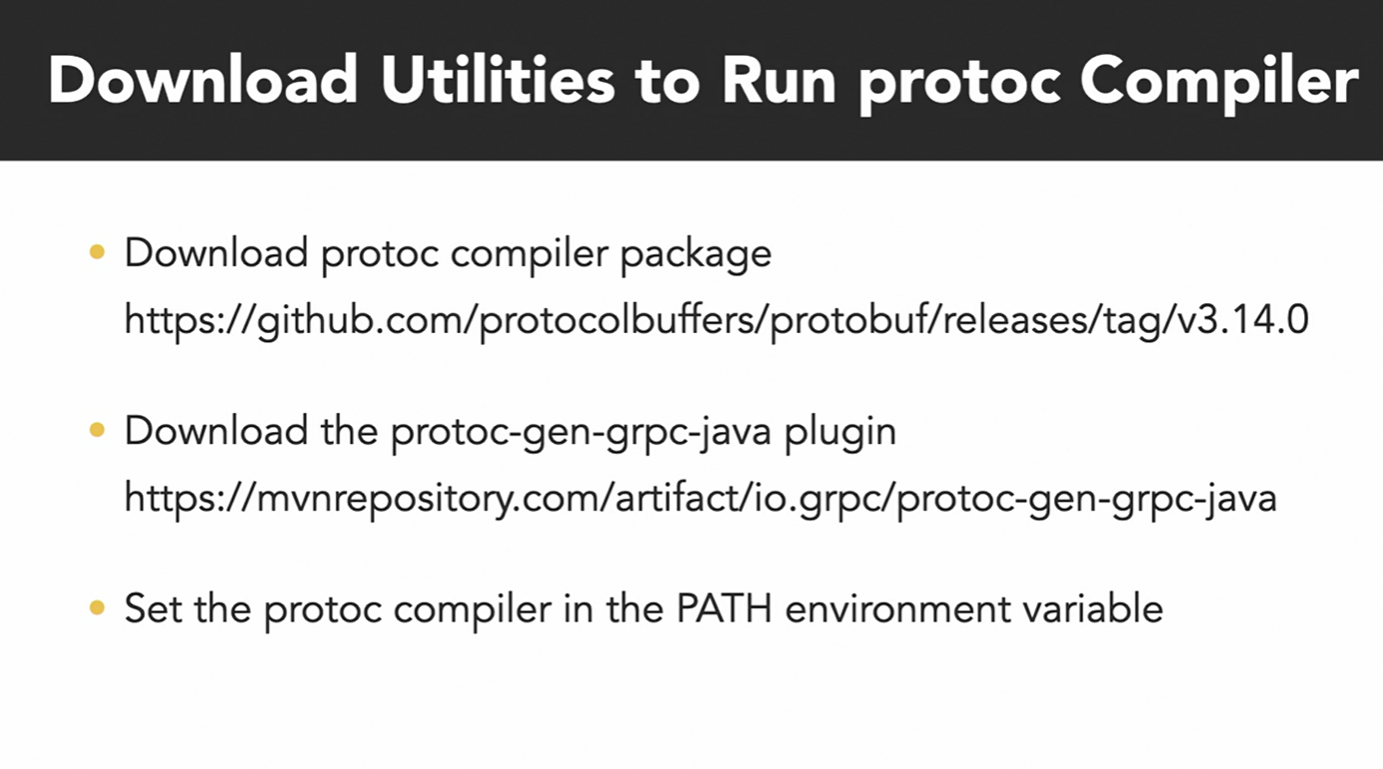

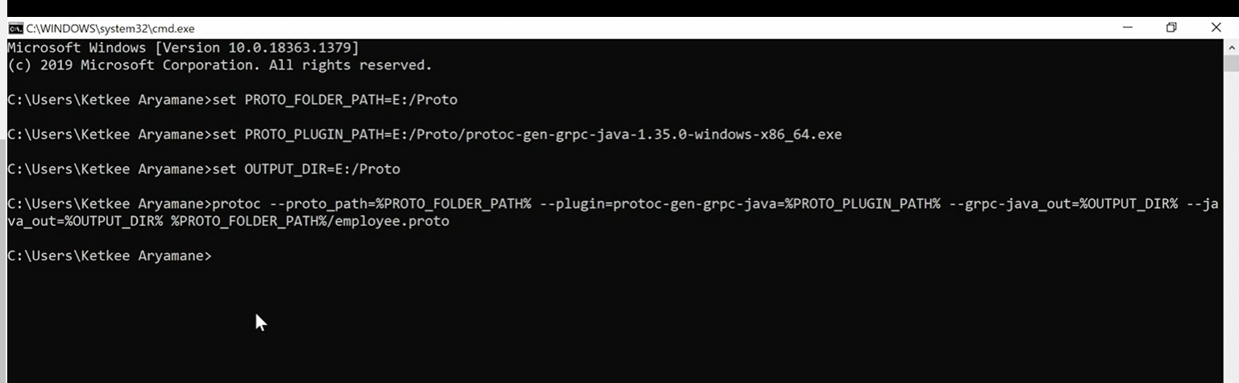

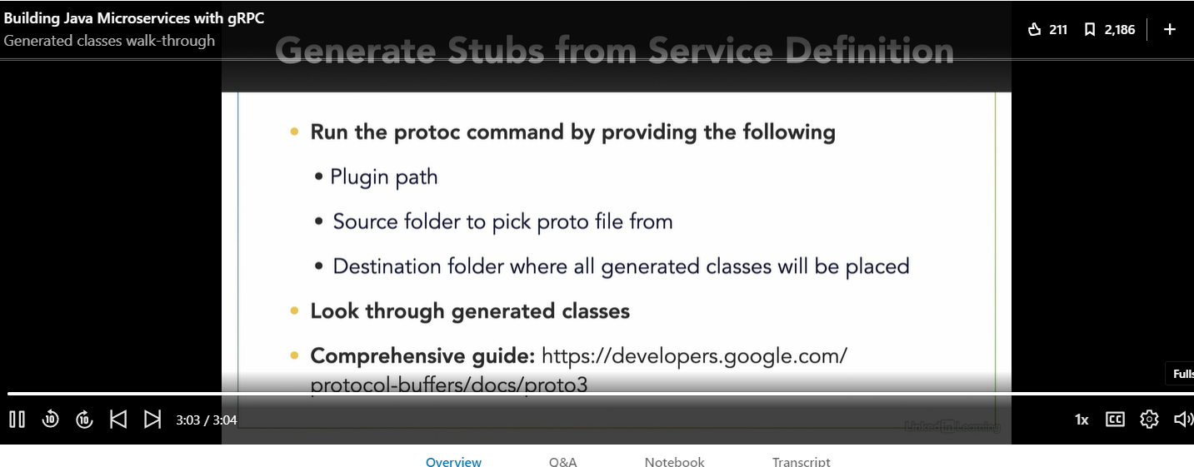

Metadata – request Metadata , ResponseMetadata (Information in key and value pair)

Channel 🡪 Connection end point , It has state - connected or idle.

Blocking and asyn calls

4 types

1. Unary RPC

Go GRPC 🡪 RPC call to server 🡪 connection is setup 🡪 server respond to it. 🡪 client receive . Example 🡪 View User detail2.

1. Client Streaming :

Stream of Request and Stream of Response Example : Website Tracking . returns single response

1. Service Streaming : Single request and multiple response . Example ( Search of Products )
2. Bidirectional Streaning : Client send Stream of Messages ( Example : all search result )

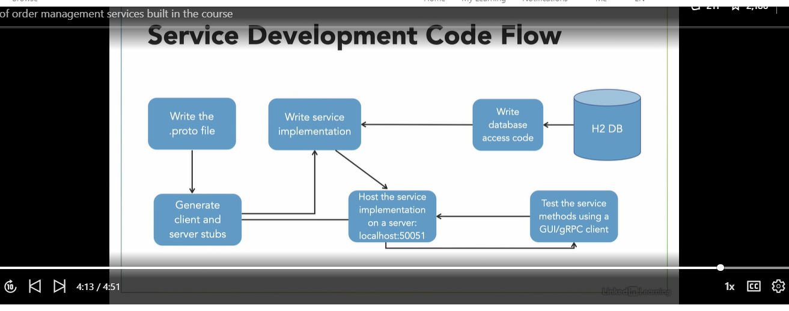

For testing grpc Java client / Bloom RPC

