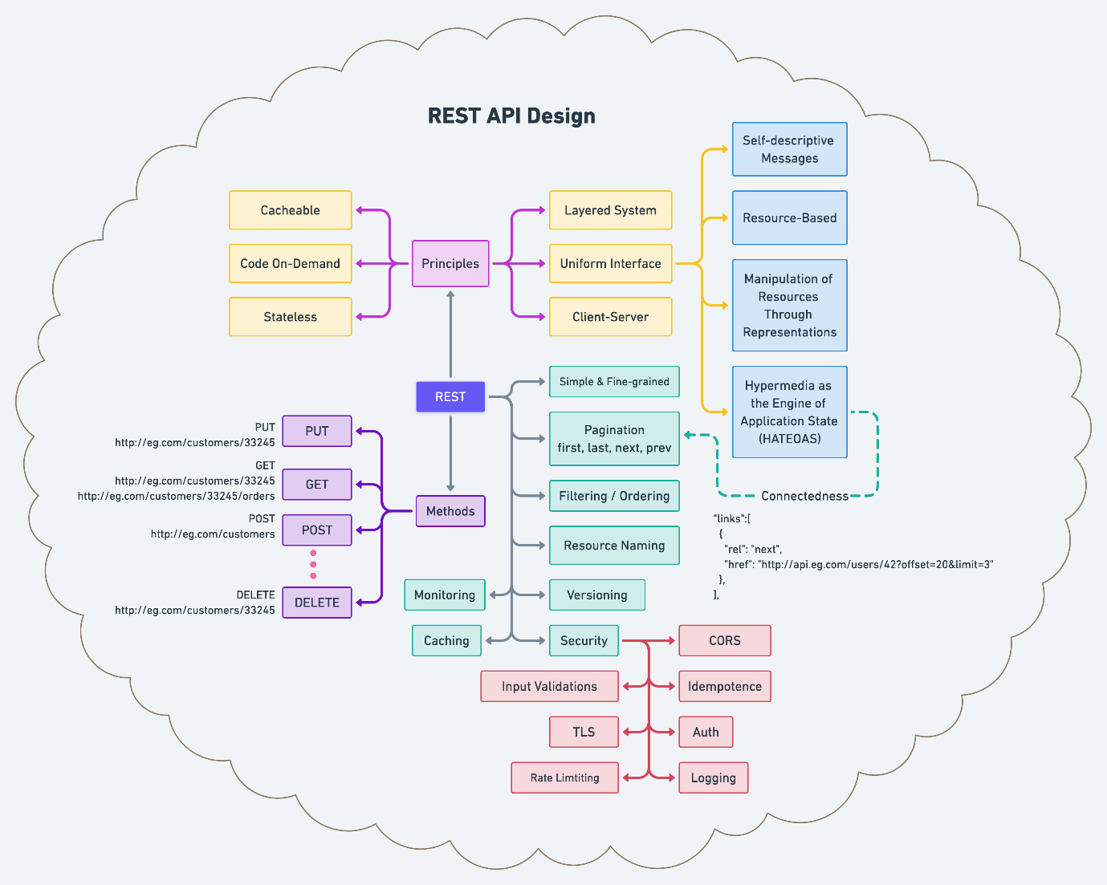

Rule of REST API

1. Trailing forward slash should not be included in URIs
2. Forward slash separator must be used to indicate a hierarchical relationship

Example : <http://api.canvas.com/shapes/polygons/quadrilaterals/squares>

1. Hyphens should be used to improve the readability of URIs
2. Underscore should not be used in URIs
3. Lowercase letters should be preferred in uri paths
4. File extensions should not be included in URIs
5. Follow plural instead of singulars



**Contents**

* [11xx informational response](https://en.wikipedia.org/wiki/List_of_HTTP_status_codes#1xx_informational_response)
* [22xx success](https://en.wikipedia.org/wiki/List_of_HTTP_status_codes#2xx_success)
* [33xx redirection](https://en.wikipedia.org/wiki/List_of_HTTP_status_codes#3xx_redirection)
* [44xx client errors](https://en.wikipedia.org/wiki/List_of_HTTP_status_codes#4xx_client_errors)
* 5xx server errore

Reference : <https://docs.spring.io/spring-framework/docs/current/javadoc-api/org/springframework/http/HttpStatus.html>

202 – Accepted

502 Bad Gateway

400 Bad Request

509 Bandwidth limit exceeded

103 checkpoint

409 Conflict

100 continue

201 created

417 Exception failed

424 failed dependency

403 – Forbidden

302 – Found

504 – Gateway Timeout

507 – Insufficient storage

500 – Internal Server Error

411 – Length required

508- Loop detected

301- Moved Permanently

404 – Not found

501- Not implemented

413 – Payload too large

102 – processing

407- Proxy Authentication required

408 – Request Timeout

429 – too many request

401 – Unathorized

415 – Unsupported Media Type

Handle responsestatus Exception as mentioned below

[https://docs.spring.io/spring-framework/docs/current/javadoc api/org/springframework/web/server/ResponseStatusException.html](https://docs.spring.io/spring-framework/docs/current/javadoc%20api/org/springframework/web/server/ResponseStatusException.html)

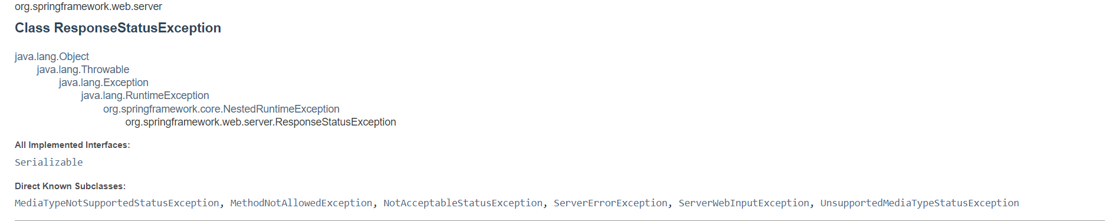

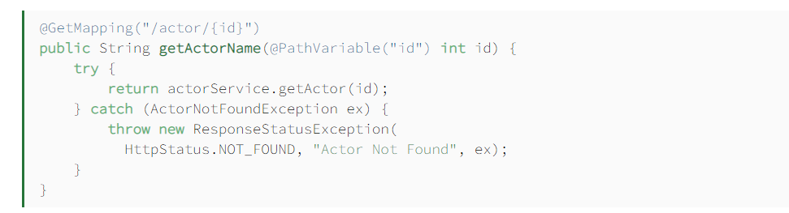

Make the rest end point by spring security ( Ref : https://spring.io/guides/gs/securing-web/)

1. Add dependency for *spring-security-test* and *spring-boot-starter-security*
2. Create @Configuration Class with @EnableWebSecurity and extend WebSecurityConfigurerAdapter

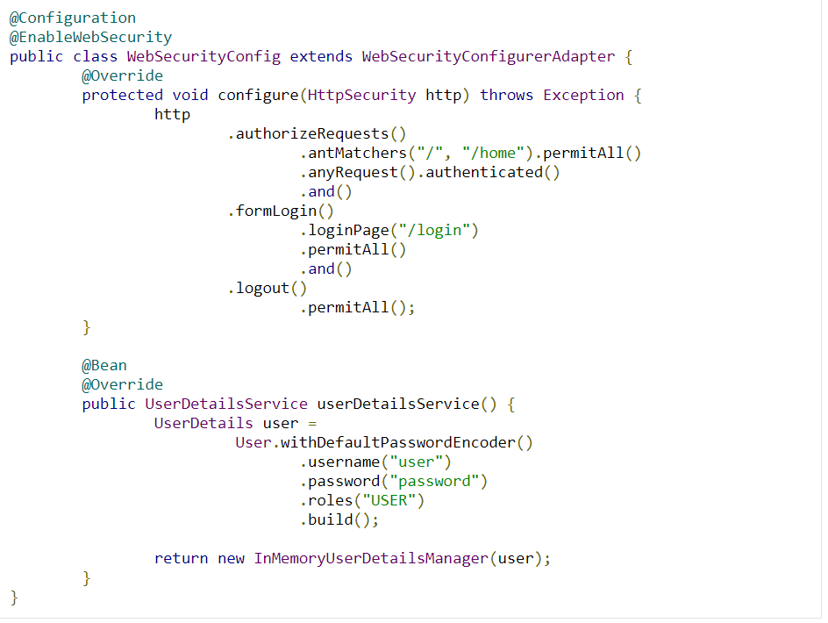

1. Configure methos helps to which path should be secured and which should not. Permit all with / and /home .
2. Login page is allowed to everyone .
3. <https://www.javainterviewpoint.com/spring-security-inmemoryuserdetailsmanager/> - Reference