**Frequently asked Frontend programming interview questions**

Photo by [Rahul Mishra](https://unsplash.com/@rahuulmiishra?utm_source=unsplash&utm_medium=referral&utm_content=creditCopyText) on [Unsplash](https://unsplash.com/@rahuulmiishra?utm_source=unsplash&utm_medium=referral&utm_content=creditCopyText" \t "_blank)

**1. Count the occurrence of characters in given string**

**2. Shift all 0s to the right**

**3. Create a Singleton instance from functions**

**4. Pollyfill of bind**

**5. Pollyfill of Promise.all()**

**6. Flat a given array with and without level control**

**7. Infinite Currying**

**8. Find nth Largest and Smallest number**

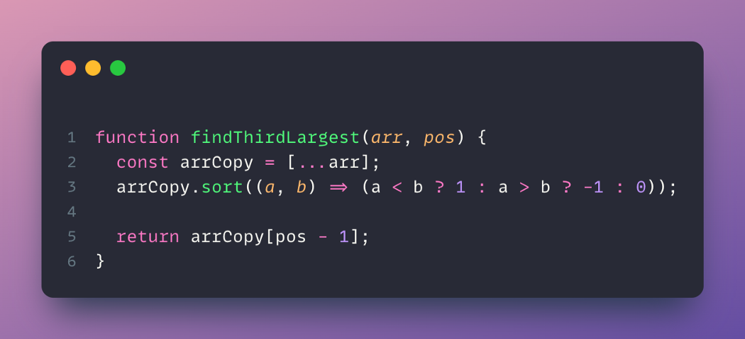

Although, interviewer was not happy with this solution, he was looking a solution without sorting.At that time I can only think of a solution using for loop.Do let me know if you have any better solution for this.

**9. Check if String is palindrome**

Note: This will not work in case of string have spaces.

**10. Fibonacci series with Memoization**

console.time();  
console.log(res(22));  
console.timeEnd(); // 1.408203125 msconsole.time();  
console.log(res(22));  
console.timeEnd(); // 0.015869140625 ms

**11. Implement Debounce**

**12. Implement Throttle**

[Read more about throttle function.](https://stackoverflow.com/questions/27078285/simple-throttle-in-javascript)

**13. Check if pair with given sum exists in an array**

**14. Square each digit of number without using any string function**

**[Interviewer: Square each digit of number without using any string function](https://rahuulmiishra.medium.com/interviewer-square-each-digit-of-number-without-using-any-string-function-d39f296bb57f" \t "_blank)**

[Recently I gave an interview for the role for Sr. Frontend Developer. The Interviewer asked me this question:](https://rahuulmiishra.medium.com/interviewer-square-each-digit-of-number-without-using-any-string-function-d39f296bb57f" \t "_blank)

[rahuulmiishra.medium.com](https://rahuulmiishra.medium.com/interviewer-square-each-digit-of-number-without-using-any-string-function-d39f296bb57f" \t "_blank)