1. Fetch only relevant resources
2. Minifiy youe code -**Minification** can include the removal of **code comments**, **white space**, and **unused code**, as well as the **shortening of variable and function names**.
3. Pre-fetch resource

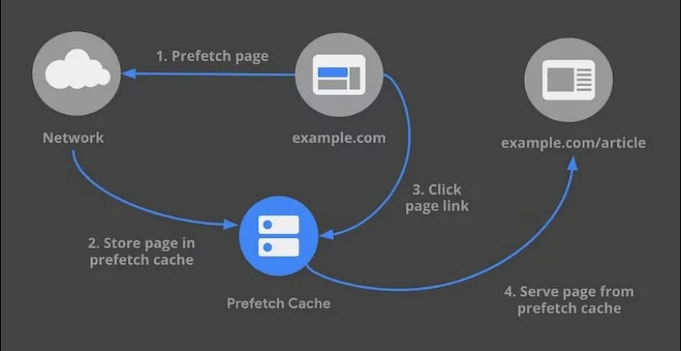

1. Use responsive images or Art direction
2. Lazy loading of relevant resources
3. Tree shake your code
4. Use page speed insights to detect potential issues

Js-routing

State-management

Browser API

Binding

Authorization tokens to request

Data mappings