**Top 8 diagramming tools for software architecture**

**The best free and paid tools to diagram your software architecture**

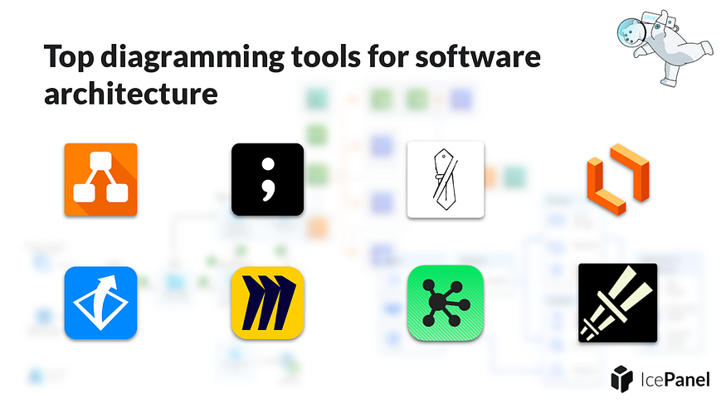

**⚡ Tl;dr**

* Software architecture tools can be categorized into three groups, modelling tools, diagrams as code and diagramming tools.
* Diagramming is best for quick sketches in conversation and experimentation of ideas.

**🚀 Let’s kick-off**

Diagramming software architecture provides several benefits to communicating complexity. Clear system designs give engineering teams an enhanced understanding of the architecture and plan for future development whilst identifying potential issues.

Diagramming is best for quick sketches in conversation and experimentation of ideas. They are easy to make but often thrown away and difficult to keep up to date.

**1️⃣**[**Diagrams.net**](http://diagrams.net/)

[Diagrams.net](https://www.diagrams.net/) (formerly [draw.io](http://draw.io/)) is a collaborative online diagramming tool with an offline desktop app for added security.

Free and open source.

Best for teams who want to ensure data security by storing their diagrams in a secure or offline location.

It includes features such as:

* Real-time collaboration
* Offline desktop app
* Store diagrams locally in the browse
* Storage in Google Drive, Sharepoint, OneDrive, GitHub, GitLab, Dropbox or Notion
* Support for UML, C4, ArchiMate, BPMN and SysML shapes
* AWS, Azure, GCP, Cisco and Kubernetes icon packs

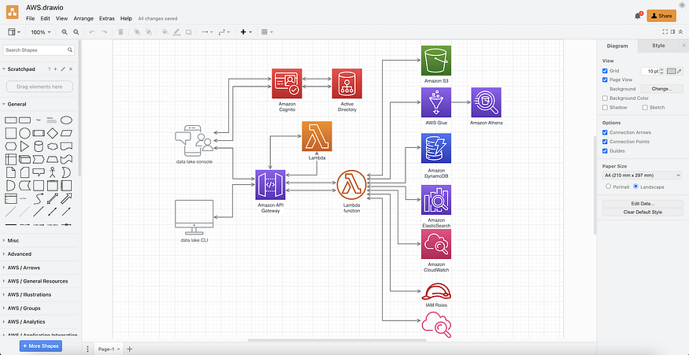

Diagrams.net screenshot

**2️⃣ Lucidchart**

[Lucidchart](https://www.lucidchart.com/) is a collaborative diagramming tool with templating and shape types to create many diagram types, such as flow charts, process flows, mind maps and more.

Free and paid.

Best for teams collaborating on quick and flexible diagrams.

It includes features such as:

* Real-time collaboration to work with your team
* Connect to data
* Integrate with other tools in your stack
* Templates to help guide you
* A learning campus to learn what you can do in the tool

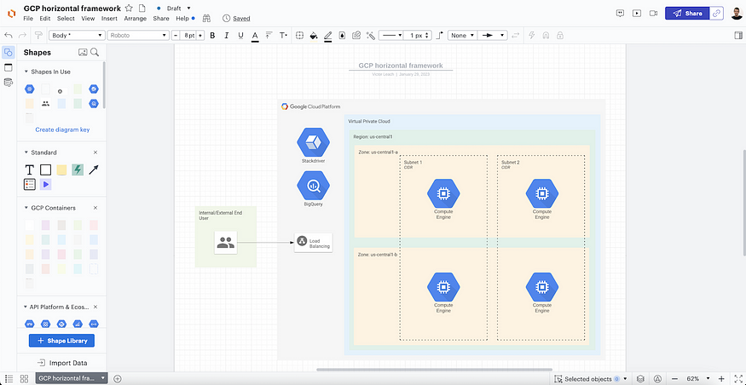

Lucidchart screenshot

**3️⃣ Excalidraw**

[Excalidraw](https://excalidraw.com/) is a collaborative virtual whiteboarding tool with the paid option of Excalidraw+.

Free and open source with a paid option.

Best for teams who want to sketch diagrams using pre-existing components quickly.

It includes features such as:

* Rapid sketching with handwriting style
* Simple and minimalist interface
* Libraries to quickly add pre-existing components
* End-to-end encryption
* Share drawings by links
* NPM library to integrate into your app
* Comments, versioning and search included with Excalidraw+

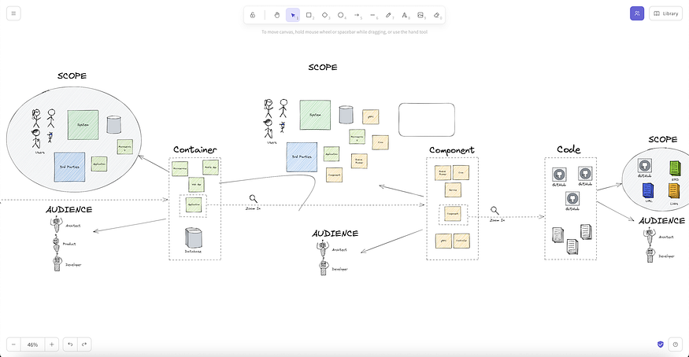

Excalidraw screenshot

**4️⃣ tldraw**

[tldraw](https://www.tldraw.com/) is a collaborative online tool for sketching diagrams.

Free and open source.

Best for people looking for a free, open-source solution for diagramming.

It includes features such as:

* Flexible sketching of shapes and lines
* Change sketch style
* Sticky notes
* Multiplayer mode for collaboration

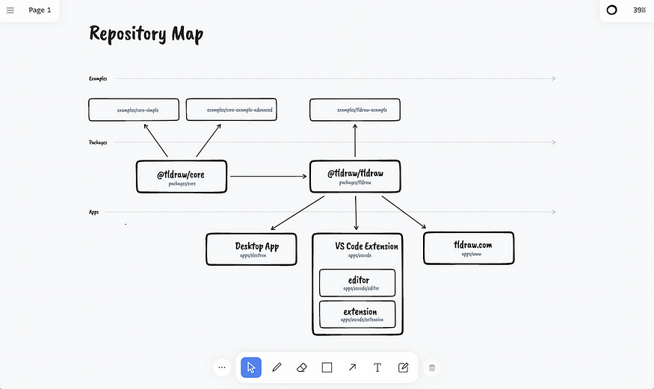

tldraw screenshot

**5️⃣ Gliffy**

[Gliffy](https://www.gliffy.com/) is a collaborative drag-and-drop diagramming tool.

Paid.

Best for larger teams who want to diagram software architecture and have enterprise requirements.

It includes features such as:

* Real-time collaboration
* Support for UML, ER, data flow, process and C4 modelling
* Cloud architecture diagrams
* Integration with Jira, Confluence and Google Drive

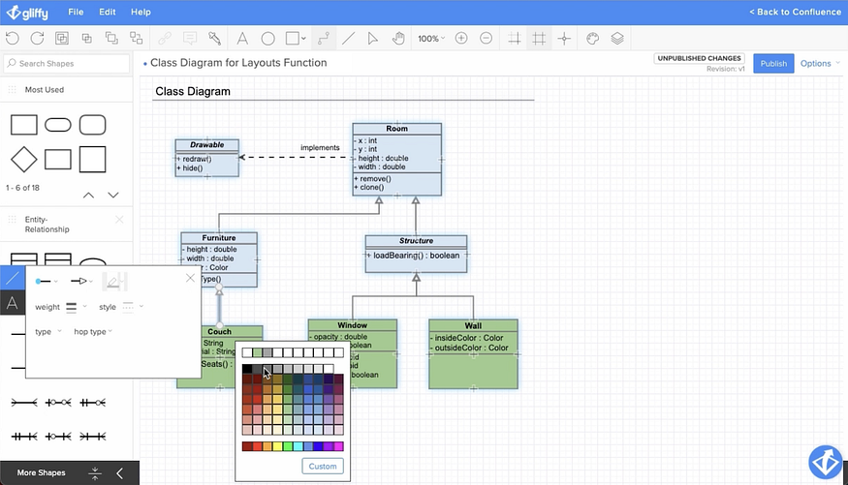

Gliffy screenshot

**6️⃣ OmniGraffle**

[OmniGraffle](https://www.omnigroup.com/omnigraffle) is a macOS and iOS desktop application for diagramming and prototyping.

Paid.

Best for individuals who want their diagrams stored on their local machine and want to manipulate many file types.

It includes features such as:

* Layered documents, grids and auto layout
* SVG import and paste
* Visio import and export
* Apple Pencil support
* Object metadata
* PNG, JPG, GIF, BMP, TIFF, PDF, EPS and PSD file types

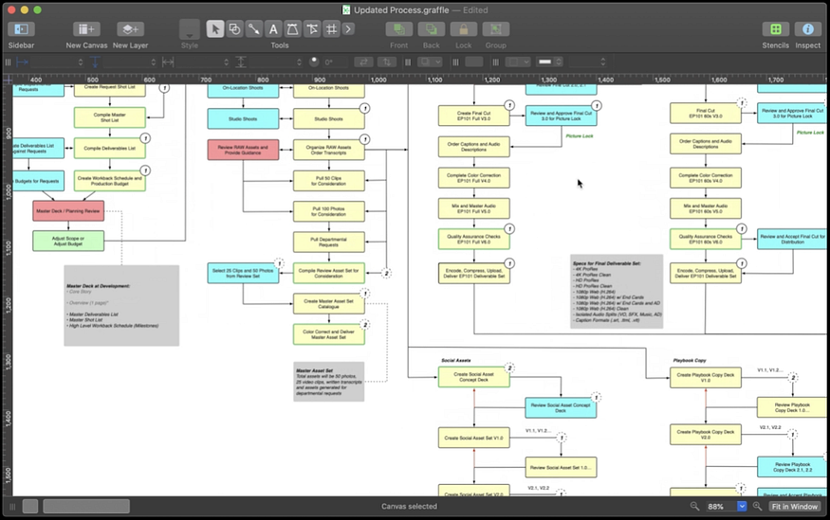

OmniGraffle screenshot

**7️⃣ Miro**

[Miro](https://miro.com/) is a collaborative whiteboarding tool with templating and team-based tooling to help facilitate workshops.

Free and paid.

Best for teams collaborating on diagrams and facilitating workshops.

It includes features such as:

* Real-time editing on an interactive whiteboard
* Mouse over collaboration to see who’s viewing your diagram
* Workshop facilitation tools such as timers and voting
* Community-made templating

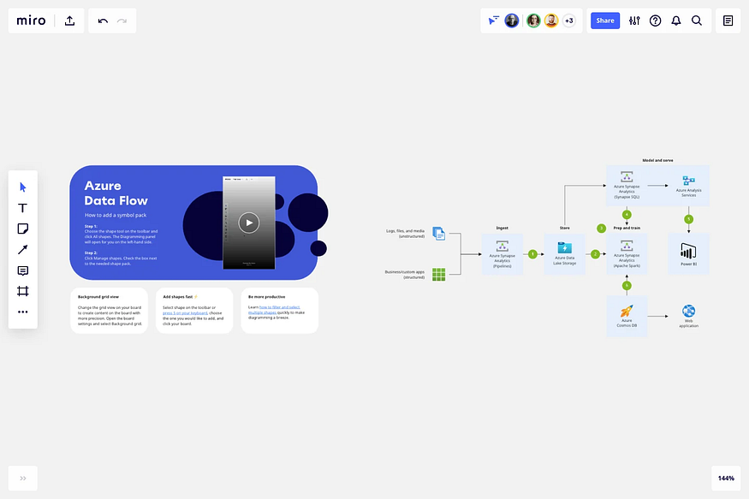

Miro screenshot

**8️⃣ CloudSkew**

[CloudSkew](https://www.cloudskew.com/) is an online tool for drawing cloud architecture diagrams.

Free and paid.

Best for individuals wanting to quickly create architecture and network diagrams for the major cloud platforms.

It includes features such as:

* Icons for AWS, Azure, GCP, Kubernetes, IBM Cloud, Alibaba Cloud and OCI
* Autosaved to the cloud
* Architecture diagrams, network diagrams and flowcharts
* Diagram templates

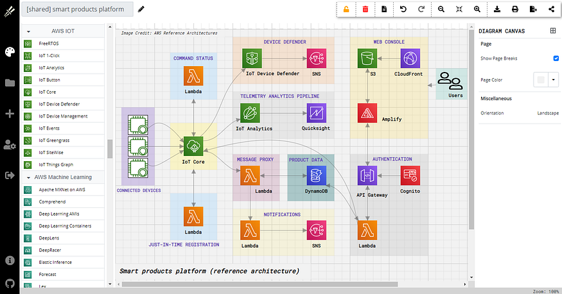

CloudSkew screenshot

**🏁 To wrap up**

There are many software architecture diagramming tools, and it’s important to consider which is best suited for your organization.

Some key things to consider.

* Can the diagrams be edited and consumed by everyone in the organization who needs to?
* Does your team already have a license for one of these tools for other purposes?
* Does the diagramming tool support the correct cloud or technology icons you need?
* How easy is it to keep your diagrams up-to-date and consistent?