What is blockchain ?

* Backbone technology of Digital crypto currency bitcoin
* Disctributed database of records of all transactions or digital event that have been executed and shares among participating parties.
* Verified by majority of participants in the system.
* Bitcoin is the most popular cyptocurrency – an example of blockchain.
* Satoshi Nakamoto published a white paper “BitCoin : A peer to peer electronic
* Cash system.” In 2008
* Bloackchain records the transaction in digital ledger which is distributed over the neetwork thus making it incorruptible.
* Anything of value like Land Asserts ,Cars can be recorded as blockchain as transaction.

How blockchain works ?

* Bitcoin is a cryptocurrency uses blockchain to exchange difgital asserts online.
* Bitcoin uses cryptographic proof instead of third party trust for 2 parties to execute transactions over the internet.
* Each transaction protects through digital signature.

Distributed Database :

* No central server to hold the data of blockchain .
* Data is distributed across millions of computer connected with blockchain .

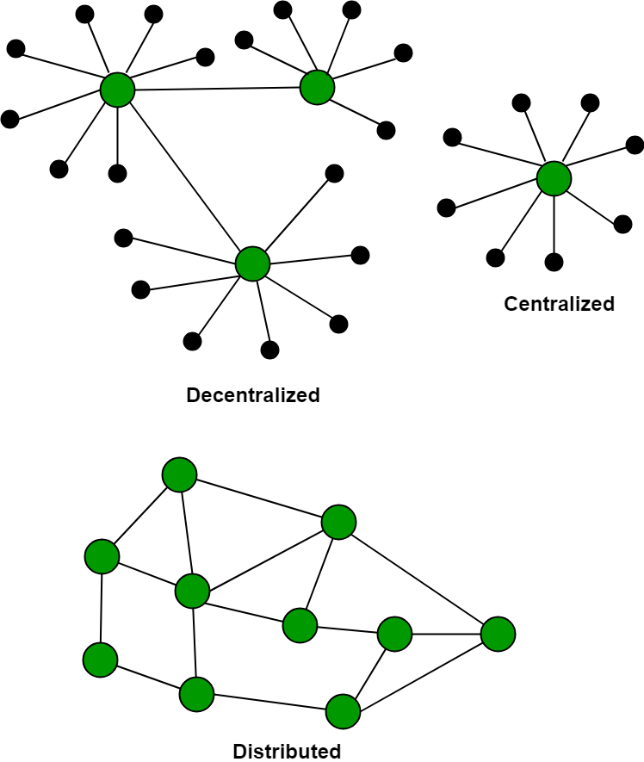

* Node is computer connected with blockchain network.
* Node gets connected with blockchain using client.
* Client helps in validating and propagates transaction on the blockchain
* When computer connects blockchain , copy of blockchain data gets downloaded into system and node comes in sync with latest block of data on blockvchain.
* Miners : Node connected to blockchain helps in execution of transction in return of an incentives.

Why to use blockchain. What are the disadvantage of current system.

* Cash can only be used in low amount transaction locally.
* Huge waiting time in processing of trenactions
* Need of third party verification and execution of transcation make the process comples.
* If the central Server like banks is compromised , the whole system is affected including participants
* Validation charge is high and making the process mre expensive.

Blockchain build trust through following 5 attributes.

Distributed : distributed ledger is shared and updated with every incoming transaction among the nodes and no central server controlling of data.

Secure : No unauthorized access to blockchain made through permissions and cryptography

Transparent : Thy can verify the identities without any mediators

Consensus – based - Participants must agree the transaction is valid . This is achived by consensus algorithms.

Flexible :

Smart Contreacts which are executed based on certain conditions , can be written into the platforms.

Blockchain network can involve in pace with business processes.

Berkeleys X Blockchain fundamentals – Professional Certificate

Buildspace

Oddyssey DAO

Crypto Zombies

QuestBook

CryptoDevHub

Ethereum

OpenSea -NFTS

Consensys

Vyper Fun

Eth.Build

Crypto Hack

ProtoSchool

MIT Blockchain & Money

Create your own NFT Collection

Alchemy

dApps

Flow

Solidity

1. Web3 University
2. Web3 Apps on Cloudfare

* Website security company
* Cloudfare Ehtereum gateway
* Build web3 application on network

1. QuestBook
2. Eat the Blocks on Youtube

* FlashLoan , UI/UX for decentralized network
* Deploying smart contracts
* Installing web3

1. Web 3.0 on Adam’s Academy

* CPD Qualification standards
* Web3 determinants
* Web3 mechanics
* Web3 semantics