## What is Serverless?

Serverless is a term that generally refers to serverless applications. Serverless applications are ones that don’t need any server provision and do not require to manage servers.

## What is AWS Lambda?

**AWS Lambda** is an event-driven, serverless computing platform provided by Amazon as a part of Amazon Web Services. Therefore you don’t need to worry about which AWS resources to launch, or how will you manage them. Instead, you need to put the code on Lambda, and it runs.

In AWS Lambda the code is executed based on the response of events in AWS services such as add/delete files in S3 bucket, HTTP request from Amazon API gateway, etc. However, Amazon Lambda can only be used to execute background tasks.

AWS Lambda function helps you to focus on your core product and business logic instead of managing operating system (OS) access control, OS patching, right-sizing, provisioning, scaling, etc.

In this AWS Lambda tutorial for beginners, you will learn:

* [How does AWS Lambda work?](https://www.guru99.com/aws-lambda-function.html#3)
* [Events that Trigger AWS Lambda](https://www.guru99.com/aws-lambda-function.html#4)
* [AWS Lambda Concepts](https://www.guru99.com/aws-lambda-function.html#5)
* [AWS Lambda VS AWS EC2](https://www.guru99.com/aws-lambda-function.html#6)
* [AWS Lambda VS AWS Elastic Beanstalk](https://www.guru99.com/aws-lambda-function.html#7)
* [Use Cases of AWS Lambda](https://www.guru99.com/aws-lambda-function.html#8)
* [Best practices of Lambda function](https://www.guru99.com/aws-lambda-function.html#9)
* [When not to use AWS Lambda](https://www.guru99.com/aws-lambda-function.html#10)
* [Advantages of using AWS Lambda](https://www.guru99.com/aws-lambda-function.html#11)
* [Limitations of AWS Lambda](https://www.guru99.com/aws-lambda-function.html#12)

## How does AWS Lambda work?

The following AWS Lambda example with block diagram explains the working of AWS Lambda in a few easy steps:

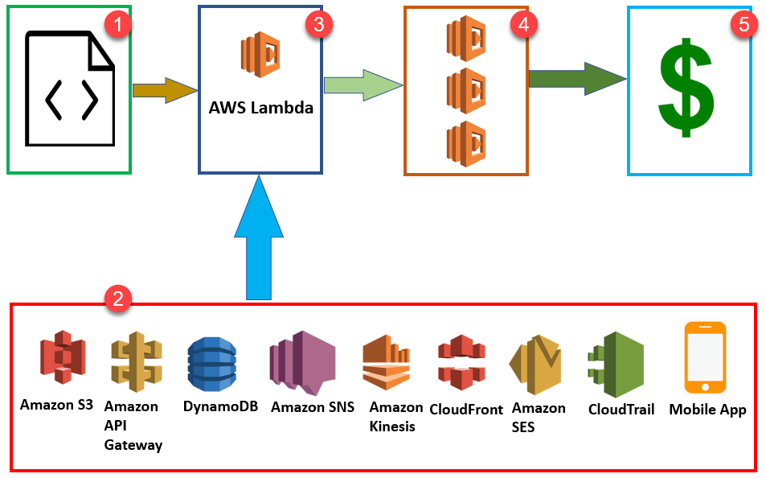

AWS Lambda Block Diagram

**Step 1:** First upload your AWS Lambda code in any language supported by AWS Lambda. [Java](https://www.guru99.com/java-tutorial.html), Python, Go, and C# are some of the languages that are supported by AWS Lambda function.

**Step 2:**These are some AWS services which allow you to trigger AWS Lambda.

**Step 3:** AWS Lambda helps you to upload code and the event details on which it should be triggered.

**Step 4:** Executes AWS Lambda Code when it is triggered by AWS services:

**Step 5:** AWS charges only when the AWS lambda code executes, and not otherwise.

This will happen in the following scenarios:

* Upload files in an S3 bucket
* When HTTP get/post endpoint URL is hit
* For adding/modifying and deleting Dynamo DB tables
* In the process of data streams collection
* Push notification
* Hosting of website
* Email sending

**Note:**You should remember that you will charge for AWS services only when the AWS Lambda code executes, else you don’t need to pay anything.

## Events that Trigger AWS Lambda

Here, are Events which will be triggered when you use AWS Lambda.

* Insert, updating and deleting data Dynamo DB table
* To include push notifications in SNS
* To search for log history in CloudTrail
* Entry into an S3 object
* DynamoDB can trigger AWS Lambda whenever there is data added, modified, and deleted in the table.
* Helps you to schedule the event to carry out the task at regular time pattern.
* Modifications to objects in S3 buckets
* Notifications sent from Amazon SNS.
* AWS Lambda can be used to process the CloudTrail logs
* API Gateway allows you to trigger AWS Lambda on GET/POST methods.

## AWS Lambda Concepts

**Function:**

A function is a program or a script which runs in AWS Lambda. Lambda passes invocation events into your function, which processes an event and returns its response.

**Runtimes:**

Runtime allows functions in various languages which runs on the same base execution environment. This helps you to configure your function in runtime. It also matches your selected [programming language](https://www.guru99.com/best-programming-language.html).

**Event source:**

An event source is an AWS service, such as Amazon SNS, or a custom service. This triggers function helps you to executes its logic.

**Lambda Layers:**

Lambda layers are an important distribution mechanism for libraries, custom runtimes, and other important function dependencies. This AWS component also helps you to manage your development function code separately from the unchanging code and resources that it uses.

**Log streams:**

Log stream allows you to annotate your function code with custom logging statements which helps you to analyse the execution flow and performance of your AWS Lambda functions.

## How to use AWS Lambda

Now, we will learn how to use AWS Lambda with AWS Lambda example:

**Step 1**) Step 1) Open AWS Lambda URL  
Goto <https://aws.amazon.com/lambda/> and Get Started

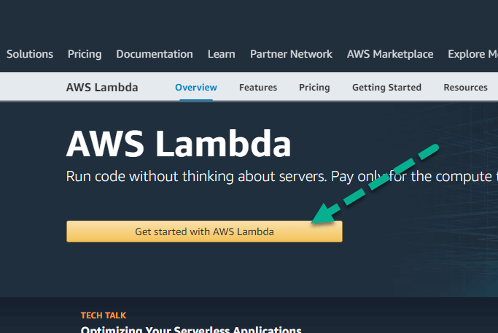

**Step 2**) Create an account  
Next, Create an account or sign in with your existing account

**Step 3**) Edit the code & Click Run,  
In the next Lambda page,

1. Edit the code
2. Click Run

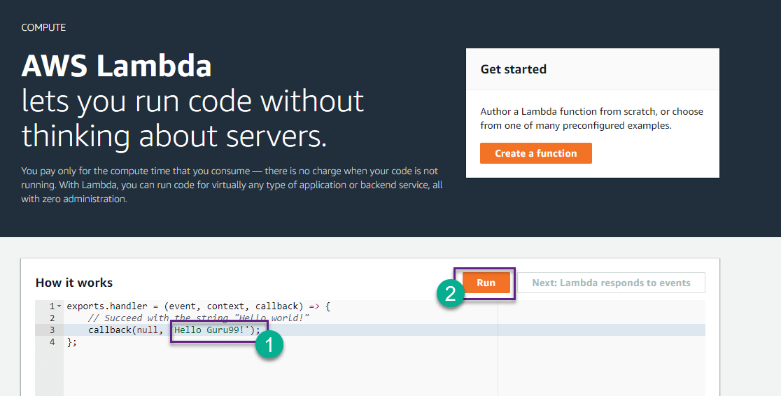

**Step 4**) Check output  
You will see output

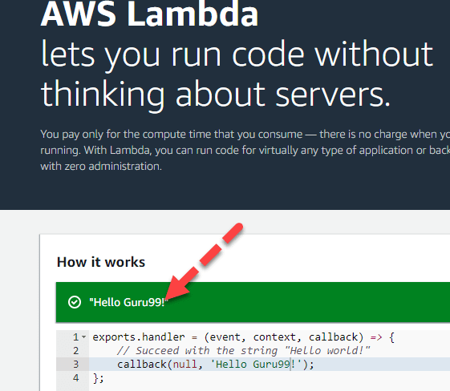

## AWS Lambda VS AWS EC2

Here, are some major differences between AWS Lambda and [EC2](https://www.guru99.com/creating-amazon-ec2-instance.html).

|  |  |  |
| --- | --- | --- |
| **Parameters** | **AWS Lambda** | **AWS EC2** |
| Definition | AWS Lambda is a Platform as a Service (PaaS). It helps you to run and execute your backend code. | AWS EC2 Is an Infrastructure as a Service (laaS). It provides virtualized computing resources. |
| Flexibility | Does not offers any flexibility to log in to compute instances. It allows you to choose a customized operating system or language runtime. | Offers the flexibility to select the variety of instances, customoperating systems, security patches, and network, etc. |
| Installation process | You need to select your environment where you want to runthe code and push the code into AWS Lambda. | For the first time in EC2, you have to choose the OS and install all the software required and then push your code in EC2. |
| Environment restrictions | It is restricted to fewlanguages. | No environment restrictions. |

## AWS Lambda VS AWS Elastic Beanstalk

Here, are some major differences between AWS Lambda and Elastic Beanstalk.

|  |  |  |
| --- | --- | --- |
| **Parameters** | **AWS Elastic Beanstalk** | **AWS Lambda** |
| Main task | Deploy and manage the apps on AWS Cloud without worrying about the infrastructure which runs those applications. | AWS Lambda is used for running and executing your Back-end code. You can’t use it to deploy an application. |
| Selection of AWS resources | It gives you a Freedom to select AWS resources; For example, you can choose EC2 instance which is optimal according to your application. | You can’t select the AWS resources, like a type of EC2 instance, Lambda offers resources based on your workload. |
| Type of system | It is a stateful system. | It is a stateless system. |

## Use Cases of AWS Lambda

AWS Lambda used for a wide range of applications like:

* Helps you for ETL process
* Allows you to perform real-time file processing and real-time stream processing
* Use for creating web applications
* Use in Amazon products like Alexa Chatbots and Amazon Echo/Alexa
* Data processing (real-time streaming analytics)
* Automated Backups of everyday tasks
* Scalable back ends (mobile apps, loT devices)
* Helps you to execute server-side backend logic
* Allows you to filter and Transform data

## Best practices of Lambda function

Here are some best practices of [AWS](https://www.guru99.com/what-is-aws.html) Lambda functions:

* Use the right “timeout.”
* Utilize the functions of local storage which is 500MB in size in the /temp folder
* Minimizing the use of start-up code which is not directly related to processing the current event.
* You should use built-in CloudWatch monitoring of your Lambda functions to view and optimize request latencies.

## When not to use AWS Lambda

Following are the situation where Lambda is surely not an ideal option:

* It is not appropriate to use AWS Lambda software packages or applications which rely on calling underlying Windows RPCs
* If is used for custom software applications with licensing agreements like MS-Office document processing, Oracle databases, etc.
* AWS Lambda should not be used for custom hardware process such as GPU acceleration, hardware affinity.

## Advantages of using AWS Lambda

Here, are pros/benefits of using AWS lambda:

* AWS Lambda is a highly flexible tool to use
* It helps you to grant access to resources, including VPCs
* Author directly with [WYSIWYG editor](https://www.guru99.com/best-wysiwyg-html-editor.html) in console.
* You can use it as a plugin for Eclipse and Visual Studio.
* As it is serverless architecture, you don’t need to worry about managing or provisioning servers.
* You do not need to set up any Virtual Machine.
* Helps developers to run and execute the code’s response to events without building any infrastructure.
* You just need to for the compute time taken, only when your code runs.
* You can monitor your code performance in real time through CloudWatch.
* It allows you to run your code without provisioning or to manage any other server
* Helps you to execute the code only when needed
* You can scale it automatically to handle a few requests per day and even support more than thousands of requests per second.
* AWS Lambda can be configured with the help of external event timers to perform scheduled tasks.
* Lambda function in AWS should be configured with external event and timers so; it can be used for scheduling.
* Lambda functions are stateless so that it can be scaled quickly.
* AWS Lambda is fast so it will execute your code within milliseconds.

## Limitations of AWS Lambda

Here are the cons/disadvantages of using AWS Lambda:

* AWS Lambda tool is not suitable for small projects.
* AWS Lambda entirely relies on AWS for the infrastructure, so you can’t install any additional software if your code demands it.
* Concurrent execution is limited to 100
* AWS Lambda completely depended on AWS for the infrastructure; you cannot install anything additional software if your code demands it.
* Its memory volume can vary between 128 to 1536 MB.
* Event request should not exceed 128 KB.
* Lambda functions help you to write their logs only in CloudWatch. This is the only tool that allows you to monitor or troubleshoot your functions.
* Its code execution timeout is just 5 minutes.

## Summary

* Serverless is a term that generally refers to serverless applications.
* AWS Lambda is one such serverless compute service. Therefore, you don’t need to worry about which AWS resources to launch, or how will they manage them.
* A function is a program or a script which runs in AWS serverless Lambda.
* Runtime allows functions in various languages which runs on the same base execution environment.
* An event source is an AWS service, such as Amazon SNS, or a custom service.
* Lambda layers are an important distribution mechanism for libraries, custom runtimes, and other important function dependencies.
* Log stream allows you to annotate your function code with custom logging statements which helps you to analyse the execution flow and performance of your Lambda functions.
* AWS Lambda is a Platform as a Service (PaaS). It helps you to run and execute your backend code.
* AWS EC2 Is an Infrastructure as a Service (laaS). It provides virtualized computing resources.
* Deploy and manage the apps on AWS Cloud without worrying about the infrastructure which runs those applications.
* AWS Lambda is used for running and executing your Back-end code. You can’t use it to deploy an application.
* AWS Lambda helps you for the ETL process.
* The best practice of Lambda function in AWS is to use the right “timeout.”
* It is not appropriate to use AWS Lambda software packages or applications which rely on calling underlying Windows RPCs
* AWS Lambda is a highly flexible tool.
* AWS Lambda tool is not suitable for small projects.
* A common event which will be triggered when you use AWS Lambda is Insert, updating and deleting data Dynamo DB table.