* It is red-black tree based implementation of Map interface , AbstractMap Class ,Navigable Map.
* Stores data in form of key and value pair where key is unique identifier

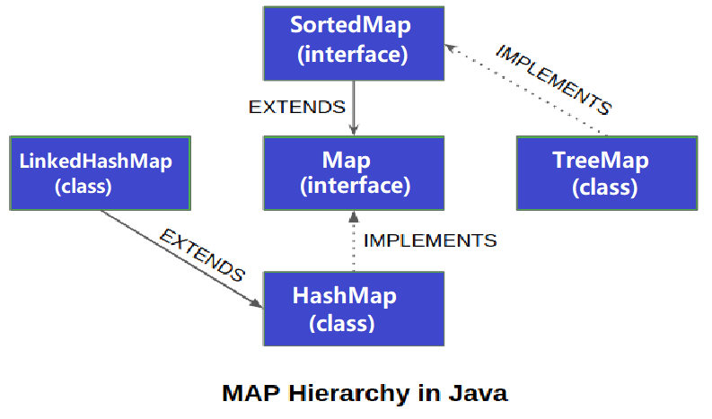

1. What is TreeMap
2. Initializing a TreeMap
3. Features of TreeMap
4. Why is TreeMap not Synchronized in Nature?
5. Internal Structure of TreeMap
6. Basic Operation of TreeMap
7. Method of TreeMap in Java
8. Constructor in TreeMap
9. Sorting in TreeMap
10. Internal Working of TreeMap
11. Red-Black Tree Algorithm
12. Step-by-step Procedure for Working on TreeMap

* The left element will always be less than the parent element.
* The right element will always be greater than or equal to the parent element.
* The logical comparison of the objects is done by natural order.