Comparable and comparator

* Its all about ordering and comparing of objects
* Both are used to compare objects and order them accordingly

Example:

Store the set of vehicles in ascending order by manufacturing year

Comparable:

* When we use comparable , we need to perform these steps
* **Implement** Pojo with Comparable interface
* **Override the compareTo** method as we want
* Sort by single property

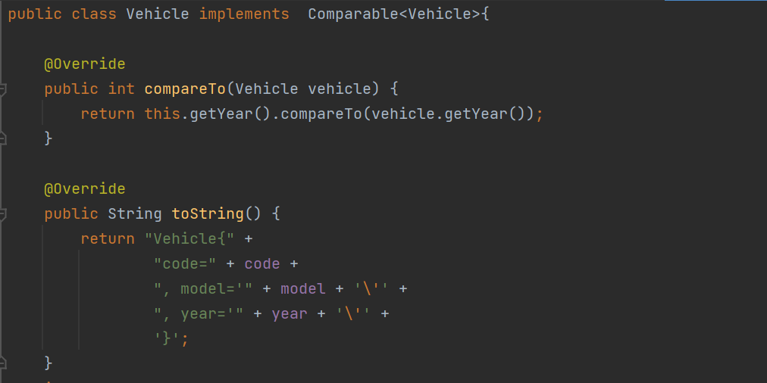

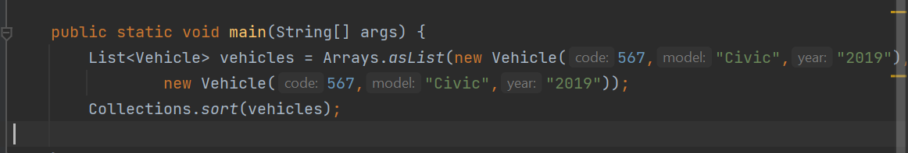

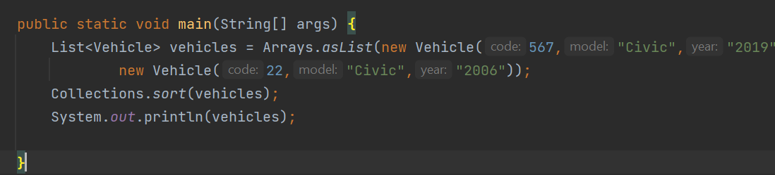

----------------------------------------------------------------

Comparator is functional Interface

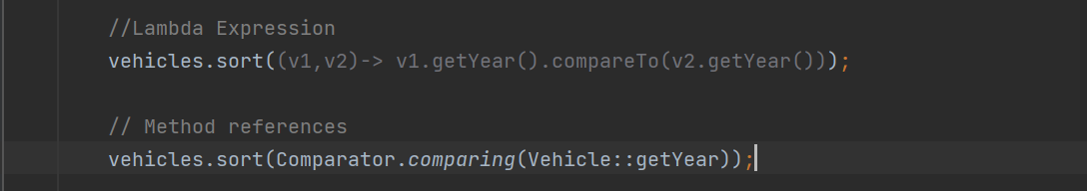

Compare using different properties

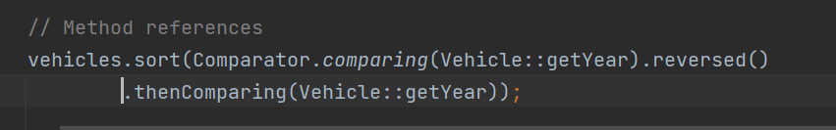

Advantage of Comparators over Comparable

* NO need to pollute Pojo class. We can create new Comparator class or implement runtime sorting.
* Separate the sorting logic
* Follows open / close principle of SOLID