**Java TreeSet Collection**

TreeSet is similar to HashSet except it sorts the TreeSet entries in ascending order.

TreeSet class is not synchronized.

TreeSet is an implementation of self balancing binary search tree. It is more efficient to store huge sorted data and perform multiple operations. Printing n elements will take O(N) time in TreeSet.

add, remove, and search operations takes O(log(N)) time.

TreeSet class implements NavigableSet interface which internally extends SortedSet interface.

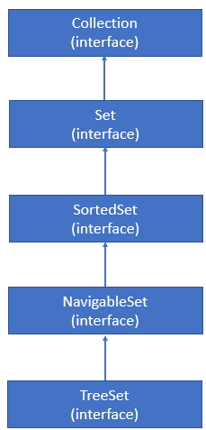

**Constructors:**

1. The below expression will create empty TreeSet having all the entries sorted by ascending order

TreeSet treeSet = new TreeSet ();

2. The below expression will create TreeSet with other collections.

TreeSet treeSet = new TreeSet(Collection collection);

3. The below expression will create TreeSet with SortedSet.

TreeSet t = new TreeSet(SortedSet s);