Latency – It’s a time delay between the cause and the effect of some physical change in the system being observed .

Hypervisors – Also known as Virtualize , VMM or virtual machine monitor

Horizontal and vertical Scale up (costly)

Infrastructure as code can be utilized via tools like Chef and Puppet to create and delete VM automatically.

Infrastructure as Service on public clouds like AWS , GCP we never run out of overloads

Containers :

* VM’s are bulky.
* Creation and deletion takes time

Containers :

What is container :

Lightweight software components that bundle the application , its dependencies and its configuration in single image , running in isolated user environment on traditional operating systems on a traditional server on virtualized environment.

Definition :

* Containers abstract applciations from the environment in which they run by providing a logical packaging maechanisam.
* We dvlop an application on our local desktop , containerize it deploy it on public cloud with confidence.

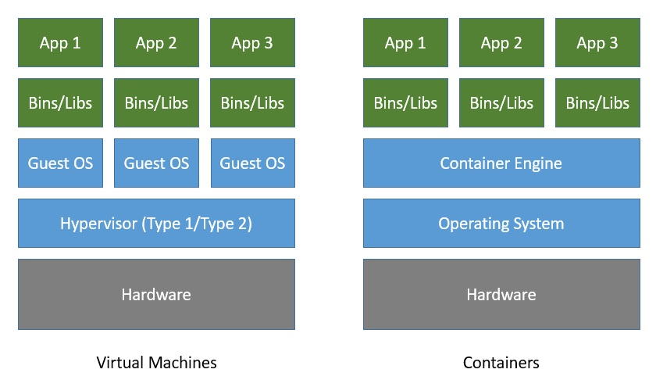

Why Container/ Benefits :

* Portability between different platforms and clouds
* Delivering higher utilization of compute resources
* Agility that allows developers to integrate with their existing Dvops environment
* Speedy delivery of enhancement
* Improved security by isolating application from host system and from each other
* Faster app startup and easier scaling
* Easier management since install ,upgrade and rollback processes are built into Kubernetes platform