User-defined Exceptions are implemented and used for boh checked and un-checked exceptions

Why we need custom exceptions:

* Java Exception to cover almost all exceptions that are bound to happen in programming.
* Business logic exceptions. Helps the application users or the developers to understand the exact problem is .
* To catch and provide specific treatment to the existing java exceptions.

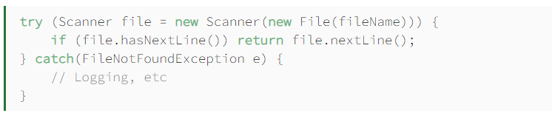

* Classic way of handling Java checked exception.
* We don’t know whether the exception is because oof file doesn’t exist of filename is invalid.