**Advanced Data Structures: Uses and Applications**

Advanced DSA — Key to professional programming

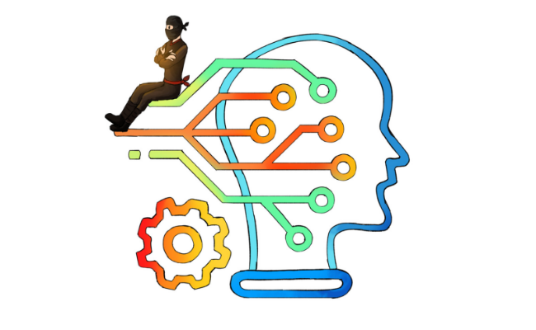

*Have you ever wondered where does Facebook keeps all of yours and other millions of user’s data?*

*Well the answer is simple- Databases.*

*But do you know how?*

*Well the answer is again simple- using Data structures*

**So what is a data structure?**

It is a way to store a large number of data in an organised manner so that it can be extracted and processed efficiently as and when required.

“The logical or mathematical model of a particular organisation of data is called a data structure”.

A data structure is a specialised format for organising, processing, retrieving and storing data. While there are several basic and advanced structure types, any data structure is designed to arrange data to suit a specific purpose so that it can be accessed and worked with in appropriate ways.

In computer programming, a data structure may be selected or designed to store data for the purpose of working on it with various algorithms. Each data structure contains information about the data values, relationships between the data and functions that can be applied to the data.

Data structures are the building blocks of any program or the software. Choosing the appropriate data structure for a program is the most difficult task for a programmer.

**There are mainly two types of Data Structure**

***1) Primitive Data Structure:*** *Data structures such as Real, Integer, Character and boolean are known as primitive data structures.*

***2) Non-Primitive Data structure:*** *Data structures like Stacks, Queues, Linked list, graphs and trees are known as non-primitive data structures. Non-Primitive Data structure is further divided into Linear and Non Linear data structure.*

***a) Linear Data Structures:*** *A data structure is called linear if all of its elements are arranged in the linear order. It’s types include…*

***Array:*** *Probably the simplest data structure you may have. Array items are indexed, item access is in constant time. But you can’t “close gaps” simply; you’ll have to shift all the items on one side of the gap to do that.*

***Linked list:*** *Each item in the list connects to the next item via a pointer (or reference). They may also be connected in reverse, too. You may easily remove an item and connect the neighbours, but you can’t access items via indices.*

***Stack:*** *Stack is a linear list in which insertion and deletions are allowed only at one end, called top.*

***Queue:*** *Queue is a linear list in which elements can be inserted only at one end called rear and deleted only at the other end called front.*

***b) Non Linear Data Structures:*** *This data structure does not form a sequence i.e. each item or element is connected with two or more other items in a non-linear arrangement. Types of non Linear data structure includes…*

***Tree:*** *Each tree node may have 0 or more child nodes. Each node can be viewed as a root node of a tree. A special kind of tree, Binary search tree, is a notable kind of tree where each node may have up to 2 child nodes. Each node holds a value. All nodes in “left sub-tree” of a node n hold values that are <= to the value stored in n; all the nodes in the right one hold values that are >. The tree is used for storing the values and searching them in logarithmic average time (if the tree is balanced, then the operations logarithmic time is assured).*

***Heap:*** *A data structure optimised for fast access to an optimum.  
etc.*

Everyone of us who have heard about Data structures, have also heard about Algorithm. This word always comes in hand with Data structure.  
So lets see, What is Algorithm in data structure?

An algorithm is defined as a step-by-step procedure or method for solving a problem by a computer in a finite number of steps. Steps of an algorithm definition may include branching or repetition depending upon what problem the algorithm is being developed for. While defining an algorithm steps are written in human understandable language and independent of any programming language. We can implement it in any programming language of our choice.

Besides merely being a finite set of rules which gives a sequence of operations for solving a specific type of problem, a well defined algorithm has five important features:

***Finiteness:****An algorithm must always terminate after a finite number of steps.*

***Definiteness:****Each step of an algorithm must be precisely defined; the actions to be carried out must be rigorously and unambiguously specified for each case.*

***Input:****An algorithm has zero or more inputs, i.e, quantities which are given to it initially before the algorithm begins.*

***Output:****An algorithm has one or more outputs i.e, quantities which have a specified relation to the inputs.*

***Effectiveness:****An algorithm is also generally expected to be effective. This means that all of the operations to be performed in the algorithm must be sufficiently basic that they can in principle be done exactly and in a finite length of time.*

In practice we not only want algorithm definitions, we want good algorithm definitions in some loosely-defined aesthetic sense. One criterion of goodness is the length of time taken to perform the algorithm. Other criteria are the adaptability of the algorithm to computers, its simplicity and elegance, etc.

As of now, we know, what is Data Structure and what is Algorithm. Let’s dive straight into its Application & Use in real life.

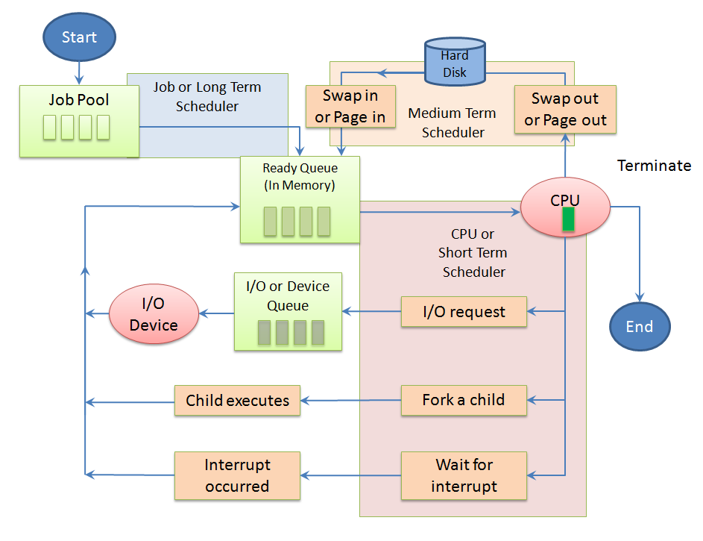

DIFFERENT QUEUES IN OS

***Array:*** *Arrangement of the leader-board of a game can be done simply through arrays to store the score and arrange them in descending order to clearly make out the rank of each player in the game.  
A simple question Paper is an array of numbered questions with each of them assigned some marks. 2D arrays, commonly known as, matrices, are used in image processing. It is also used in speech processing, in which each speech signal is an array.  
Book titles in a Library Management Systems.  
To store images of a specific size on an android or laptop.*

***Hash Table:*** *Used for fast data lookup — symbol table for compilers, database indexing, caches, Unique data representation.  
Data stored in hash tables is generally of the key-value format which is done through hash function.  
Every time we type something to be searched in google chrome or other browsers, it generates the desired output based on the principle of hashing.  
In our computers we have various files stored in it, each file has two very crucial pieces of information that is, the filename and file path, in order to make a connection between the filename to its corresponding file path hash tables are used.*

***Stack:*** *Used in Undo\redo operation in word processors, Expression evaluation and syntax parsing, many virtual machines like JVM are stack oriented.  
Converting infix to post-fix expressions.  
History of visited websites.  
Message logs and all messages you get are arranged in a stack.  
Call logs, E-mails, Google photos’ any gallery, YouTube downloads, Notifications ( latest appears first ).  
Wearing/Removing Bangles, Pile of Dinner Plates, Stacked chairs.  
Used in IDEs to check for proper parentheses matching*

***Linked list:*** *Images are linked with each other. So, an image viewer software uses a linked list to view the previous and the next images using the previous and next buttons.  
Web pages can be accessed using the previous and the next URL links which are linked using a linked list.  
To keep the track of turns in a multi-player game, a circular linked list is used.  
Left/Right swipe on Tinder uses a doubly-linked list.  
Social media content “feeds”.  
Train coaches are connected to one another in a doubly-linked list fashion.*

***Queues:*** *Transport and operations research where various entities are stored and held to be processed later ie the queue performs the function of a buffer.  
Operating System uses queues for job scheduling.  
To handle congestion in the networking queue can be used.  
Data packets in communication are arranged in queue format.  
Most internet requests and processes use queue.  
While switching multiple applications, windows use circular queue.  
A circular queue is used to maintain the playing sequence of multiple players in a game.  
Handle website traffic  
CPU scheduling  
Priority queues:  
Used when we need to store the customer order information in a drive-in burger place.  
(Customers keep on coming and they have to get their correct food at the payment/food collection window)  
Process scheduling in the kernel.*

***Trees:***

*Store hierarchical data, like folder structure, organization structure, XML/HTML data.  
BST is a tree that allows fast search, insert, delete on a sorted data. It also allows finding closest item*

***Radix tree:*** *IP routing table  
BSP tree:  
3D computer graphics  
Binary Search Tree:  
D Game Engine.  
Computer Graphics Rendering.  
Routing table.  
Red-Black Tree:  
Used when there is frequent Insertion/Deletion and few searches.*

***AVL Tree:*** *More Search and less Insertion/Deletion.  
Data Analysis and Data Mining and the applications which involve more searches.  
Suffix Tree:  
Fast full-text search, used in most word processors.  
Graphs:  
Connections/relations in social networking sites, Routing ,networks of communication, data organisation etc.  
Facebook’s Graph API uses the structure of Graphs.  
Google’s Knowledge Graph also has to do something with Graph.  
Dijkstra algorithm or the shortest path first algorithm also uses graph structure to find the smallest path between the nodes of the graph.  
The GPS navigation system also uses shortest path APIs.*

***Heap:*** *We can use it when we need to do Dynamic memory allocation in lisp.  
In heap sort Algorithm, is an algorithm for sorting elements in either min heap(the key of the parent is less than or equal to those of its children) or max heap(the key of the parent is greater than or equal to those of its children), sorting is done with the creation of heaps.*

* Applications of various Algorithms:

DIJKSTRA ALGORITHM



Breadth First Search Algorithm

***-GREEDY ALGORITHM:*** *Dijkstra algorithm.  
Shopping on a tight budget but want to buy gifts for all family members.  
Prim’s and Kruskal’s algorithms are used for finding the minimum spanning trees.*

***-DIJKSTRA ALGORITHM:*** *Used in applications like Google Maps to find the shortest path in a graph.*

***-PRIM’S and KRUSKAL’S Algorithm:*** *Used for finding the minimum spanning trees.*

***-Sorting Algorithm:*** *To order things by their value.  
Back-end Databases (Merge Sort).  
Playing Cards with your friends (Insertion Sort).  
sort() — uses Intro-sort (a hybrid of Quick-sort, Heap-sort, and Insertion Sort), Faster than qsort()  
Contact list on the phone  
Online shopping . To sort prize in different range . example : Flip-kart and Amazon.*