**The Guide To Choosing The Right Database For Your Project**

Clearly Explained Rules On Selecting The Right Database For Your Application With AWS Database Examples

Contemporary microservices depend heavily on databases. There are various kinds of databases available. It is vital to choose the right database to increase the longevity of the project as different databases have different strengths and weaknesses that make them more suitable for certain types of applications and use cases.

Wrong database choice can lead to performance issues, data integrity problems, and scalability challenges

**Introduction**

Choosing the right database for your application is an important decision factor. The databases come in various types ranging from relational and key-value to graph and document databases.

Selecting the right database depends on the specific requirements of your application. Subsequently, understanding the strengths and weaknesses of different types of databases can help you make an informed decision and ensure efficient data storage and management.

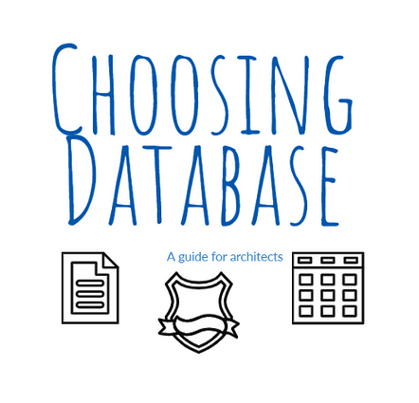

**Article Aim**

This article aims to outline succinct and clear rules on how we can choose the right database for our applications.

AWS offers a wide range of database services to meet the needs of different types of applications, from relational databases to NoSQL databases and data warehousing solutions. This article also provides an overview of AWS services.

**1. Let’s start by understanding what a database is**

* In a nutshell, a database is a software application that records a collection of data.
* There are a large number of databases available to us, each with its own strengths and weaknesses.
* Each database stores the data in a different manner that allows for efficient retrieval, manipulation, and analysis.
* Proper guidelines for managing databases are essential to ensure data consistency, accuracy, and security.

Selecting the wrong database can hurt the performance and reliability of an application and changing a database after an application is live can be a risky and tedious task. Therefore it’s crucial to understand the different types of databases and their characteristics.

**2. Different Types Of Databases**

Choosing the right database for your application is crucial for efficient data storage, retrieval, and management. There are various types of databases available:

**Relational SQL Database**

* This database is appropriate for structured data where records with similar structures can be represented as rows in tables with fixed columns.
* Ideal for applications that require complex data relationships and transactions that can enforce data integrity constraints and consistency.
* Accounting, CRM, and entity management tools are good projects to use for SQL databases.

**NoSQL Database**

* For handling large volumes of unstructured or semi-structured data such as documents and files.
* Ideal for applications that require high scalability and fast query response times.
* Content management, social media, text-based and real-time applications are appropriate applications where a NoSQL database can be used.

**Graph Database**

* For managing complex multi-levelled relationships between data sets.
* The databases are optimised for transversing graphs and hierarchies.
* Suitable for applications that require navigation of relationships between data.
* Fraud detection, recommendation engines, and social networks are common examples where graph databases can be used.

**Time-Series Database**

* Used for handling time-stamped data
* The databases are optimised for fast insertion and retrieval of data by a timestamp.
* The databases can handle large volumes of data in real-time.
* Typical applications that use time-series databases are IoT, sensor systems, and financial systems that rely on time-stamped market data, log files etc.

**Object Database**

* For handling complex object-oriented data structures
* The objects are usually created in a manner that represents a natural mapping of the domain. This makes storing and managing the data easier.
* Common projects are such as those found in scientific and engineering applications.

**3. Database Choices In AWS To Use For Your Applications**

Amazon Web Services (AWS) offers a variety of database services to meet the needs of different types of applications. This section aims to outline the summary of the AWS database services:

**Amazon Relational Database Service (RDS)**

* Managed relational database service that provides automated backup, scaling, and monitoring capabilities.
* It supports various relational database engines, including MySQL, PostgreSQL, Oracle, SQL Server, and MariaDB.

**Amazon Aurora**

* Relational database engine, MySQL and PostgreSQL-compatible
* Offers advanced features such as multi-master replication, automatic failover, and self-healing storage
* Designed for high performance, scalability, and availability, making it an excellent choice for mission-critical applications.

**Amazon DynamoDB**

* NoSQL database service that offers features such as auto-scaling, backup, and restore capabilities.
* Fast, flexible and designed for scalability and high availability.
* Supports key-value and document data models and

**Amazon DocumentDB**

* Fully-managed MongoDB-compatible document database service.
* Provides the scalability and availability of a NoSQL database while maintaining the flexibility and richness of the MongoDB data model.

**Amazon Neptune**

* Fast and reliable graph database service.

**Amazon Timestream**

* Fast, scalable, and serverless time-series database service that is designed for handling time-stamped data.

**Amazon Redshift**

* Fully-managed data warehousing service for handling large-scale data analytics workloads and offers advanced features such as machine learning integration and real-time data streaming.

**Amazon ElastiCache**

* Fully managed, Redis- and Memcached-compatible in-memory database service
* Delivers real-time, optimised service that can scale to millions of operations per second.

**Summary**

It is vital to choose the right database to increase the longevity of the project as different databases have different strengths and weaknesses that make them more suitable for certain types of applications and use cases.

Wrong database choice can lead to performance issues, data integrity problems, and scalability challenges, which can have a negative impact on the application’s functionality and usability.

By choosing the right database service, we can ensure efficient data storage, management, and analysis for our applications.