ACID :

ACID properties ensures the accuracy of database before and after transaction.

Atomicity : Either a transactions performed completely or should not execute at all.

Consistency : Database should remain consistent after the transaction.

Isolation : One transaction sould be invincible to another transaction till it get completed.

Durability : Data should remain in DB even if the system fails or crashes in power failure occurs. Store in non-volatile memory (system memory)

(

SQL Joins

Supported Types of Joins in MySQL

* INNER JOIN: Returns records that have matching values in both tables
* LEFT JOIN: Returns all records from the left table, and the matched records from the right table
* RIGHT JOIN: Returns all records from the right table, and the matched records from the left table
* CROSS JOIN: Returns all records from both tables

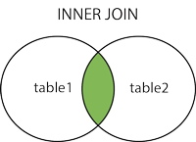  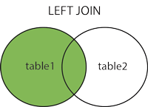  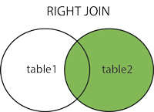  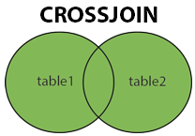

Inner Join 🡪 returns all the matching records in both the tables.

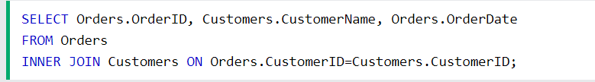

Left Join 🡪 returns all the records from the left table and matching records from the right table.

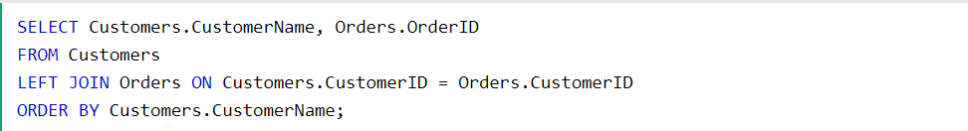

Right Join 🡪 returns all the records from the right table and the matching record from the left table.

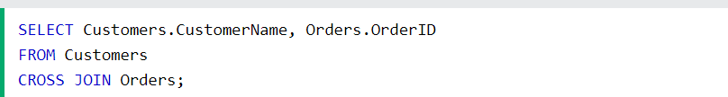

**Note:** The CROSS JOIN keyword returns all matching records from both tables whether the other table matches or not. So, if there are rows in "Customers" that do not have matches in "Orders", or if there are rows in "Orders" that do not have matches in "Customers", those rows will be listed as well.

If you add a WHERE clause (if table1 and table2 has a relationship), the CROSS JOIN will produce the same result as the INNER JOIN clause:

To get the top 3 records from DB

1. **select** **min**(salary) **from**
2. (**select** **distinct** salary **from** emp **order** **by** salary **desc**)
3. **where** rownum < 3;