**Design a Database for Flight Booking System from Scratch**

**Background:**

The procedure of making a flight reservation is a complicated one in today’s society. Airlines require a method of managing everything in order to handle bookings from eager passengers on a continuous basis. The way records are kept has changed significantly over time as a result of technical advancements, such as the introduction of computers, which allowed airlines to abandon manual procedures.

**Objectives:**

a. Keeping track of and securely keeping booking records.  
b. The database should make it simple to recover and retrieve booking information.  
c. Data loss will be prevented, and data integrity will be upheld, removing the possibility of data corruption.  
d. Reducing data entry errors that could have an impact on the data that’s stored in the system.  
e. Only authorized users will be able to access the information via the automated flight booking system.  
f. Reduce duplication by keeping a centralized database and only saving data once.  
g.Reduces paperwork.

**Purpose:**

This project’s main objective is to save paperwork while still giving consumers a straightforward way to look for and book flights. Users can check their tickets and reservations, receive information on ticket prices, and retrieve data on several flights that are available at various times on a given date using this database. It stores all the information needed to plan a trip, including the source, destination, and any layovers.  
It will store, organize, and manage a sizable amount of data, including a database of multiple flights, in order to maintain a vast scale of data.

**Initial ERD Design:**

**Discussed Business Problem :**

1. A Flight Booking System will keep a track and maintain booking of records efficiently and safely.
2. Booking details should be easily recoverable and retrievable from the database.
3. Airlines need to constantly process bookings from expectant passengers, they need a means of keeping on top of everything. Therefore, storing the records of flight schedules and passenger details will keep the data organized.
4. The automated flight booking system will allow only authorized users to access the information.
5. The system reduces redundancy by maintaining a centralized database and storing all information only once.

**Entities Present:**

1. Airport
2. Passenger
3. Flight_Details
4. Flight_Service
5. Seat_Details
6. Flight_Cost
7. Reservation
8. Travel_Class
9. Calendar
10. Payment
11. Payment_Status
12. Service_Offering

**Relationships between entities:**

1. An airport manages multiple flights. An airport may or may not have a flight landing/takeoff. Hence, it’s optional. Whereas for flight details, it is mandatory to have one airport association.
2. A flight may offer multiple services and each service may be offered to many flights.
3. A flight comprises multiple seats. It is mandatory that the flight consists of a seat. For Seat details to exist, it is mandatory that it is linked to at least one flight.
4. A passenger can make multiple reservations for a flight. Passengers may or may not reserve a flight. However, it is mandatory that reservation has to be associated with only one passenger.
5. Reservation confirms the Seat Details. It is mandatory that a reservation is linked with a Seat. A seat may or may not be linked with a reservation. One seat can only be linked to one reservation.
6. A travel class should consist of multiple seats. A seat should be linked to only one travel class.
7. A Payment may consist of multiple payment status. Whereas, a payment status should have a Payment associated with it.
8. A Payment Status should have a Reservation. A reservation may consist of multiple payment status.
9. The Flight cost should be determined from the Calendar.
10. The Seat Details should be associated with a Flight cost. The Flight Cost is calculated based on the Seat Details.

**Key Design:**

1. Each Airport can have multiple flight details associated with its respective source and destination.
2. Each Flight may offer many flight services like Food Service, Entertainment Service, Wifi Service etc. Each Flight_Service may be offered to many flights. Service_Offering is an associative entity which stores Service_ID and Flight_ID.
3. Each Flight mandatorily comprises one or many seats and each seat is associated with a particular Travel_Class_ID. A seat can belong to Business class or economy class etc.
4. Each passenger may or may not make multiple reservations. If a passenger makes a reservation, a seat of the passenger’s choice will be assigned. The Seat_Details will point to Travel_Class and Flight_Details. For each seat reserved, a passenger may or may not pay to confirm the seat. A passenger can reserve one seat per Reservation_ID.
5. Payment_Status is an associative entity which holds the information related to particular Reservation_ID and Payment_ID.
6. If the passenger has or hasn’t done the payment it will reflect in payment status and the respective payment due date and amount will be stored in Payment.
7. Flight_Cost can be determined on the basis of Seat_Details and Calendar from which a particular seat belongs to a travel class and the date when the seat is booked respectively.

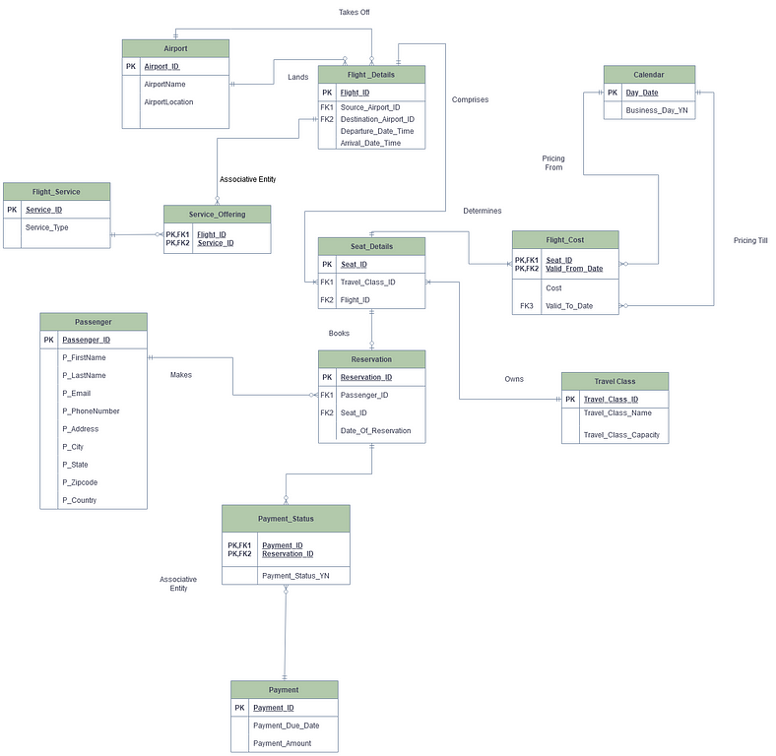

**Final ERD Design:**

This intial ER Diagram can be improved by removing redundancies and refining the entities

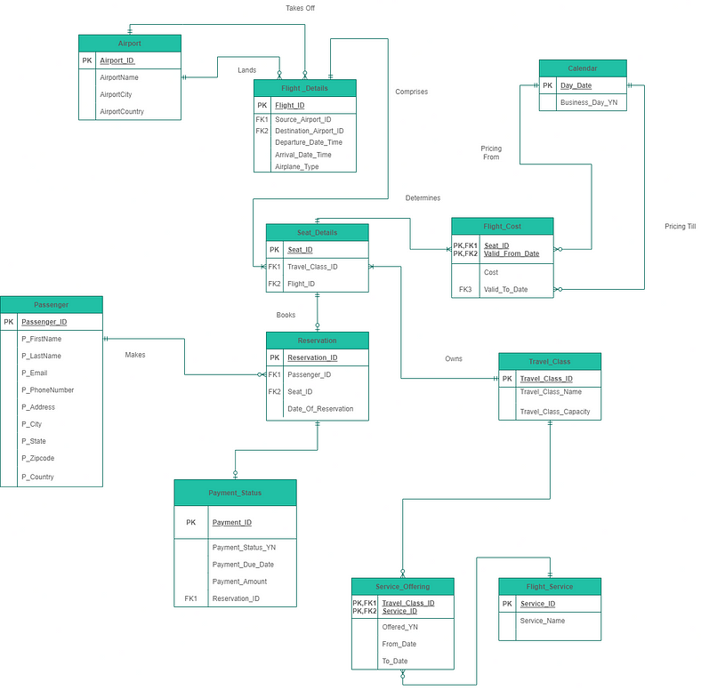

· Airport entity has AirportCity and AirportCountry which provides the airport specifications.

· Flight_Type attribute has been added to Flight_Details

· Payment entity has been removed from the ER diagram and its attributes have been listed under Payment_Status.

· The cardinality between Payment_Status and Reservation has been made optional one to mandatory many. Therefore, Reservation_ID becomes foreign key inside Payment_Status.

· Service_Offering which is an associative entity has 3 new attributes called Offered_YN , From_Date and To_Date. From_Date and To_Date that would give us the period when certain flight services are provided. Offered_YN would tell us if that service is been offered to a particular travel class.

· From the previous ER Diagram, we have removed Service_Type from Flight_Service and Class_Type from Travel_Class as it’s not required to enhance it.

**Database Implementation:**

With the Data Model ready,let us implement it using SQL.I have chosen Microsoft SQL server for the implementation

Here is a configured list of every object used in this project

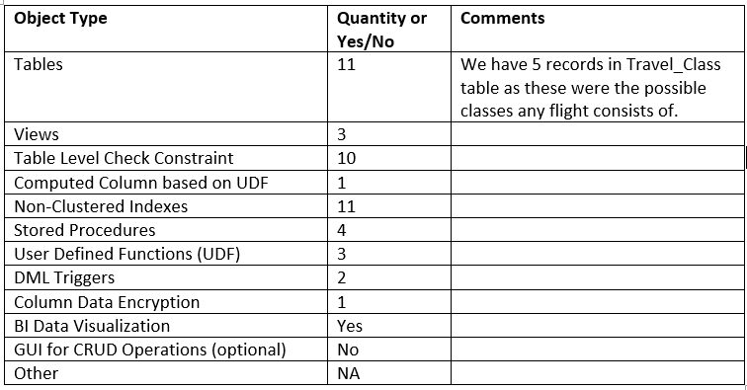

let’s look at the DDL script first.

**DDL:**

go  
Create Database FBS;  
go  
USE FBS  
--Create Airport table  
CREATE TABLE Airport  
(  
Airport_ID int not null,  
AirportName varchar(100),  
AirportCity varchar(100),  
AirportCountry varchar(100),  
CONSTRAINT Airport_PK PRIMARY KEY (Airport_ID)  
);  
  
  
-- create Passenger table   
-- new changes  
create table Passenger   
(  
Passenger_ID INT not null,  
P_FirstName VARCHAR(100),  
P_LastName VARCHAR(100),  
P_Email VARCHAR(100) CONSTRAINT email_check CHECK (P_Email LIKE '[a-z,0-9,_,-]%@[a-z]%.[a-z][a-z]%'),  
P_PhoneNumber BIGINT not null UNIQUE CONSTRAINT Ph_length_check CHECK (len([P_PhoneNumber])=10),  
P_Address VARCHAR(100),  
P_City VARCHAR(100),  
P_State VARCHAR(100),  
P_Zipcode VARCHAR(100) CONSTRAINT zip_chk CHECK (LEN(P_Zipcode)=5),  
P_Country VARCHAR(100)  
CONSTRAINT Passenger_ID_PK PRIMARY KEY (Passenger_ID)  
);  
  
-- create Travel class  
CREATE TABLE Travel_Class  
(  
 Travel_Class_ID INT NOT NULL,  
 Travel_Class_Name VARCHAR(100) CONSTRAINT name_list_chk CHECK (Travel_Class_Name IN('First Class','Business Class','Premium Economy','Economy Class','Basic Economy')),  
 Travel_Class_Capacity BIGINT,  
 CONSTRAINT Travel_Class_PK PRIMARY KEY (Travel_Class_ID)  
);  
  
-- create Calendar table  
CREATE TABLE Calendar  
(  
 Day_Date Date NOT NULL,  
 Business_Day_YN CHAR(1) Constraint check_character_Business_Day_YN Check(Business_Day_YN In ('Y','N')),  
 CONSTRAINT Calendar_PK PRIMARY KEY (Day_Date)  
);  
  
-- create Flight Service table  
create table Flight_Service  
(  
Service_ID INT not null,  
[Service_Name] VARCHAR(100) CONSTRAINT Service_chk CHECK([Service_Name] in ('Food','French Wine','Wifi','Entertainment','Lounge')),  
CONSTRAINT Flight_Service_PK PRIMARY KEY (Service_ID)  
);  
  
--ALTER TABLE Flight_Service ALTER [Service_Name] CONSTRAINT Service_chk CHECK([Service_Name] in ('Food','French Wine','Wifi','Entertainment','Lounge'));  
-- create Flight Details table  
CREATE TABLE Flight_Details (  
 Flight_ID INT NOT NULL,  
 Source_Airport_ID INT NOT NULL,  
 Destination_Airport_ID INT NOT NULL ,  
 Departure_Date_Time DateTime,-- CONSTRAINT date_check CHECK (Departure_Date_Time< Arrival_Date_Time),  
 Arrival_Date_time DateTime,  
 Airplane_Type VARCHAR(100) CONSTRAINT airplane_check CHECK(Airplane_Type IN ('Airbus A380','Boeing 747')),  
 CONSTRAINT Flight_Details_PK PRIMARY KEY (Flight_ID),  
 CONSTRAINT Flight_Details_Source_FK1 FOREIGN KEY (Source_Airport_ID) REFERENCES Airport(Airport_ID),  
 CONSTRAINT Flight_Details_Destination_FK2 FOREIGN KEY (Destination_Airport_ID) REFERENCES Airport(Airport_ID),  
 CONSTRAINT Date_check_FD CHECK (Departure_Date_Time< Arrival_Date_Time),  
 CONSTRAINT airport_chk CHECK (Source_Airport_ID != Destination_Airport_ID)  
 );  
  
 -- create Seat Details table  
 CREATE TABLE Seat_Details  
(  
 Seat_ID VARCHAR(100) NOT NULL,  
 Travel_Class_ID INT NOT NULL,   
 Flight_ID INT NOT NULL,  
 CONSTRAINT Seat_Details_PK PRIMARY KEY (Seat_ID),  
 CONSTRAINT Seat_Details_TravelClassID_FK1 FOREIGN KEY (Travel_Class_ID) REFERENCES Travel_Class(Travel_Class_ID),  
 CONSTRAINT Seat_Details_FlightID_FK2 FOREIGN KEY (Flight_ID) REFERENCES Flight_Details(Flight_ID)  
)  
  
-- create Reservation table   
 CREATE TABLE Reservation (  
 Reservation_ID INT NOT NULL,  
 Passenger_ID INT NOT NULL,  
 Seat_ID VARCHAR(100) NOT NULL,  
 --Default Value recorded below  
 Date_Of_Reservation Date DEFAULT(getDate()),  
 CONSTRAINT Reservation_PK PRIMARY KEY (Reservation_ID),  
 CONSTRAINT Reservation_Passenger_ID_FK1 FOREIGN KEY (Passenger_ID) REFERENCES Passenger(Passenger_ID),  
 CONSTRAINT Reservation_Seat_ID_FK2 FOREIGN KEY (Seat_ID) REFERENCES Seat_Details(Seat_ID)  
 );  
  
 -- create Payment Status table  
 --add table again  
 CREATE TABLE Payment_Status (  
 Payment_ID INT NOT NULL IDENTITY(1,1),  
 Payment_Status_YN CHAR(1) Constraint check_character_Payment_Status_YN Check(Payment_Status_YN In ('Y','N')),  
 Payment_Due_Date Date,  
 Payment_Amount INT,  
 Reservation_ID INT NOT NULL,  
 CONSTRAINT Payment_Status_PK PRIMARY KEY (Payment_ID),  
 CONSTRAINT Payment_Reservation_ID_FK FOREIGN KEY (Reservation_ID) REFERENCES Reservation(Reservation_ID)  
 );  
  
--create Flight cost table   
CREATE TABLE Flight_Cost  
(   
 Seat_ID VARCHAR(100) NOT NULL,  
 Valid_From_Date Date NOT NULL,  
 Valid_To_Date Date NOT NULL,  
 Cost BIGINT,  
 CONSTRAINT Flight_Cost_PK PRIMARY KEY (Seat_ID,Valid_From_Date),  
 CONSTRAINT Flight_Cost_Seat_ID_FK1 FOREIGN KEY (Seat_ID) REFERENCES Seat_Details(Seat_ID),  
 CONSTRAINT Flight_Cost_Valid_From_Date_FK2 FOREIGN KEY (Valid_From_Date) REFERENCES Calendar(Day_Date),  
 CONSTRAINT Flight_Cost_Valid_To_Date_FK3 FOREIGN KEY (Valid_To_Date) REFERENCES Calendar(Day_Date)  
);  
  
--create Service offering table   
CREATE TABLE Service_Offering  
(  
 Travel_Class_ID INT NOT NULL,  
 Service_ID int NOT NULL,  
 Offered_YN CHAR(1) Constraint check_character_Offered_YN Check(Offered_YN In ('Y','N')),  
 From_Month VARCHAR(20),  
 To_Month VARCHAR(20),  
 CONSTRAINT Service_Offering_TCI_FK1 FOREIGN KEY (Travel_Class_ID) REFERENCES Travel_Class(Travel_Class_ID),  
 CONSTRAINT Service_Offering_SID_FK2 FOREIGN KEY (Service_ID) REFERENCES Flight_Service(Service_ID),  
 CONSTRAINT Service_Offering_PK PRIMARY KEY (Travel_Class_ID,Service_ID)  
);  
  
--Creating indexes for all primary keys  
CREATE UNIQUE INDEX SO_Index ON Service_Offering(Travel_Class_ID,Service_ID);  
CREATE UNIQUE INDEX FC_Index ON Flight_Cost(Seat_ID,Valid_From_Date);  
CREATE UNIQUE INDEX PS_Index ON Payment_Status(Payment_ID);  
CREATE UNIQUE INDEX R_Index ON Reservation(Reservation_ID);  
CREATE UNIQUE INDEX SD_Index ON Seat_Details(Seat_ID);  
CREATE UNIQUE INDEX FD_Index ON Flight_Details(Flight_ID);  
CREATE UNIQUE INDEX FS_Index ON Flight_Service(Service_ID);  
CREATE UNIQUE INDEX Cal_Index ON Calendar(Day_Date);  
CREATE UNIQUE INDEX T_Index ON Travel_Class(Travel_Class_ID);  
CREATE UNIQUE INDEX Pass_Index ON Passenger(Passenger_ID);  
CREATE UNIQUE INDEX Air_Index ON Airport(Airport_ID);  
  
--Creating non clustered index  
USE P4_FBS  
CREATE NONCLUSTERED INDEX email_indx ON Passenger(P_Email);  
CREATE NONCLUSTERED INDEX dep_indx ON Flight_Details(Departure_Date_Time);  
CREATE NONCLUSTERED INDEX city_indx ON Airport(AirportCity);  
go  
sp_helpindex Airport  
go  
sp_helpindex Passenger  
go  
sp_helpindex Flight_Details

Let us setup triggers and necessary functions to auto insert data and calculate flight costs based on the dates

go  
USE FBS  
go  
CREATE TRIGGER Payment_Insert ON Reservation  
--MAKE IDENTITY FOR PAYMENT ID  
  
FOR INSERT  
AS  
BEGIN  
 DECLARE @ResId int  
 DECLARE @Res_date DATE  
 DECLARE @due_date DATE  
 DECLARE @Cost bigint  
 DEClARE @seat VARCHAR(20)   
 SELECT @ResId = Reservation_ID FROM inserted  
 SELECT @Res_date = Date_Of_Reservation FROM inserted  
 SELECT @seat= Reservation.Seat_ID FROM Reservation WHERE Reservation_ID=@ResId  
 SELECT @Cost=Cost FROM Flight_Cost WHERE Flight_Cost.Seat_ID=@seat AND Flight_Cost.Valid_From_Date=@Res_date  
 SELECT @due_date=DATEADD(DAY,1,@Res_date)  
 INSERT INTO Payment_Status(Payment_Status_YN,Payment_Due_Date,Payment_Amount,Reservation_ID)  
 VALUES ('N',@due_date,@Cost,@ResId);  
  
  
END  
  
  
  
--UDF  
--OUR UDF WILL TAKE BUSINESS DAY,Departure Date,Travel cLASS id,Deafult price  
go  
CREATE FUNCTION Cal_Cost(@Start_Date date,@dep_date date,@travel_id int,@business char(1))  
RETURNS BIGINT  
AS  
BEGIN  
 DECLARE @Diff int  
 Select @Diff=DateDIFF(day,@Start_Date,@dep_date)  
 RETURN 100+((Select  
 CASE  
 WHEN @business='Y' THEN 10  
 ELSE 0  
 END As Business_Inc)+  
 (Select  
 CASE   
 WHEN @travel_id=1 THEN 50  
 WHEN @travel_id=2 THEN 40  
 WHEN @travel_id=3 THEN 30  
 WHEN @travel_id=4 THEN 20  
 ELSE 10  
 END As Class_Inc)+  
 (Select  
 CASE   
 WHEN @Diff>20 AND @Diff<=30 THEN 0  
 WHEN @Diff>10 AND @Diff<=20 THEN 20  
 ELSE 50  
 END AS Interval_Inc  
 ))  
   
   
END  
  
  
--function body end  
  
GO  
CREATE TRIGGER Set_Cost ON Seat_Details  
FOR INSERT  
AS  
BEGIN  
 Declare @Default_price BIGINT  
 Set @Default_price=100  
 DECLARE @Start_date date  
 DECLARE @Final_Cost BIGINT  
 Declare @business char(1)  
 --Declare @default_price bigint  
 Declare @flight_cost bigint  
 DECLARE @dep_date date  
 --set @default_price=100  
 Declare @S_id varchar(20)  
 SELECT @S_id = Seat_ID FROM inserted  
 Declare @travel_id int  
 SELECT @travel_id= Travel_Class_ID FROM inserted  
 DECLARE @flight_id int  
 SELECT @flight_id=Flight_ID FROM inserted  
   
 Select @business=Business_Day_YN FROM Calendar  
 WHERE Day_Date=  
 (SELECT CONVERT(Date,Departure_Date_Time)   
 FROM Flight_Details WHERE Flight_ID=@flight_id  
 )-- from Flight_Details where Flight_ID=@flight_id  
 SELECT @dep_date=CONVERT(Date,Departure_Date_Time)   
 FROM Flight_Details WHERE Flight_ID=@flight_id  
  
 SELECT @Start_date=DATEADD(MONTH,-1,@dep_date)  
 DECLARE @last_date date  
 SELECT @last_date=DateADD(day,-1,@dep_date)  
-- WHILE LOOP  
   
 WHILE @Start_date < @last_date  
 BEGIN  
  
 SELECT @Final_Cost=[dbo].[Cal_Cost](@Start_date,@dep_date,@travel_id,@business)  
 DECLARE @valid_to date  
 SET @valid_to= DATEADD(Day,1,@Start_date)  
 INSERT INTO Flight_Cost(Seat_ID,Valid_From_Date,Cost,Valid_To_Date)  
 VALUES(@S_id,@Start_date,@Final_Cost,@valid_to)  
 SET @Start_date = DATEADD(Day,1,@Start_date)  
 END  
  
END

Implementing Stored Procedures to improve functionality of our database and make it easier for developers to access the database and make any changes

USE FBS  
--procedure 1  
Go  
CREATE PROCEDURE Flight_Availability  
@Departure_Date date,  
@Arrival_Date date,  
@available char(1) OUTPUT  
  
AS  
IF EXISTS(SELECT Flight_ID FROM Flight_Details  
 WHERE CONVERT(Date,Departure_Date_time) = @Departure_Date  
 AND CONVERT(Date,Arrival_Date_time) = @Arrival_Date   
)  
  
BEGIN  
 SET @available='Y'   
 SELECT * FROM Flight_Details  
 WHERE CONVERT(Date,Departure_Date_time) = @Departure_Date  
 AND CONVERT(Date,Arrival_Date_time) = @Arrival_Date  
   
END  
ELSE  
BEGIN  
  
Print 'Flight Detail Doesnt exist'  
end  
  
  
  
  
  
  
  
  
--PROCEDURE 2  
  
Go  
CREATE PROCEDURE [dbo].[UpdateFlightDetails]   
@flag bit output,-- return 0 for fail,1 for success  
@FlightID INT,  
@DeptDateTime DATETIME,  
@ArivalDateTime DATETIME,  
@AirplaneType VARCHAR(100)  
AS  
BEGIN  
 Update Flight_Details set Departure_Date_Time = @DeptDateTime,  
 Arrival_Date_time = @ArivalDateTime,  
 Airplane_Type = @AirplaneType  
 Where Flight_ID = @FlightID   
 set @flag=1;  
   
END  
  
  
  
 --Procedure 3  
  
 Go  
 CREATE PROCEDURE [dbo].[PassengerCRUD]   
 @Action VARCHAR(10),   
 @Passenger_ID int = NULL,   
 @FName VARCHAR(100) = NULL,   
 @LName VARCHAR(100) = NULL,   
 @Email VARCHAR(100) = NULL,  
 @PNumber BIGINT = NULL,   
 @Address VARCHAR(100) = NULL,  
 @city VARCHAR(100) = NULL,   
 @State VARCHAR(100) = NULL,   
 @Zipcode VARCHAR(100) = NULL,   
 @Country VARCHAR(100) = NULL  
  
AS  
BEGIN  
 SET NOCOUNT ON;  
   
 --SELECT  
 IF @Action = 'SELECT'  
 BEGIN  
 SELECT Passenger_ID, P_FirstName,P_LastName,P_Email,P_PhoneNumber,P_Address,P_City,  
 P_State,P_Zipcode,P_Country  
 FROM Passenger  
 END  
   
 --INSERT  
 IF @Action = 'INSERT'  
 BEGIN  
 INSERT INTO dbo.Passenger([Passenger_ID], [P_FirstName],[P_LastName],[P_Email],[P_PhoneNumber],[P_Address],[P_City],  
 [P_State],[P_Zipcode],[P_Country] )  
  
 VALUES (@Passenger_ID, @FName, @LName, @Email, @PNumber, @Address, @city, @State, @Zipcode, @Country)  
 END  
   
 --UPDATE  
 IF @Action = 'UPDATE'  
 BEGIN  
 UPDATE Passenger  
 SET Passenger_ID = @Passenger_ID, P_FirstName = @FName, P_LastName = @LName, P_Email= @Email, P_PhoneNumber = @PNumber,   
 P_Address = @Address, P_City = @city, P_State = @State, P_Zipcode = @Zipcode, P_Country = @Country  
 WHERE Passenger_ID = @Passenger_ID  
 END  
   
 --DELETE  
 IF @Action = 'DELETE'  
 BEGIN  
 DELETE FROM Passenger  
 WHERE Passenger_ID = @Passenger_ID  
 END  
END  
  
  
  
--Procedure 4  
GO  
CREATE PROCEDURE UpdatePayment   
 @paymentID INT,@paid_date date OUTPUT  
AS  
 BEGIN  
 Update Payment_Status  
 SET Payment_Status_YN='Y' WHERE Payment_ID=@paymentID  
 SELECT @paid_date=GETDATE()  
   
END

Finally insert valid data using DML to manipulate and get insights

**Execution:**

The right way to set this up is by running DDL,Trigger Script,Stored Procedures and finally your DML script.

**Visualization:**

Finally, with my inserted data I have used Tableau to visualize and infer certain insights

