<https://medium.com/javarevisited/20-binary-tree-algorithms-problems-from-coding-interviews-c5e5a384df30>

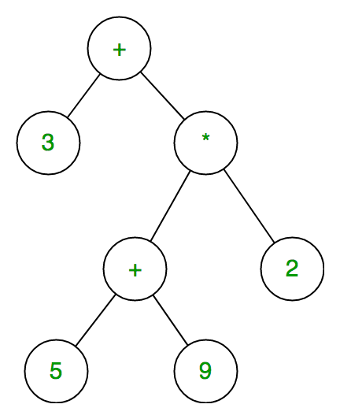

* 2 maim ways of tree(or graph)
* BFS ( Breadth-first-search)
* DFS(Depth-first -search)
* Amoung DFS , 2 main ways of three traversal.
  + Left-node-right(In-order traversal)
  + Left-right-node(Post order traversal
  + Node-left-right(Pre-order traversal)

BFS used fro graph path problems

So we use DFS , pre-order traversal.

Uses a stack implementation

Runtime Complexity – O(n)🡪we traverse each node only once (N is the number of the tree nodes)

Space complexity of DFS is O(h) 🡪 h is he maximum height of the tree.