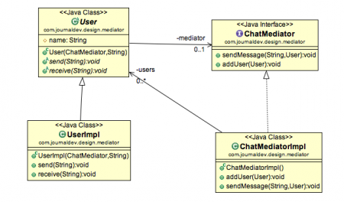

**Mediator Design Pattern Important Points**

* Mediator pattern is useful when the communication logic between objects is complex, we can have a central point of communication that takes care of communication logic.
* Java Message Service (JMS) uses Mediator pattern along with [**Observer pattern**](https://www.journaldev.com/1739/observer-design-pattern-in-java) to allow applications to subscribe and publish data to other applications.
* We should not use mediator pattern just to achieve lose-coupling because if the number of mediators will grow, then it will become hard to maintain them.