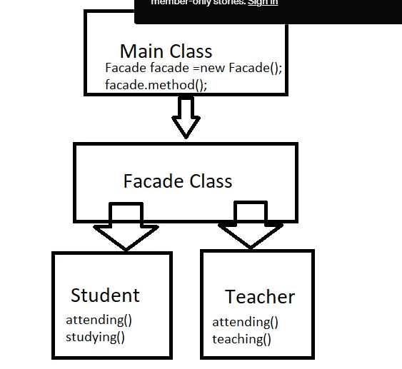

|  |
| --- |
| package designpatterns.facade; |
|  |  |
|  | interface Attend{ |
|  | void attending(); |
|  | } |
|  | class Student implements Attend{ |
|  | @Override |
|  | public void attending(){ |
|  | System.out.println("I am attending school..."); |
|  | } |
|  | public void studying(){ |
|  | System.out.println("I am studying...."); |
|  | } |
|  |  |
|  | } |
|  | class Teacher implements Attend{ |
|  | @Override |
|  | public void attending(){ |
|  | System.out.println("I am attending school..."); |
|  | } |
|  | public void teaching(){ |
|  | System.out.println("I am teaching..."); |
|  | } |
|  | } |
|  |  |
|  | //Facade Class start here |
|  | class Facade{ |
|  |  |
|  | Student student; |
|  | Teacher teacher; |
|  |  |
|  | public Facade(){ |
|  | student = new Student(); |
|  | teacher = new Teacher(); |
|  | } |
|  |  |
|  | public void teaching(){ |
|  | teacher.attending(); |
|  | teacher.teaching(); |
|  | } |
|  | public void studying(){ |
|  | student.attending(); |
|  | student.studying(); |
|  | } |
|  |  |
|  | } |
|  |  |
|  | /** |
|  | * |
|  | * @author Kasun Dissanayake |
|  | */ |
|  | public class Example1 { |
|  |  |
|  | public static void main(String[] args) { |
|  | Facade facade = new Facade(); |
|  | facade.teaching(); |
|  | facade.studying(); |
|  | } |
|  | } |