Best way to implement LRU is doubly linked list and hashmap

Time complexity – O(1) and space complexity O (n)

* Cache supports get(key) and put(key,value) operations toretrieve and insert .
* If cache is full , operaton put() first removes the entry which is LRU , then it will insert a new entry.

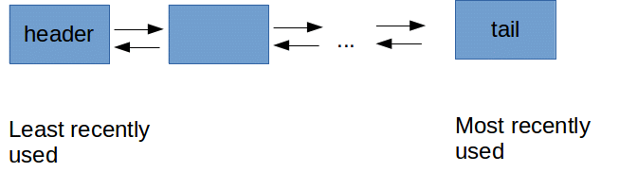

* Track the recently used entries
* Track the entries which are not used long time
* We need to make the insertion , retrieval operation fast.

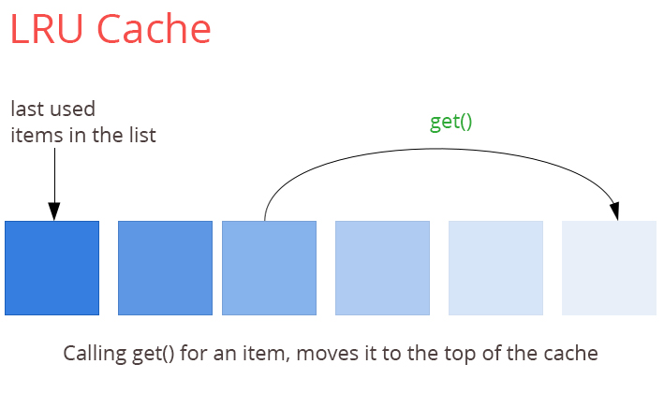

Hashmap provides O(1) for lookup and insertion as well.

Doubly linked list to track the recently used entries.

Doubly linked list will hold the value of key and hashmap will hold the address and key of the nodes of the list.

