Visitor Pattern

<https://www.javagists.com/java-visitor-design-pattern>

* Behavioural Pattern
* This pattern is used when object structure contains different kinds of operation to use in different situations.
* Allows to define a new operation without changing the classes of elements on which it operates.
* It adheres to open /closed principle.

Allows the developer to define new operations without modifying the classes on which it operates

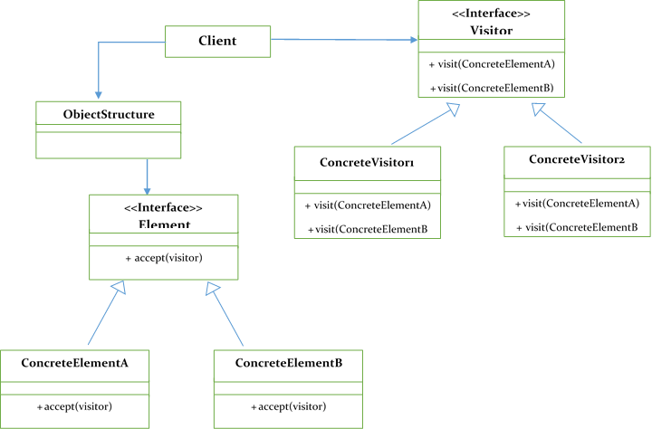

Components of Visitor Pattern

Visitor :

* + Interface or Abstract Class
  + Has bunch of visiting methods that accepts various concrete components as parameters – Overloading mechanisam

