Docker interview questions

https://www.guru99.com/docker-interview-questions.html

1. What is docker?

* Opensource lightweight containerization
* Helps to automate the deployment of applications in lightweight and portable containers.

1. Why docker? Advantages

* Easy and efficient initial setup
* Simple configuration and interacts with docker-compose.

1. Features of docker?

* Easy Modeling
* Version control
* Developers’ productivity
* Operational efficiencies.

1. Drawbacks?

* Doesn’t provide storage
* Poor monitoring option
* No automated re-scheduling

1. Docker image? How to create?

* It helps to create docker containers.
* Every docker image is stored in docker registry.

Download docker Engine

* Start the docker engine
* Create a container on OS
* Create a docker file – Dockerfile
* Create a docker file as mentioned in the <https://hub.docker.com/openjdk> (official release)
* Created shortname for project in pom.xml (<finalName>docker-spring-boot)

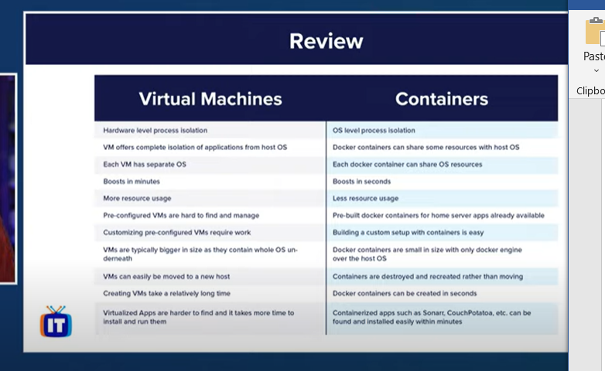

2. What is docker ?

-