**1. Add Description (with Emojis & Link)**

This is the **lowest hanging fruit** in creating an impressive **GitHub repository**. You can just add a short description of the **repository** to heighten its appeal. Make sure to throw in some **emojis** too 😉.

You also get **extra brownie points** 🎂 for adding **relevant links** too!

You can update the **description** and the **link** from the top right **settings icon**

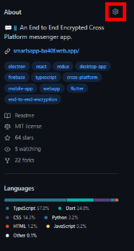

**2. Add Tags**

Adding **tags** is the next and most crucial step in this article. It not only makes it easier for **GitHub** to promote the **repository** but also makes it **look much more professional**!

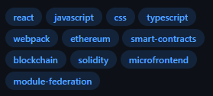

**Tag** related settings are also available in the **repository configuration** shown in the previous step

**3. Add License**

No point denying it, this is the most boring step, but essential for **fair use of the repository**. Moreover, it also shows up in the info tab, so just get it done with.



To add a **License**, create a file called LICENSE at the **root of the project**

**4. Add Readme**

The **ReadMe** is the first thing a visitor sees when they visit the **repository**, so taking some time to create a polished **repository** is crucial. It should describe **what problem the code solves**, **how to set it up**, and any **other relevant information**.

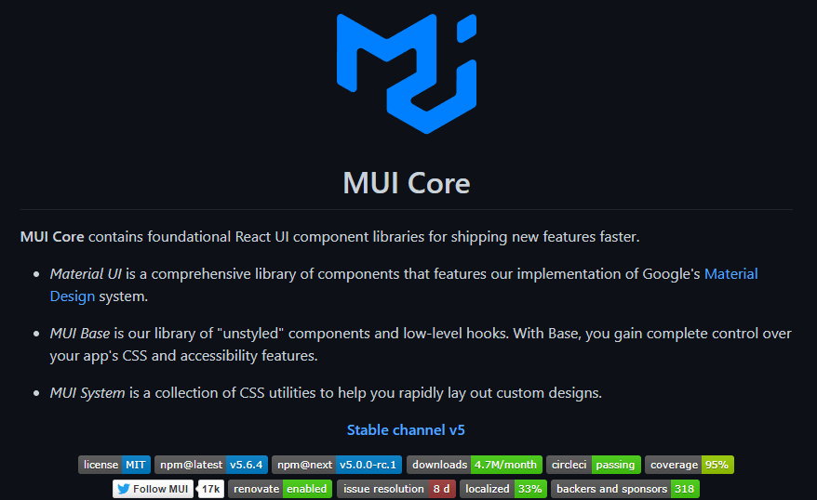

There is always some way to make the **ReadMe** engaging. Even if you don’t have much to write about the **repository** itself. Take the example of a **repository** containing **coding problem solutions**. You can easily **list out the problems** in the **ReadMe** and **link to the solutions**.

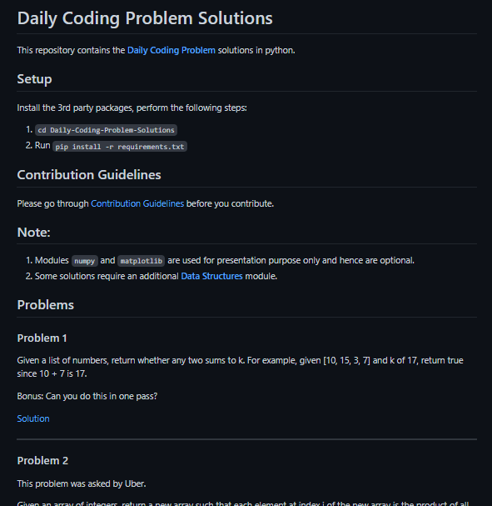

To add a **ReadMe**, create a ReadMe.md file at the **root of the project**.

**5. Use Descriptive Commit Messages**

Using descriptive **commit messages** might look like a chore, but it too helps in taking the appeal of the repository higher. Make sure the **commit message** is explanatory.

There are various schools of **commit message** structures, any of which is acceptable. I personally like the following one:

<type>[optional scope]: <description>

If you want to dive deeper into how it is structured, check out [this article](https://www.conventionalcommits.org/en/v1.0.0-beta.2/)

**6. BONUS: Use Multiple Languages**

Using **multiple languages** in your repository is a great way to grab the user’s attention, but this is highly context-dependent. You should **NOT** use **multiple languages** only to increase the appeal, but only if it is required.

Even if you falter in this department, as long as you implement the other tricks, **you are completely covered**!