* Declare class as final
  + Other classes cannot extend it or modify the behaviour
* Declare all instance variables as final
  + To prevent from being modified once thry are initialized.
* Do not provide setter methods
* Initialize all instance variables in the constructor
* Do not allow subclasses to override methods

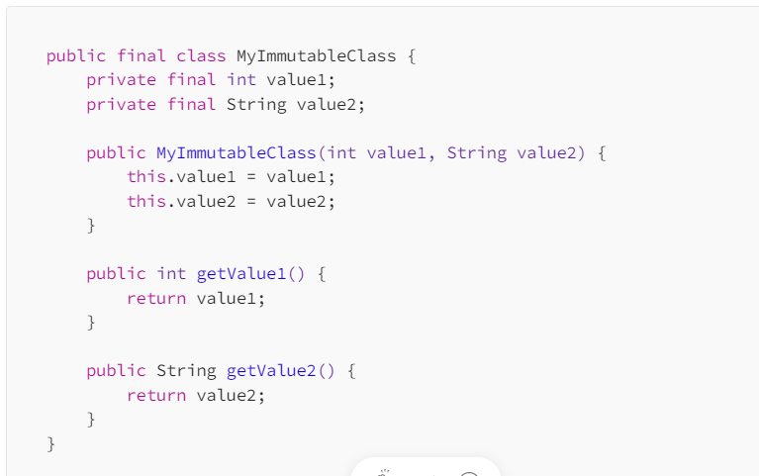

Built-in immutable classes in java

1. String – It represents sequence of character and is one of the most commonly used class in java.Once String object is created its content cannot be modified.
2. Integer,Long,Double ,Float,Short,Byte and Character: Primitive data types and also immutable.
3. BigDecimal and BigInteger : Used for performing arthicmatic operations on large numbers also immutable
4. LocalDate ,LocalTime,LocalDateTime and Instant :They are prt of java.time.time package introduced in java 8.
5. Java.util.optional : This class is used to represent a value that may or may not b present .

Immutable classes have several benefits

* Thread safety
* Write high quality , bug free code .

Create immutable Map in Java

* Use Collections .unmodifiableMap()
* If we try to modify immutable Map then unsupportedOperationException.