**Runtime polymorphism (function overriding):**

It is also called as dynamic polymorphism or function overriding.

Function having same name with exactly same number and sequence of parameters defined in both parent and child class is called as function overriding.

Process where call to overridden method will get resolves only at dynamic or run time.

**Function overriding Rules:**

1. Method name must be same in both parent and child class.
2. Method should have same number and sequence of parameter.
3. There must be an IS-A relationship (inheritance).

**Example:**

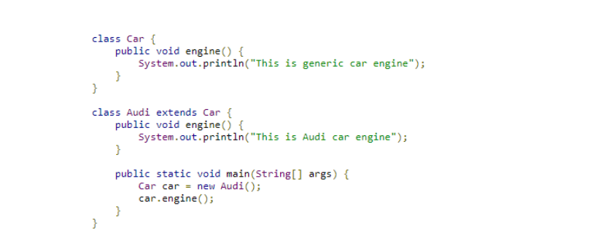

**OUTPUT:**

This is Audi car engine