User-defined Exceptions are implemented and used for both checked and unchecked exceptions

Why we need custom exceptions:

* Java Exception to cover almost all exceptions that are bound to happen in programming.
* Business logic exceptions. Helps the application users or the developers to understand the exact problem is.
* To catch and provide specific treatment to the existing java exceptions.

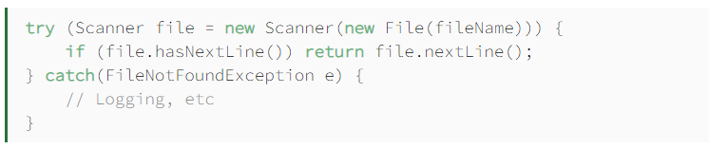

* Classic way of handling Java checked exception.
* We don’t know whether the exception is because oof file doesn’t exist or the filename is invalid.

For custom exceptions, we need to extend *java.lang.exception* class

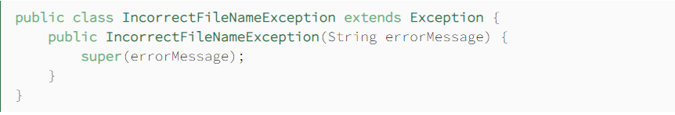

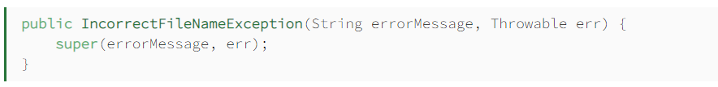

We need to pass the root exception to the method call.

* For unchecked exception, we need to extend the *java.lang.RuntimeException* class

