Java pplication running a lot of resources

* Includes memory
* Network bandwidth
* No. of cycles

Minimizing the number of resources used by it called java performance tuning.

* Garbage collector does not remove the unused object present in heap memory resulting in poor performance of application.

1. Use Profiler
   * For checking each and every part of byte code
   * To determine inefficient part of code
   * Net beans profiler,Java Visual VM
2. Write less code
3. Premature optimization
4. Write efficient algorithms
   * Instead of using array , use hashmapt o increase efficiency.
5. Java heap
   * Java heap space sjpuld be expanded just up to ½ of the server total random access memory. If more then results in performance issues.
6. Tuning garbage collection
   * Keep an eye on outliers along the average time taken for transaction .
7. For concatenating string avoid using + operator . Use StringBuilder for string concatenation
8. Use primitives instead of Objects
   * Primitives are stored in stack and objects store in heap
   * Use primitives instead of Wrapper class
9. Accessing collection should require as few method as possible

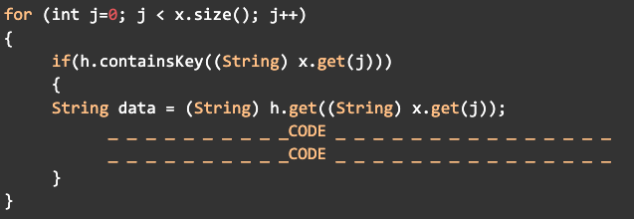

Best way

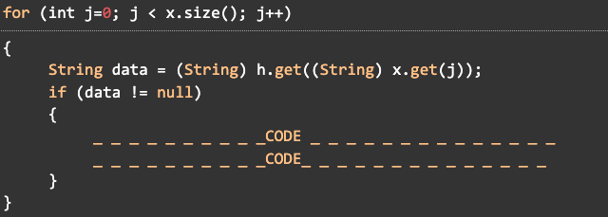

1. Be care ful in using synchronization