Sure. Shenandoah GC is a low-pause garbage collector (GC) that is designed to reduce the amount of time that an application spends in GC pauses. It does this by performing more of the GC work concurrently with the running application.

[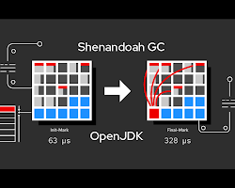Opens in a new window[](https://developers.redhat.com/articles/2021/09/16/shenandoah-openjdk-17-sub-millisecond-gc-pauses)developers.redhat.com](https://developers.redhat.com/articles/2021/09/16/shenandoah-openjdk-17-sub-millisecond-gc-pauses)

Shenandoah GC diagram

Shenandoah is a regionalized collector, which means that it divides the heap into a set of regions. The GC then works on these regions one at a time. This allows Shenandoah to perform compaction of the heap concurrently with the running application, which further reduces pause times.

Shenandoah is still under development, but it has been shown to be effective in reducing pause times for a variety of applications. It is currently available in OpenJDK 11 and later.

Here are some of the key features of Shenandoah GC:

* Low pause times: Shenandoah is designed to minimize the amount of time that an application spends in GC pauses.
* Concurrent compaction: Shenandoah can compact the heap concurrently with the running application, which further reduces pause times.
* Regionalized collector: Shenandoah divides the heap into a set of regions, which makes it easier to manage and compact the heap.
* Experimental: Shenandoah is still under development, but it has been shown to be effective in reducing pause times for a variety of applications.

If you are looking for a GC that can provide low pause times for your application, then Shenandoah is a good option to consider. However, it is important to note that Shenandoah is still under development, so there may be some stability issues.