* UI for complex CRM (Customer Relationship Management)
* To populate different portions – invoke dozens of microservices
* Network location of microservice changes and tend to happen frequently.
* Support – monitoring, authentication,security and CORS.
* UI will send request ot gateway and in turn gateway will forward the request to relevant microservices.
* Auth and Security : rejecting request that do not satisfy them
* Monitoring : Tracking meaningful date and statistics .
* Dynamically routing request to different backend clusters
* Stress Testi – increase the traffic to cluster to gauge performance.
* Load Shedding : allocating capacity for each type of request and dropping request that go over the limit.

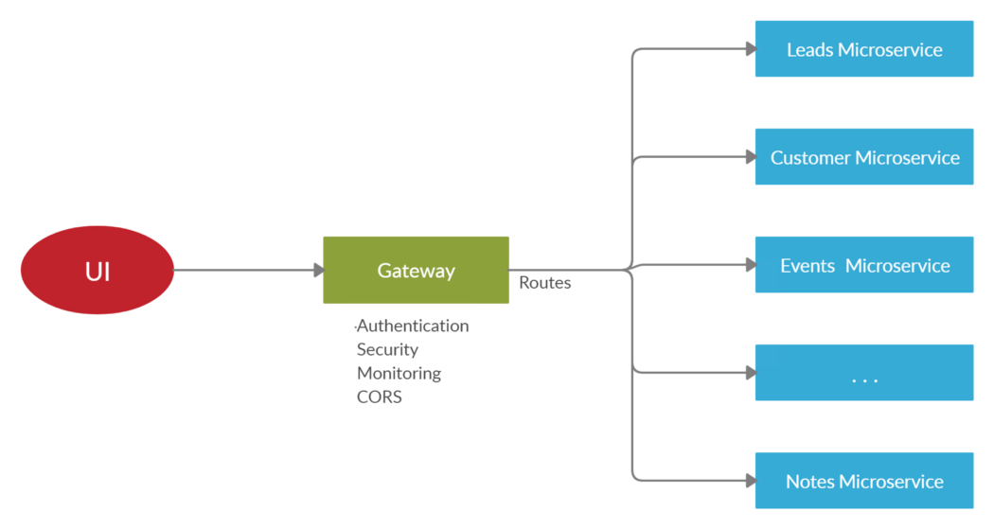

Filters of 4 types

* Pre – filters run before the request is routed.
* Route – handle the actual routing of the request
* Post – filters run after request has been routed
* Error – runs if error occurs in course of handling the request .

Eureka :

Interacts with Eureka for Network location.

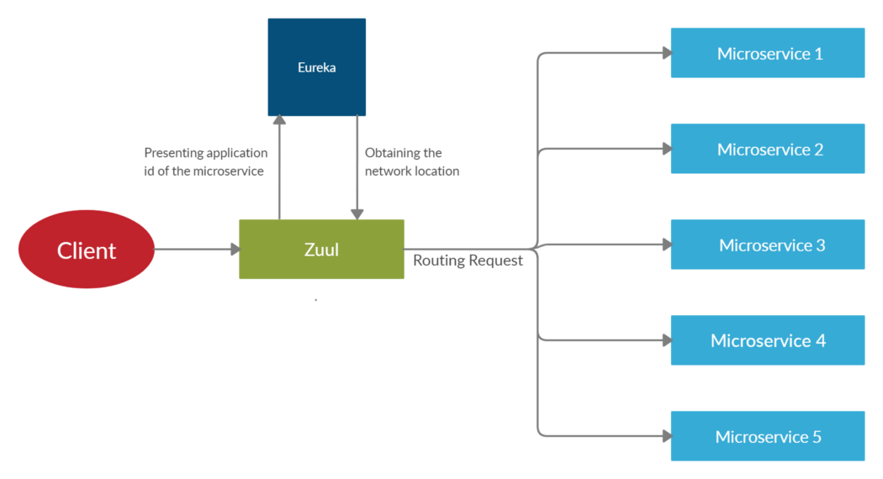

Eureka client :

eureka.client.register-with-eureka = false

Eureka Server :

eureka.client.fetch-registry = false

Extend Zuul Filter Clss

* Should filter
* Filtertype
* Filter order