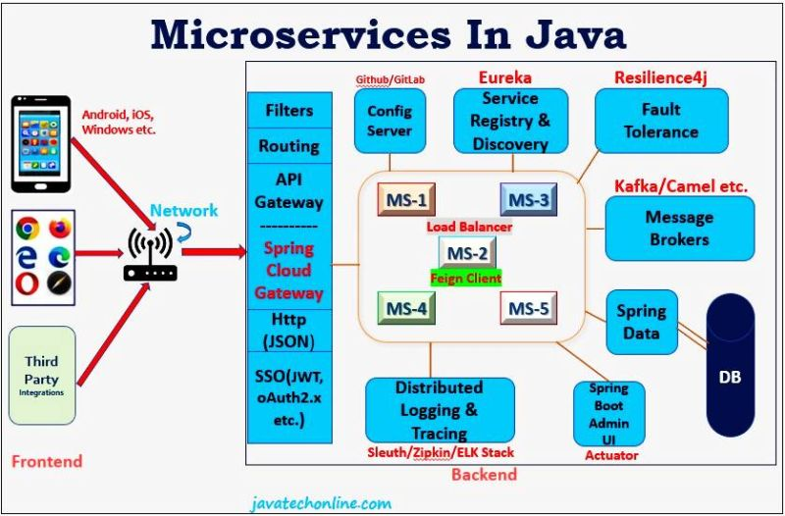

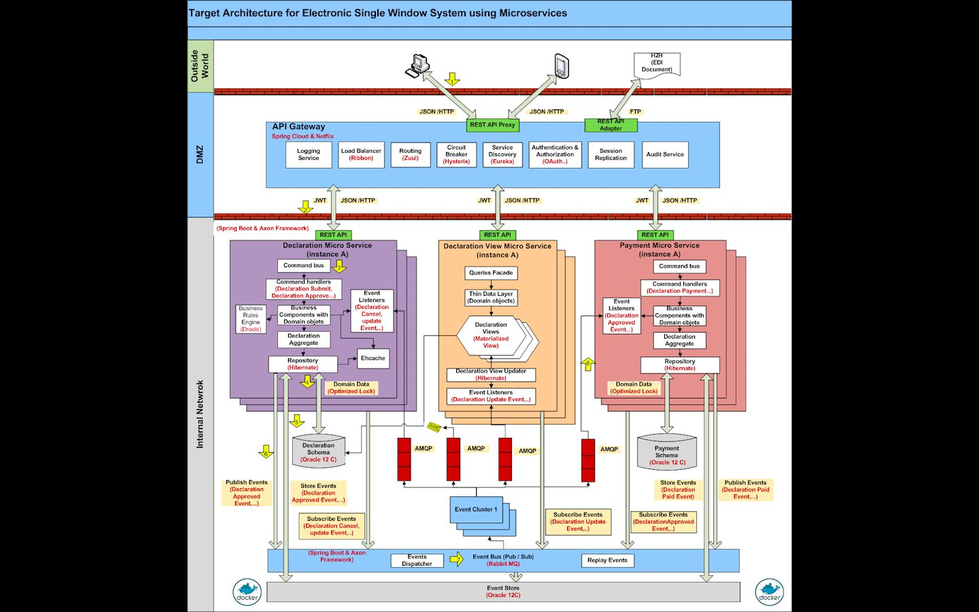

10 Microservices Patterns and Principles to learn

1. Database per Microservice
2. Event Sourcing
3. CQRS
4. Saga
5. BFF
6. API Gateway
7. Strangler
8. Circuit Breaker
9. Externalized Configuration
10. Consumer -driven Contract Tracing