The BFF pattern focuses on optimizing the communication between microservices and the frontend

In a [Microservices architecture](https://medium.com/javarevisited/difference-between-microservices-and-monolithic-architecture-for-java-interviews-af525908c2d5), the BFF pattern is used to decouple the frontend and backend components, allowing for independent development, scalability, and flexibility. The **BFF acts as an intermediary between the frontend and the backend microservices**, providing a layer of abstraction that enables the frontend to interact with the backend in a more efficient and targeted manner.

The BFF pattern typically involves the following characteristics:

1. **Tailored APIs**The BFF is *designed to expose APIs* that are optimized for the specific needs of the frontend application or client. This may include aggregating data from multiple microservices, formatting data in a specific way, or providing a simplified and streamlined API for the frontend to consume.
2. **Aggregation and composition**The BFF *may aggregate or compose data from multiple backend microservices to fulfill the requirements of the frontend.* This can help reduce the number of API calls made by the frontend and minimize the amount of data transmitted over the network.
3. **Performance optimization**The BFF may *optimize data retrieval mechanisms, caching, and other performance-related aspects* to ensure optimal performance for the frontend application. This may involve caching frequently used data, optimizing queries, or pre-processing data to reduce processing overhead on the frontend.
4. **Security and authentication**The*BFF can handle security and authentication-related concerns*, such as authentication and authorization of requests from the frontend, and ensure that only authorized requests are forwarded to the backend microservices.
5. **Frontend-specific functionality**  
   The BFF can also provide frontend-specific functionality that is not part of the core backend microservices, such as handling UI-related logic, user session management, or other frontend-specific concerns.

Here is a nice diagram which shows BFF design Pattern in Microservices architecture in action:

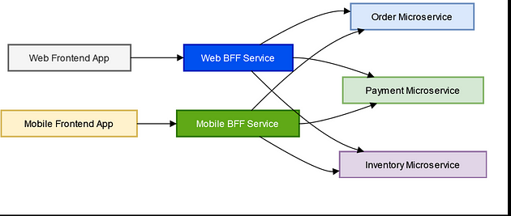

In this architecture, both the Web Frontend App and Mobile Frontend App communicate with their respective dedicated BFF Services, which act as intermediaries between the frontends and backend microservices.

The BFF Service for the Web Frontend App (BFF Service (Web)) and the BFF Service for the Mobile Frontend App (BFF Service (Mobile)) may have different implementations optimized for the specific requirements of each frontend platform. Both BFF Services may aggregate data from the same set of backend microservices (Order, Payment, and Inventory Microservices)

In short, the BFF pattern allows for a more fine-grained control and customization of the backend services for different frontend applications, enabling improved performance, flexibility, and maintainability. However, it also requires careful coordination and management to ensure consistency, scalability, and security across the microservices ecosystem.