Purpose :

* Can design flexible and modular systems that respond to events and trigger appropriate actions.
* Communications ( system notification , data updates and interactions )
* 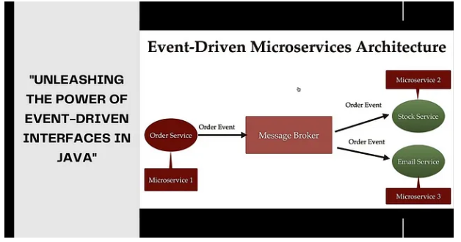
* Event driven interfaces focus on events and event handlers .
* Defining events , handler interfaces, registering listenersand utilizing mechanisam like event dispatchers.

OrderPlacedEvent

* 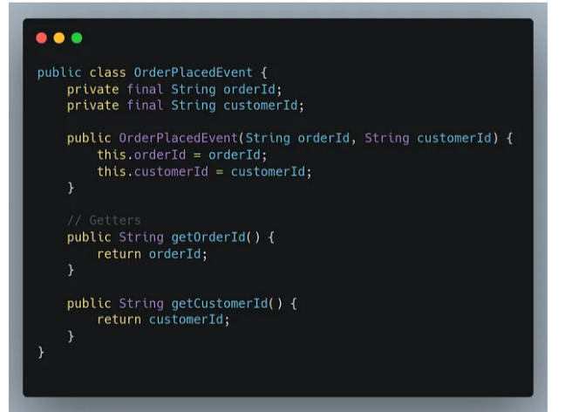
* 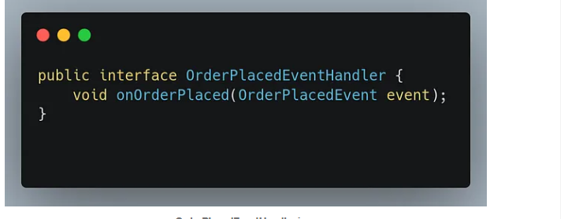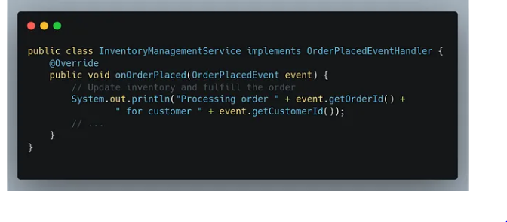
* 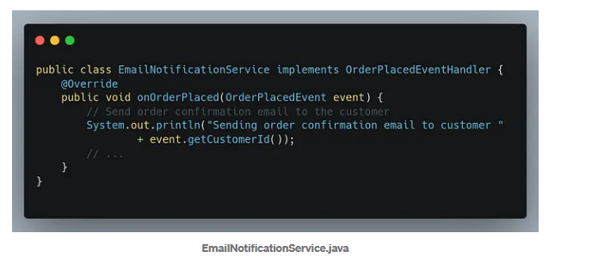
* ***EventDispatcher***
* *The EventDispatcher class acts as a central component responsible for dispatching events to the appropriate event handlers. It maintains a mapping of event types to their corresponding event handlers. The registerEventHandler method allows registering an event handler for a specific event type, and the dispatchEvent method triggers the dispatching of an event. It looks up the event handlers based on the event type and invokes the corresponding onOrderPlaced method on each registered event handler.*
* 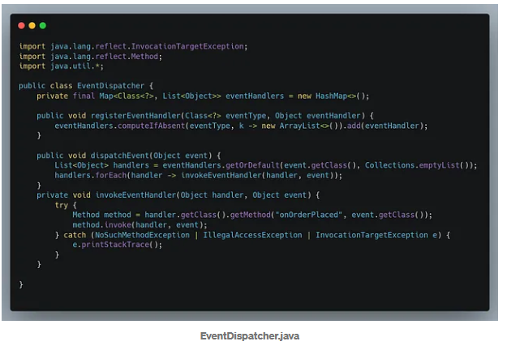

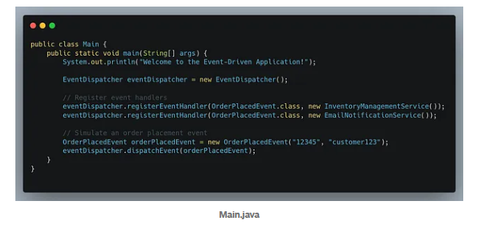

Benefits

Loose Coupling and modularity

* Eaier maintenance

Simplified System manintenance

* Events like MessageSentEvent
* NotofocationReceivedEvent
* ProfileUdatedEvent

Distributed system and asnc processing

* Enable scalability and fault tolerance in distributed environemnts