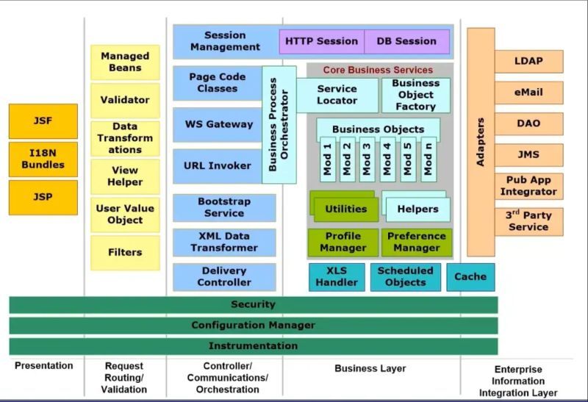

𝐁𝐫𝐢𝐞𝐟 𝐰𝐨𝐫𝐤𝐢𝐧𝐠 𝐨𝐟 𝐌𝐨𝐧𝐨𝐥𝐢𝐭𝐡𝐢𝐜 𝐀𝐫𝐜𝐡𝐢𝐭𝐞𝐜𝐭𝐮𝐫𝐞.  
  
Firstly we have a 𝐏𝐫𝐞𝐬𝐞𝐧𝐭𝐚𝐭𝐢𝐨𝐧 𝐥𝐚𝐲𝐞𝐫 (which deals with UI and all static pages) ➡️ 𝐑𝐞𝐪𝐮𝐞𝐬𝐭 𝐫𝐨𝐮𝐭𝐢𝐧𝐠/𝐯𝐚𝐥𝐢𝐝𝐚𝐭𝐢𝐨𝐧 𝐥𝐚𝐲𝐞𝐫 (which intercepts all the incoming requests and ensures hashmap transformation and many more) ➡️ 𝐂𝐨𝐧𝐭𝐫𝐨𝐥𝐥𝐞𝐫/𝐂𝐨𝐦𝐦𝐮𝐧𝐢𝐜𝐚𝐭𝐢𝐨𝐧𝐬/𝐎𝐫𝐜𝐡𝐞𝐬𝐭𝐫𝐚𝐭𝐢𝐨𝐧 𝐥𝐚𝐲𝐞𝐫 (which orchestrates the incoming request to business components) ➡️ 𝐁𝐮𝐬𝐢𝐧𝐞𝐬𝐬 𝐥𝐚𝐲𝐞𝐫 (is the place where business logic is written) ➡️ 𝐀𝐝𝐚𝐩𝐭𝐞𝐫 𝐥𝐚𝐲𝐞𝐫 (final layer which is to interact with different apps i.e DB, email,pub-sub).