What is future and future task?

Futures allow us to execute functionality on different threads to free up our current one for further computation

ExecutorService is Interface used to retrieve different threads using method to execute on.

It provides pool of threads and API for assigning them task.

There are some factory Methods which allows to generate concrete implementation. We can crea our own as well.

Callable Interface – We need the work we would like to do for the retrieving threads returning a single value using single method.

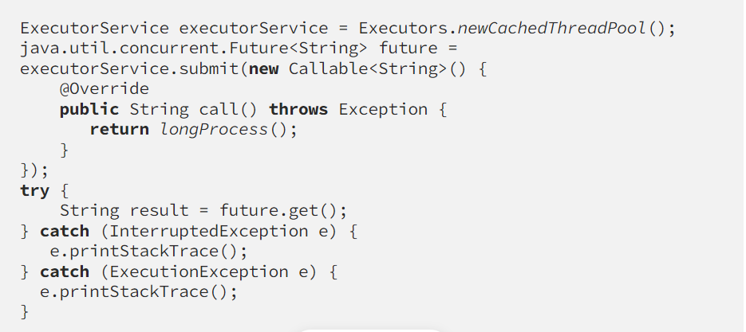

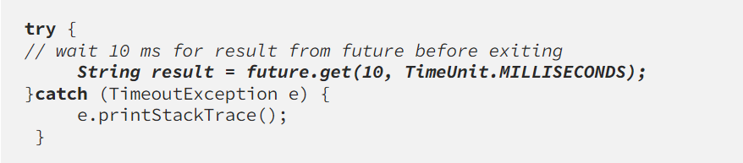

* Wait for 10 seconds and then it timeout