* Future has been introduced in java 5
* No manual completion
* Cannot be chained multiple future.
* Cannot combine multiple further together
* No exception handling

Completable Future

* Added in Java 8
* Implements future and completion stage interface
* Provides a huge set of convenience methods for creating, chaining, and combining multiple futures.
* It also has comprehensive exception-handling support.

Methods :

1. runAsync() : it takes runnable object and returns void CompletableFuture.
2. supplyAsync():

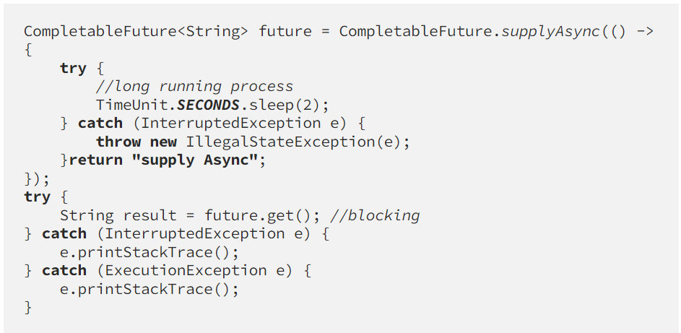

The difference between runAsync() and supplyAsync() is that the former returns a Void while supplyAsync() returns a value obtained by the Supplier.

If the custom Executor is not provided, both methods are asynchronously completed by tasks running in the ForkJoinPool (explained above in precursors).

Callback Methods :

1. thenApply()
2. thenAccept()
3. thenReturn()

Completable Future resolves below limitations :

1. Non-Blocking
2. Completing future programmatically
3. Perform error handling
4. Ability to chain several futures
5. Ability to combine results of multiple futures (run in parallel)

Error Handling :

