Java Concurrent Utilities

L

|  |  |  |  |  |
| --- | --- | --- | --- | --- |
|  | Add | Remove | Get | contains |
| ArrayList | O(1) | O(n) | O(1) | O(n) |
| LinkedList | O(1) | O(1) | O(n) | O(n) |
| CopyOnWriteArrayList | O(n) | O(n) | O(1) | O(n) |

Concurrent collections

* ConcurrentHashMap
* CopyOnWriteArrayList and CopyOnWriteArraySet
* BlockingQueue
* Deque and BlockingDeque
* ConcurrentSkipListMap and ConsurrentSkipListSet

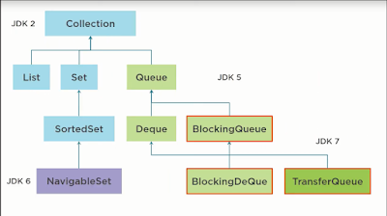

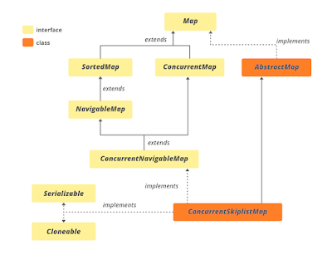

* Java.util.concurrent
  + Executors
  + Queues
  + ExecutorService
  + ScheduledExecutorService
  + Blocking Queue
    - ArrayBlockingQueue
    - Delay Queue
    - Linked Blocking queue
    - Priority Blocking Queue
    - Synchronous Queue
    - Linked Blocking Queue
  + Blocking Deque
  + Callable and Future
  + CountdownLatch
  + Cyclic Barrier
  + Concurrentmap
  + Concurrent Navigable Map
  + Exchanger
  + ForkJoinPool
  + Locks
  + Semaphore
  + Phaser
  + Atomic
  + Reentrant Locks
  + Read -write Locks
  + Race Condition
  + Dead Lock
  + Starvation
  + Mutex
  + Livelock
  + Synchronizer
  + Latch