Wait method :

Forces the current thread to wait until some other thread invokes notify() or notifyAll() on the same object.

Wait(long time out ) - we can specify the timeout after which the thread will be woken up automatically.

It’s a native method

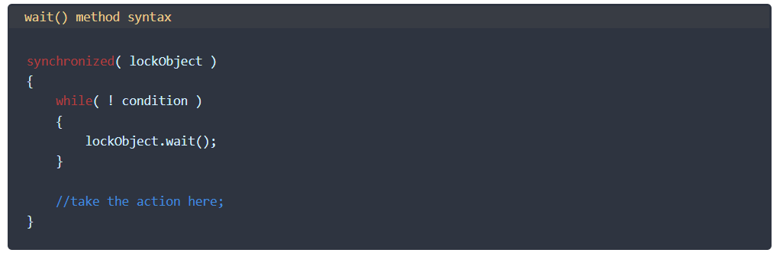

Notify :

Choice of thread to wake up is non-deterministic and depends on Implmenetation.