Volatile keyword is java is used to make java variable as being stored in main memory

All the thread accesses the volatile variable from main memory and from CPU cache.

Can be used for primitive types and object references

When used with objects , all thread see the most up-to-date values for all fields in the object.

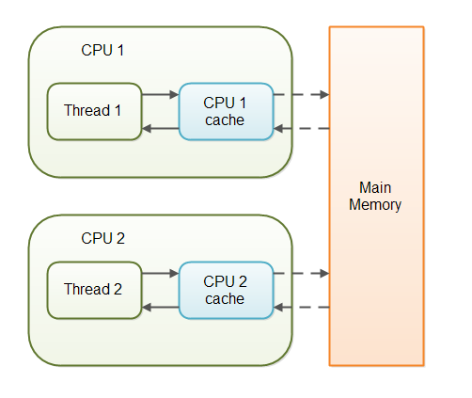

|  |
| --- |
| public class Singleton { |
|  | private static volatile Singleton _instance; // volatile variable |
|  | public static Singleton getInstance() { |
|  | if (_instance == null) { |
|  | synchronized (Singleton.class) { |
|  | if (_instance == null) |
|  | _instance = new Singleton(); |
|  | } |
|  | } |
|  | return _instance; |
|  | } |

Lazy instantiation

If _instance variable is not volatile then thread which is creating instance is not able to communicate to other thread.