1. Describe your technical experience so far.
2. Write a function in java which takes a string and replace the camel case characters (upper case) with '_' and followed by lower case of that character

Input: "thisIsASampleQuestionAndAnswerShouldBeYOrN"

Output: "this_is_a_sample_question_and_answer_should_be_y_or_n"

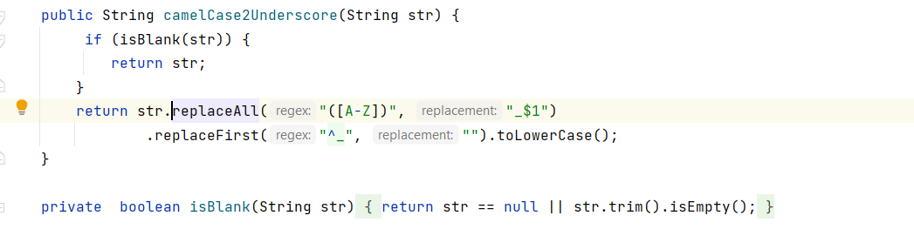

1. Write a function which takes the Output of step 2 and generates the Input of step 2. (reverse of step 2)

Input: "this_is_a_sample_question_and_answer_should_be_y_or_n"

Output: "thisIsASampleQuestionAndAnswerShouldBeYOrN"

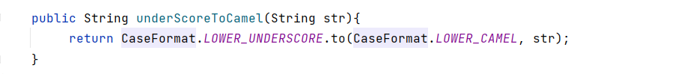

1. How to handle logging in latest microservices architecture ?

I described Elastic search , logstash and Kibana stack along with treating logging as a separate microservice , which I implemented in my previous projects.

<https://www.youtube.com/watch?v=5s9pR9UUtAU>

1. Write steps to create a Post Rest Endpoint for the url www.app1.org/8843/r1 , consider 8843 as a port (Explain how to create a rest end point in Spring Controller )
2. Write Steps how to consume the rest end point created in step 5 , consider it is consumed programmatically (you can explain using Spring Web Client )
3. Explain the use case where Jmeter and JProfiler helped you (as this was mentioned in my resume).
4. Consider a scenario where we have two application App1 and App2 , instances of both are hosted on multiple servers , request to these servers are managed by a load balancer . We are testing this for performance, and we send 20000 request at a time to the load balancer, for the first batch all the request are going fine but the 20001th request failed saying "Time out error" after that the next batch also goes fine. Then again on the 40008th request it failed. Consider this issue is occurring intermittently and we do not have any stack trace generated in the application log or the web container log..

What would be your approach to debug the issue and find the root cause, and what all possible root cause you think can come.

I said one possible root cause an be the number of request is exceeding the configured threshold set in the servers. (I am not sure for this answer)