JWT

1. JSON Web token – Authorization Information
2. Structure of JWT ?

* Header
* Payload
* Signature

1. Set expiry date

private String doGenerateToken(Map<String, Object> claims, String subject) {

return Jwts.builder().setClaims(claims).setSubject(subject).setIssuedAt(new Date(System.currentTimeMillis()))

.setExpiration(new Date(System.currentTimeMillis() + jwtExpirationInMs)).signWith(SignatureAlgorithm.HS512, secret).compact();

}

1. Workflow of JWT

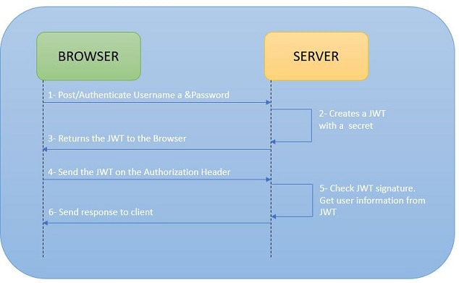

1. Advantage of JWT ?

* Good performace
* Portable
* Cookies not allowed
* Digitally signed
* Setting expiry time.
* Plaintext

1. OAuth

* Authorization Protcol
* Authenticate using JWT doesnot allow to logout
* To make a proper logout use OAuth

1. JWS – stateless authentication

* Authorizing server doesn’t keep track of anything.
* No need to store the user information ins the session.

1. JWT has password ?

* Allows to regerenate the password.
* Has encoded user information.

1. AbstractSecurityInterceptor in spring Security ?

* Handles initial authorization of an incoming request .
* FilterSecurityInterceptor and MethodSecurityInterceptor are Implementation of AbstractSecurityInterceptor
* FilterSecurityInterceptor 🡪 default Filter.All authenticated user request will be authorized by FilterSecurityInterceptor
* MethodSecurityInterceptor 🡪 Implement method level security.Enables us to apply security at method level.

1. Spring boot Methos level security ?

* @PreAuthorize annotation used on controller method level security.

1. @PreAuthorise and @Secured

* Check the authorization before executing the method.
* @Secured - the roles cant be couples with AND /OR condition
* Spring expression language is not supported by @Secured annotation.

1. Difference between hasRole() and has Authority() ?

* hasRole() defines the Role (for Example: "Employee" or "Visitor"), while hasAuthority() defines the Rights (for Example: One Employee can only use the Main Door, but another one can also use the Backdoor

1. Spring Security’s @PreAuthorize and HttpSecurity ?

* HttpSecurity function rejects the requests in web request Filter
* HttpSecurity is associated with URL endpoints
* @PreAuthorize ,occurs later , before the controller method is executed.
* @PreAuthorize is associated with controller methods.
* @PreAuthorize uses SpEL 9Spring Expression Language)

1. @PreAuthorize annotation is enabled by @EnableglobalMethodSecurity(prePostEnabled = true)

@Component

@EnableWebSecurity

@EnableGlobalMethodSecurity(prePostEnabled = true, securedEnabled = true)

public class SecurityConfig extends WebSecurityConfigurerAdapter {

.......

.......

}

1. How to use Authorization based on OAuth 2.0 with PreAuthorize

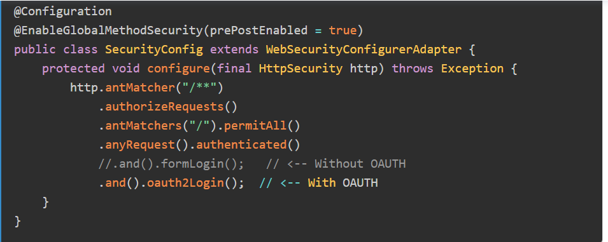

Secure REST APi

1. Authentication and Authorization.

Authentication –

* + Identify the user from others
  + Using username and password
  + Example : Fingerprint ,security token ,security questions ,
  + SAML token received through SSO Login

Authorization :

* + Determine “What user is allowed to do”
  + Permission provided by system admin to access to the system

1. 4 ways to secure RESTFUL Services
   * BASIC Authentication
   * DIGEST Authentication
   * Client CERT Authentication
   * OAuth2 API keys
2. RESTful webservices security Implemetnation.

* Using SecurityContext
* Using Annotations

BASIC Authentication

* + Login using username and password
  + Encoded using Base64 Format
  + But not encrypted or hashed in anyway.
  + Any sniffer can read the data from the network.

DIGEST Authentication

* + Efficient password security as MD5, SHA, BCrypt ,Scrypt algorithms
  + Reset the password enach time when login is happened.

Client CERT Authentication

* + Certificate Authority
  + HTTPs communication procotol
  + Don’t have secure channel to prevent anyone from stealing the client;s identity.

OAuth2 API Keys

* + Site Authetication using API key and secret key belongs to the user.Provider will alow you to authenticate access to public information

Security Implementation

* Javax.ws.rs.core.SecurityContext interface provide access to security -related information for request and very similar to javax.servlet.http.HttpServletRequest

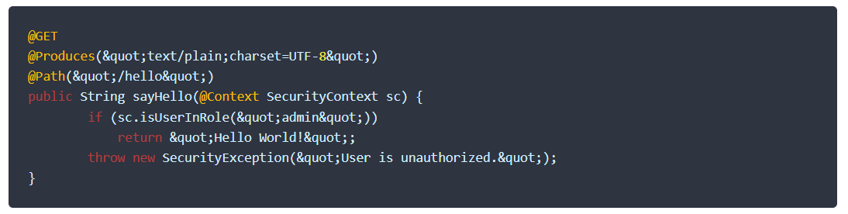

* JAR-RS annotation for method level authorization
  + Widely used in Enterprise Application and used to verify roles and responsibilities of an authenticated used for certain operation
    - @PermitAll
    - @DenyAll
    - @RolesAllowed

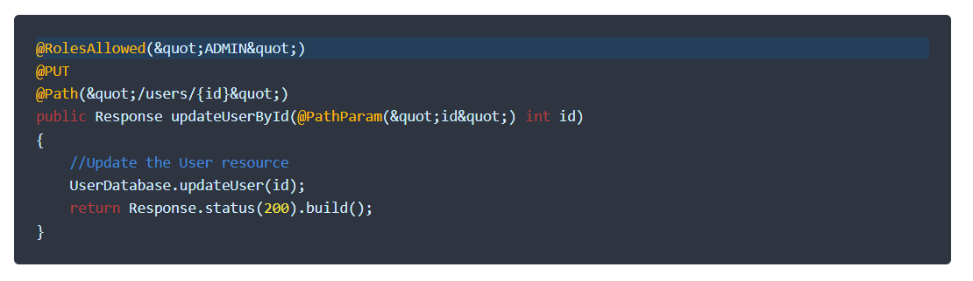

REST API Security Best Practices :

1. Use only HTTPS protocol , so that whole communication is always encrypted.
2. Never send auth credentials or API keys as query param. They may appear in URL and can be logged or tracked easily.
3. Use harder encryption levels
4. PUT,POST and DELETE request is protected from Cross Site Request Forgery,
5. Validate the input data ASAP in server method.Use ony primitive data as input parameter
6. Rely on frameworj provided validation features as tested by larger community.