**Building a WebSocket Server in a Microservice Architecture**

Designing a WebSocket server in a microservice architecture for real-time communications



Photo by [Taylor Vick](https://unsplash.com/@tvick?utm_source=medium&utm_medium=referral) on [Unsplash](https://unsplash.com/?utm_source=medium&utm_medium=referral" \t "_blank)

This article is written to share my exploration of real-time communication between frontend and backend using WebSocket. In recent years, microservice is an architectural approach that many developers have adopted, and one of the key principles of microservice architecture is the “Single Responsibility Principle.”

In this exploration, we will look into designing and implementing a WebSocket server that is responsible for establishing a WebSocket connection with the frontend (web application) and also acting as a middleware (or proxy) for real-time communications between the frontend and backend.

***Note****: This article will not go into detail on how WebSocket or publish-subscribe messaging pattern works.*

**[GitHub - bkjam/websocket-microservice: Exploration on Websocket Microservice for Real time…](https://github.com/bkjam/websocket-microservice" \t "_blank)**

[You can't perform that action at this time. You signed in with another tab or window. You signed out in another tab or…](https://github.com/bkjam/websocket-microservice" \t "_blank)

[github.com](https://github.com/bkjam/websocket-microservice" \t "_blank)

**My WebSocket Server Series**

* 01: Building WebSocket server in a microservice architecture
* 02:[Design considerations for scaling WebSocket server horizontally with publish-subscribe pattern](https://betterprogramming.pub/design-considerations-for-scaling-websocket-server-horizontally-with-a-publish-subscribe-pattern-fe6de9988400)
* 03: [Implement a scalable WebSocket server with Spring Boot, Redis Pub/Sub, and Redis Streams](https://betterprogramming.pub/implement-a-scalable-websocket-server-with-spring-boot-redis-pub-sub-and-redis-streams-b6b8cc08767f)
* 04: TBA

**Background Context**

There are many instances where a web application (frontend) requires real-time communication between the client (browser) and the server (backend). Some examples of such use cases are real-time feeds, real-time collaborative editing, real-time data visualization, real-time chats, notifications, event updates, etc.

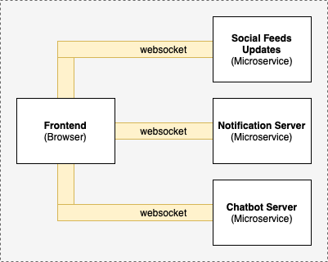

Example of WebSocket connections between the client (frontend) and individual microservices (backend)

Suppose there is a microservice for each use case; the diagram above will then illustrate how WebSocket connections are established between the client (frontend) and each of the individual microservices (backend).

As you can see, this is not an optimal design, as when the number of microservices increases, more WebSocket connections will be created. Hence, let’s look into how a WebSocket server can help to resolve this issue.

**WebSocket Server Design**

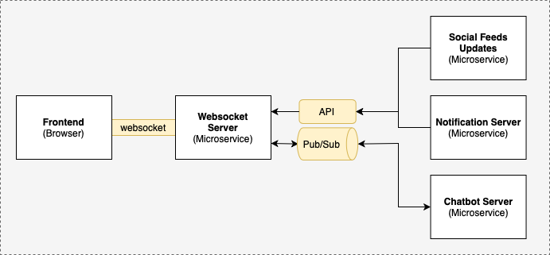

A high-level diagram of a WebSocket server in a microservice architecture

In the design above, the WebSocket server is the only microservice that establishes a WebSocket connection to the web application (frontend). For other microservices, there are two main ways for real-time communications to the web application (frontend):

1. Unidirectional (backend to frontend)  
   - All microservices (backend) can send messages to the WebSocket server via API where the message will then be forwarded to the web application (frontend) via WebSocket.
2. Bidirectional (between frontend and backend)  
   - Web application (frontend) can send messages to the WebSocket server via WebSocket, where the message will then be forwarded to the microservices (backend) via Pub/Sub.  
   - Microservices (backend) can send messages to the WebSocket server via Pub/Sub where the message will then be forwarded to the web application (frontend) via WebSocket.

**Building a WebSocket Server**

We will build a WebSocket server using Spring Boot, Stomp, and Redis Pub/Sub based on the design above. As I won’t be going into details, you can refer to these amazing articles by [Tomasz Dąbrowski](https://www.toptal.com/java/stomp-spring-boot-websocket) and [Baeldung.com](https://www.baeldung.com/websockets-spring) to learn more about WebSocket implementation with Spring Boot.

**Step 1: Initialize the Spring Boot Project**

Head over to <https://start.spring.io/> and initialize a Spring Boot project. Minimally, you will require Spring Web, Redis, and Websocket dependencies.

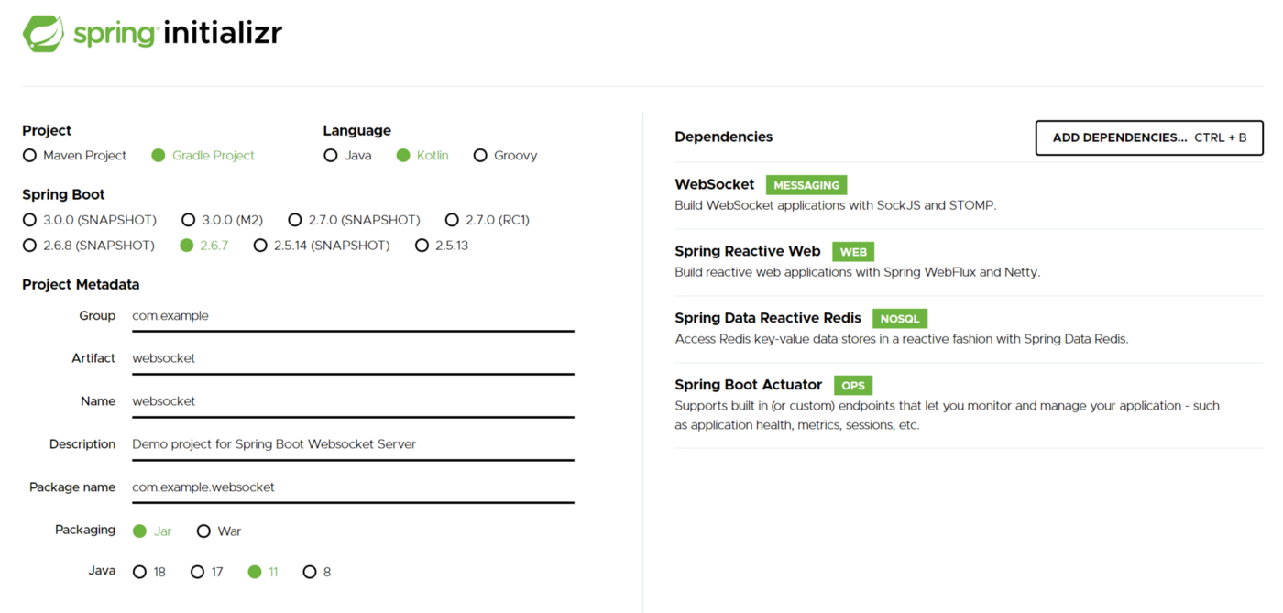

Example of Spring Boot Project

**Step 2: Configure WebSocket and STOMP messaging**

Create a configuration file, WebsocketConfig.kt, and add the configuration below. The configuration enables WebSocket capabilities for the Spring Boot application.

*Note that the stomp endpoint allows all origins for demonstration purposes, but this shouldn’t be the configuration for production setup.*

Configurations for enabling Spring Boot Websocket (WebsocketConfig.kt)

**Step 3: Create API Endpoint for unidirectional real-time communication**

The API endpoint provides a way for microservices (backend) to send messages to the web application (frontend). As the messages only require a one-way flow (backend → WebSocket Server → frontend), using APIs will be a good communication medium between microservices (backend → Websocket server).

API Endpoint for sending a message to WebSocket server

The code above creates a REST controller with a POST request endpoint that takes in a request body “NewMessageRequest” where the topic is the STOMP destination that the client (frontend) subscribes to and message is the actual message in String format. With this, you can now send a message via API to the WebSocket server, which will then be forwarded to the web application (frontend) via WebSocket.

**Step 4: Configure Redis Pub/Sub for bidirectional real-time communication (Optional)**

*Note: Depending on your use case, you can omit this step if you do not require bidirectional real-time communication between the web application (frontend) and microservices (backend).*

Communication via APIs between microservices (backend and Websocket server) will not be optimal for real-time communications as compared to using a publish-subscribe messaging pattern. Hence, for bidirectional communication, we will make use of a publish-subscribe messaging pattern.

There are many ways to implement a publish-subscribe messaging pattern but for demonstration and simplicity’s sake, we will use Redis Pub/Sub.

To get started, run a Redis server locally using docker (docker run — name redis-server -p 6379:6379 -d redis) and add the following configuration to the application.yml file for the WebSocket server to connect to the Redis server.

# application.yml  
spring.redis:  
 host: localhost  
 port: 6379

Next, create a configuration file, RedisConfig.kt, and add the configuration below. Essentially, we are configuring a ReactiveRedisTemplate that communicates with the Redis server and is configured to serialize and deserialize messages as String.

Configuration for ReactiveRedisTemplate

Following this, create a RedisService that contains logic for subscribing and publishing to the Redis server. In the example below, we subscribed to an inbound channel topic GREETING\_CHANNEL\_INBOUND which listens for incoming messages from other microservices (backend) and forwards all messages received to the STOMP destination /topic/greetings.

Lastly, create a Controller that processes messages from the web application (frontend) which are sent to the WebSocket server with the prefix /app. In the example below, messages sent to /app/greet will be forwarded (published) to an outbound channel topic GREETING\_CHANNEL\_OUTBOUND which will then be processed by any microservice (backend) that is listening to that channel.

With that, we have set up the WebSocket server to act as a middleware (or proxy) that communicates with the web application (frontend) via WebSocket and communicates with the microservices (backend) via Redis Pub/Sub.

**Testing WebSocket Connection**

Using an [open-source websocket client debugger tool built by jiangxy](https://bkjam.github.io/websocket-debug-tool/)as a mock web application (frontend), we can test the WebSocket server we built above.

**Test #1: Send message from backend to frontend (via API)**

Spin up the WebSocket server, and connect to the WebSocket server ws://localhost:8080/stomp over STOMP protocol using the WebSocket debugger tool. Once connected, configure the WebSocket debugger tool to subscribe to the topic /topic/toast.

Next, send an HTTP POST request to the WebSocket server using the command below:

curl -X POST -d '{"topic": "/topic/toast", "message": "testing API endpoint" }' -H 'Content-Type: application/json' localhost:8080/api/notification

The WebSocket debugger tool should have the output shown below:

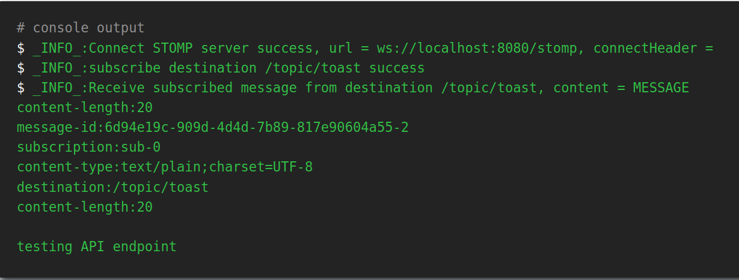

Screenshot of WebSocket debugger tool’s output for sending a message from backend via API

This shows that the WebSocket server has successfully received the message via API and forwarded the message to the web application (frontend) via WebSocket.

**Test #2: Send message from backend to frontend (via Pub/Sub)**

Spin up the WebSocket server, and connect to the WebSocket server ws://localhost:8080/stomp over STOMP protocol using the WebSocket debugger tool. Once connected, configure the WebSocket debugger tool to subscribe to the topic /topic/greetings ([defined above](https://betterprogramming.pub/building-a-websocket-server-in-a-microservice-architecture-50c6c6432e2b#6d66)).

Using Redis CLI, publish a message to the channel topic GREETING\_CHANNEL\_INBOUND([defined above](https://betterprogramming.pub/building-a-websocket-server-in-a-microservice-architecture-50c6c6432e2b#6d66)) using the command PUBLISH GREETING\_CHANNEL\_INBOUND “\"Test Message from Backend PubSub\"”.

*Note that the extra \” is required as the WebSocket server is configured to receive String messages*. The WebSocket debugger tool should receive the message as shown below

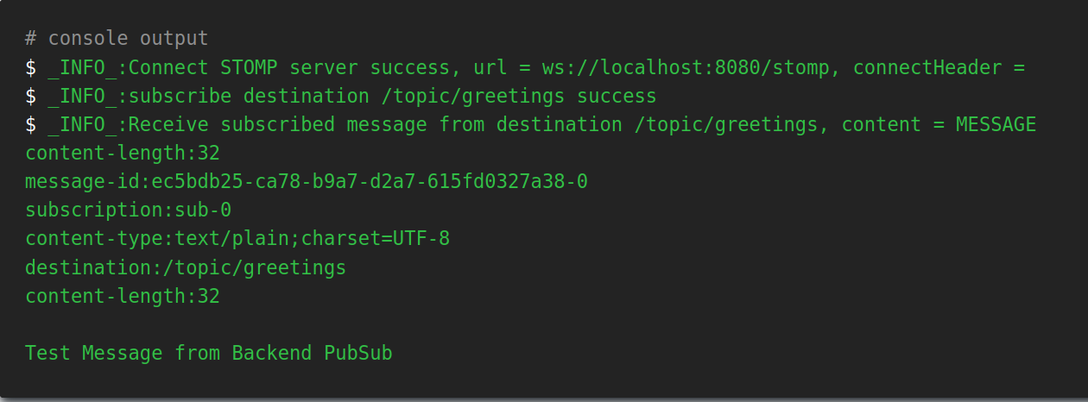

Screenshot of WebSocket debugger tool’s output for sending a message from backend via Redis PubSub

This shows that the WebSocket server has successfully received the message via Redis Pub/Sub and forwarded the message to the web application (frontend) via WebSocket.

**Test #3: Send message from frontend to backend (via Pub/Sub)**

Spin up the WebSocket server, and connect to the WebSocket server ws://localhost:8080/stomp over STOMP protocol using the WebSocket debugger tool. Once connected, using Redis CLI, subscribe to channel topic GREETING\_CHANNEL\_OUTBOUND ([defined above](https://betterprogramming.pub/building-a-websocket-server-in-a-microservice-architecture-50c6c6432e2b#531a)) using the command SUBSCRIBE GREETING\_CHANNEL\_OUTBOUND. Send a message to STOMP destination /app/greet using the WebSocket debugger tool, and you should observe the following:

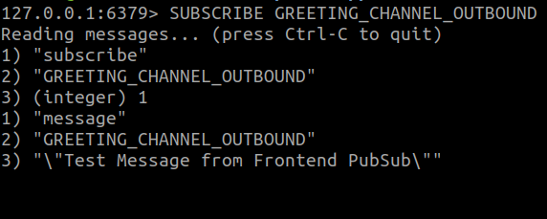

Output of Redis CLI Subscribe Command

This shows that the WebSocket server has successfully received the message via WebSocket and forwarded the message to the microservices (backend) via Redis Pub/Sub.

**Summary**

In summary, we have run through a possible design of a WebSocket server in a microservice architecture. Having a WebSocket server greatly aligns with the “Single Responsibility Principle” of microservices, where it manages all WebSocket connections to the web application (frontend) as well as handles real-time communications between the web application (frontend) and other microservices (backend).

That’s it! I hope you learned something new from this article. Stay tuned for the next one, where we will look into scaling the WebSocket server.

If you like this article, please follow me for more :).

Thank you for reading until the end. Happy learning!