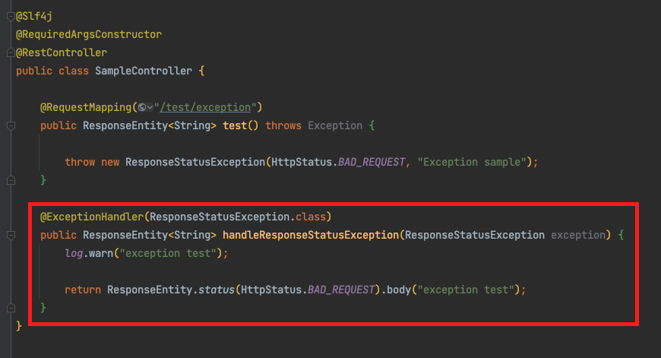

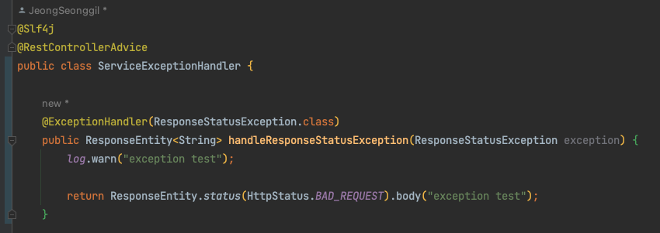s

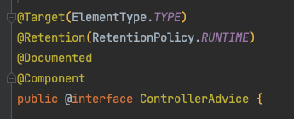

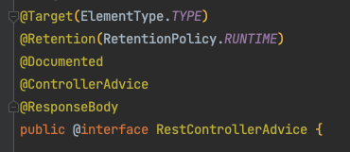

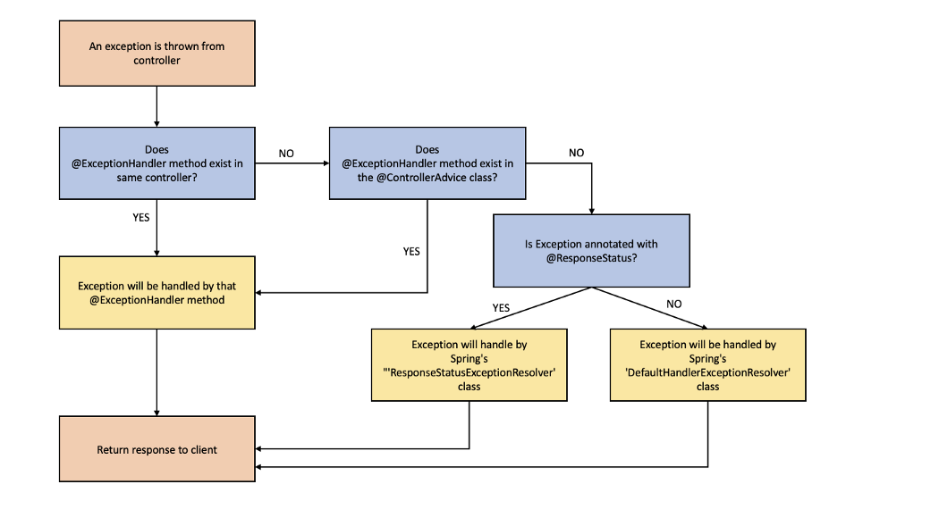

1. **ExceptionHandlerExceptionResolver works**  
   - Check if there is an appropriate **ExceptionHandler** in the controller that threw the exception  
   - If there is no suitable **ExceptionHandler**, go to **ControllerAdvice**  
   - Checks if there is a suitable **ExceptionHandler** in **ControllerAdvice**, and if not, it goes to the next **handler**
2. **ResponseStatusExceptionResolver works**  
   - Check if ResponseStatus exists or ResponseStatusException  
   - If so, the exception is passed to the servlet by sendError() in the ServletResponse and the servlet passes the request to the BasicErrorController.
3. **DefaultHandlerExceptionResolver works**  
   -Check if it is an internal exception of Spring, and if it is correct, handle the error, otherwise skip
4. **Because there is no suitable ExceptionResolver, the exception is passed to the servlet, which passes the request back to the BasicErrorController according to the automatic configuration done by SpringBoot.**

**Implementing exceptionHandler**

*As a simple example, let’s implement to return the exception we made when can’t find post by post id*

Create a list of exceptions using enum class

