Spring IOC container is responsible for Instantiating, Initializing, and wiring beans.

The container also manages the life cycle of beans

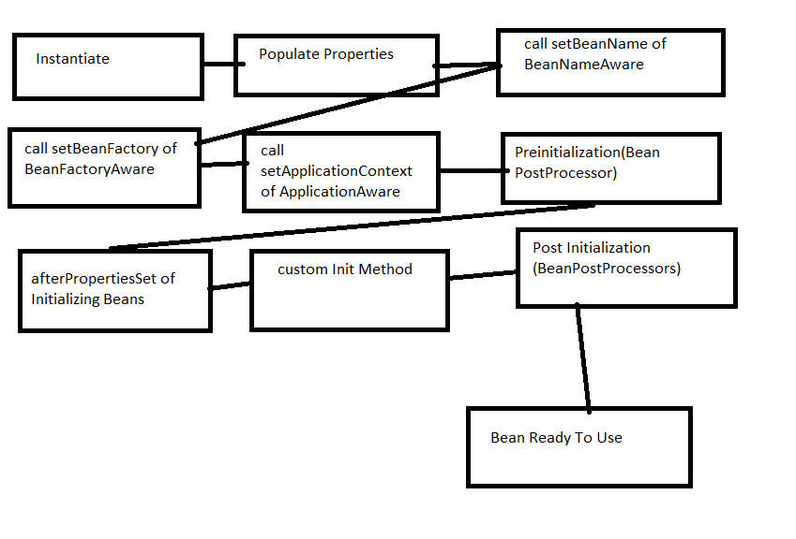

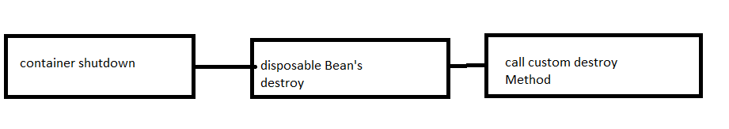

1. Once the bean is instantiated, the spring needs to perform some initialization to get the bean into a usable state and needs to clean up resources before a bean is removed from the container.

Part -1

* Different stages of the bean go through after instantiation until it is ready for use.
* Container instantiates a bean by calling its constructor and then populates its properties.

Part -2

* Shows what happens to bean once the Spring IOC container shutdown.
* When the container shutdown the container calls the bean to enable it to perform any required tasks before the bean is destroyed.

**Aware Interfaces**

This interface is used to access the Spring framework Infrastructure.

It is largely used by Spring and rarely used by Spring programmers.

There are 3 interfaces

* *BeanFactoryAware* 🡪 Provides *setBeanFactory*(), a callback that supplies the owning factory to the bean instance
* *BeanNameAware*: *setBeanAware*() callback of this interface supplies the name of the bean.
* *ApplicationContextAware*: The *setApplicationContext*() method of this interface provides the ApplicationContext object of this bean.

**BeanPostProcessor:**

Spring provides *BeanPostProcessor* interface that gives you to tap into the Spring context life cycle and interact with beans as they are processed.

*BeanPostProcessor* interface contains 2 methods

*postProcessBeforeInitialization()*:

Spring calls this method after methods of aware interfaces and before initialization callbacks like InitializingBean’s *afterPropertiesSet*() or custom init method.

*postProcessAfterInitialization():*

Spring calls this method after any bean initialization callbacks.At the runtime, Spring will inject the new bean instance and the name of the bean to both the methods

***InitializingBean* and *DisposableBean* Callback Interfaces.**

It has 2 callback interfaces:

*InitializingBean*: it declares *afterPropertiesSet()* method which can be used to write the initialization logic. The container calls the method after properties are set.

*Disposablebean*: declares the *destroy*() method which can be used to write any cleanup code. The container calls this method during destruction in shutdown.

Custom Init and Destroy Method

* We can specify init-method and *destroy-method* attributes in the tag.
* Both the attributes specify custom methods in the bean class.
* Method declared in the init-method attribute is called after the spring initializes bean properties through setter or constructor arguments. This method can be used to validate the injected properties or perform any other tasks.
* Spring calls the method declared in the destroy-method attribute just before the bean is destroyed.

Summary:

* Personally, I don’t prefer using InitializingBean and DisposableBean interfaces.
* Primarily because it tight couples your code to Spring.
* A better approach is specifying init-method and destroy-method attributes in your bean configuration file.

**Spring Beans from Born to Death**

Beans are just like humans.

Spring framework has now become the most popular Java framework in backend engineering world.

As developers, knowing how the lifecycle of a spring bean works helps us understand the beans deeper and create customized logic for beans.

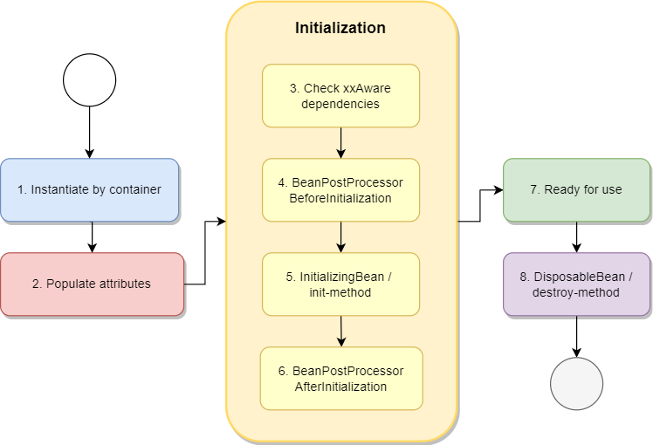

**Instantiate Bean**

Beans are first created from Spring containers, just like how humans are born.

There are mainly two types of containers — *BeanFactory* and *ApplicationContext*.

For a *BeanFactory* container, when client asks for a yet initialized bean, or injects a yet initialized bean into another bean, the container will invoke *createBean* for instantiation. This process is **lazy loading**.

In contrast with *BeanFactory*, *ApplicationContext* goes with **eager loading**. For an *ApplicationContext* container, it will instantiate **all** beans when the container starts.

**Populate Attributes**

Spring injects dependencies into the bean attributes according to BeanDefinition.

**Inject Aware interfaces**

Spring detects if the object implements any *xxAware* interfaces and injects the corresponding instances into the bean.

**BeanPostProcessor**

If you want to customize some logic before the beans are actually used, you can implement it through the *BeanPostProcessor*interface, which mainly provides two methods:

* *postProcessBeforeInitialization*(Object bean, String beanName)
* *postProcessAfterInitialization*(Object bean, String beanName)

**InitializingBean and init-method**

*InitializingBean*interfaceonly has one function:

* *afterPropertiesSet*()

We can also configure *init-method* in bean to define the method name for execution.

**DisposableBean and destroy-method**

Same as init-method, we can use *DisposableBean* and destroy-method to appoint a method for destruction.

Let’s verify using an example.

Here we create a *personBean*that implements a few interfaces including *InitializingBean*, *BeanFactoryAware*, *BeanNameAware* and *DisposableBean*.

For some methods, we will print a message that describes the method being called.

Next, we will have a customized *BeanPostProcessor*that implements *postProcessBeforeInitialization*and *postProcessAfterInitialization.*Same as above, we will print messages here.

We will now configure a XML file to tell spring about the bean definition and the necessary properties.

Lastly, we invoke an *ApplicationContext* container to construct the bean for us and destroy it.

Let’s view the result:

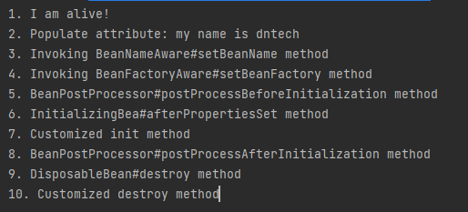

We can see that the sequence corresponds to the very first diagram above, which goes from instantiate — populate attribute — a series of initialization — destroy.