Whatspp system design:

Problem statement :

Whatsapp does not store the messages permanently in the server .

Requirement :

1. One to one conversation between users.
2. Need to show set/ delivered /read confirmation to other user
3. Last time the user was active .
4. Allow user to share images.
5. Able to send push notification to other user.

Capacity Planning:

* It is highly scalable platform.
* Worst case scenario of peak traffic
* Number of users on application every month : 1 Billion (1 crore)
* Number of active users per second at prak traffic : 650000
* Number of messages per second at peak traffic : 40 million

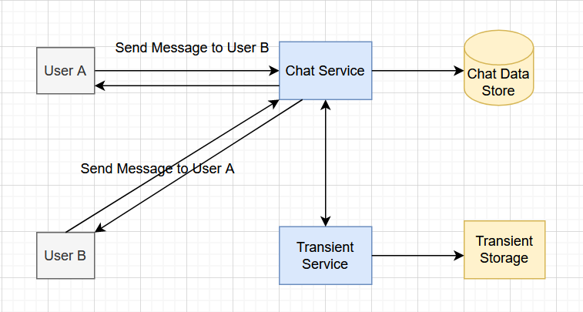

Two micro services :

Chat Service

Transient Service

Chat Service :

* One serving the traffic of online chat messages sent by active users.