# Background

This document describes several raster datasets for projected Mean Fire Return Intervals (MFRI) in California. The methodology and motivation behind these data are presented in Mann et al. (2016)**.** In that paper, the authors predict MFRI using forecasts for residential development (Mann et al., 2014) along with Actual Evapotranspiration (AET) and Cumulative Water Deficit (CWD) outputs from two different climate models (PCM and GFDL). We use the same methodology and model specification but update the forecasts under CMIP5 outputs and also generate futures under three additional Global Circulation Models (GCMS) and climate change scenarios: MIROC RCP 8.5, MIROC RCP 4.5, and MPI RCP 4.5 (see table 1)[1].

Table 1: Climate Models and Scenarios Used for Projected MFRI

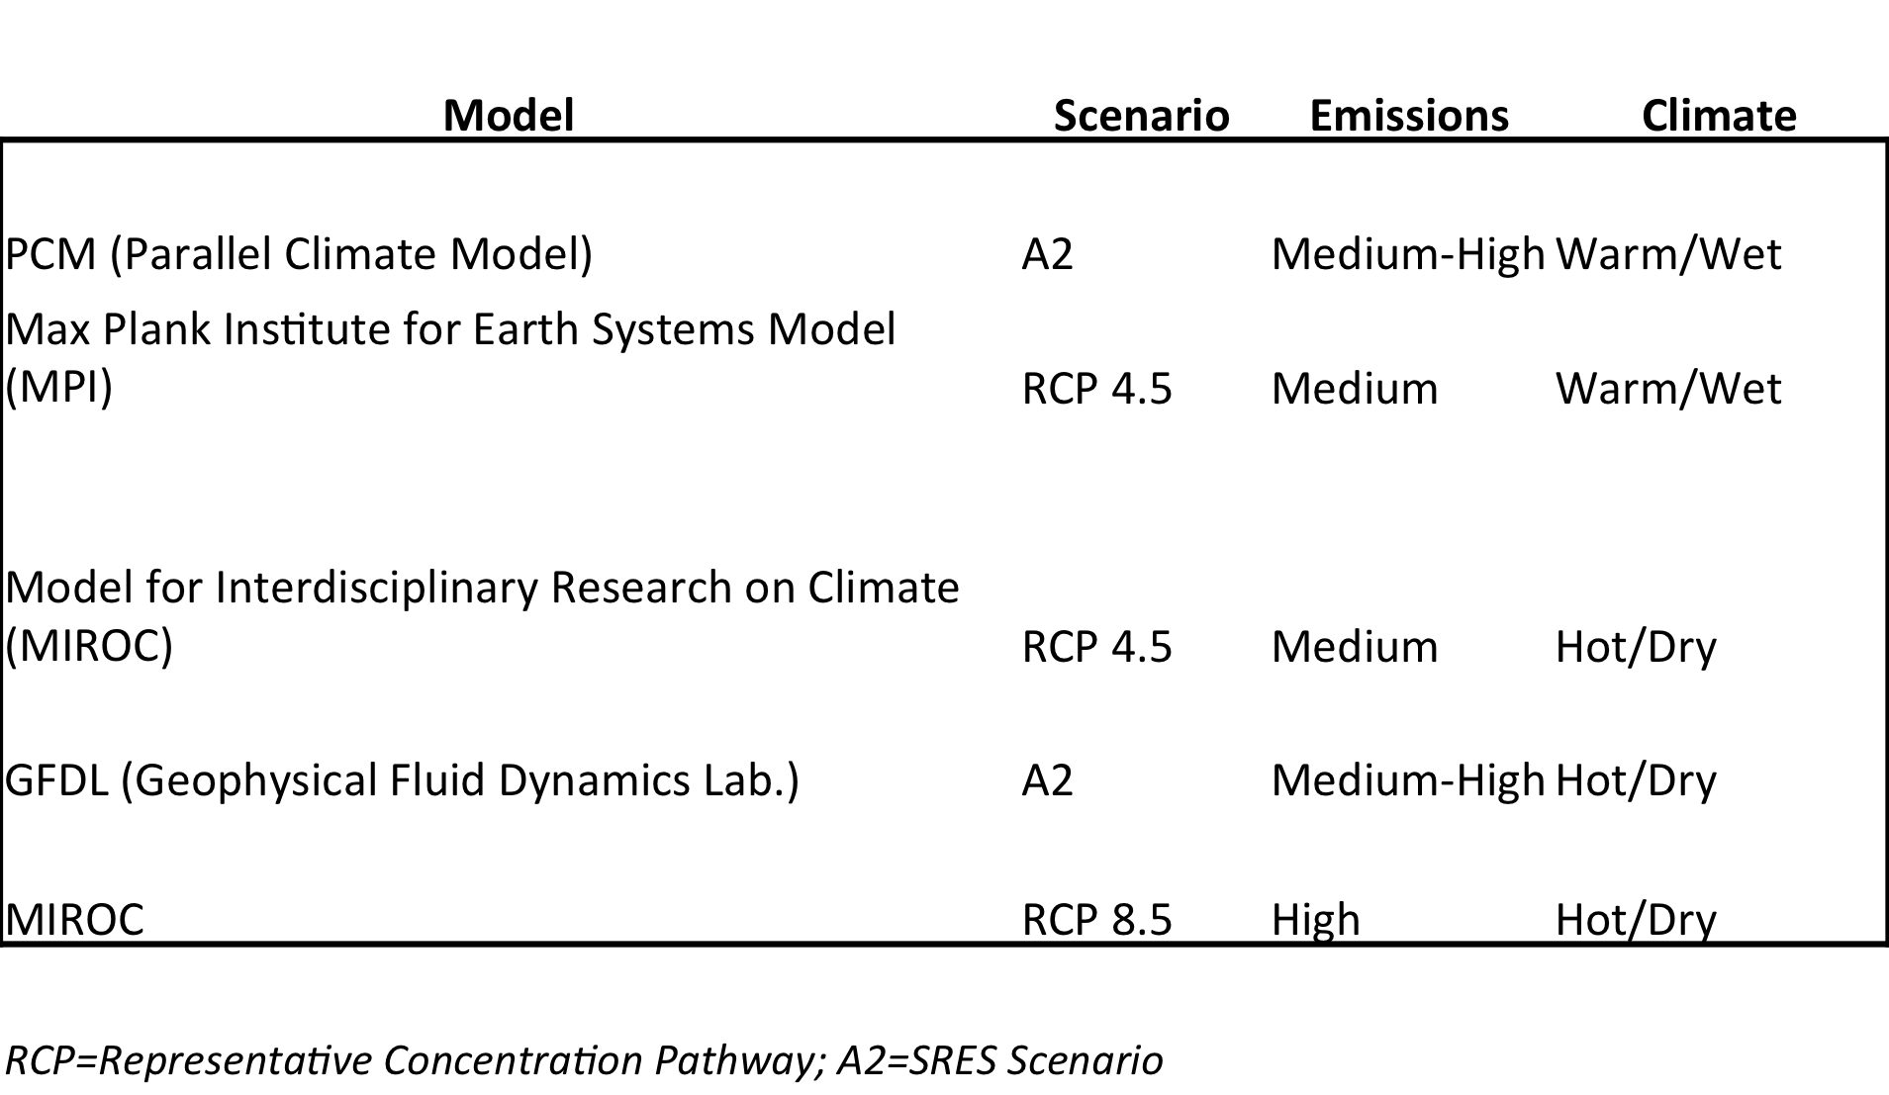

The primary model output is the number of years between fire events, also known as Mean Fire Return Interval (MFRI). For given period (p) the MFRI is defined as:

latex-image-1.pdf

where, the expected number of fires is modeled from a Zero Inflated Negative Binomial Process (count model) as described in Mann et al. We generate MFRI surfaces based on outputs from the climate models listed in table 1.

The PCM and GFLD models were used predict MFRI for 2000-2025 and 2026-2050. The remaining models predict MFRI for 2006-2025 and 2026-2050. Inputs for the 2000-2005 period were not available for those other models. The numerator in the MFRI calculation for those datasets reflects this.

# Datasets

The zip file ‘fire_future_gtiffs.zip’ contains the predicted MFRI values from 1976_2000 (used as the baseline, “period 1” in the above graphic) and the forecast MFRI for various time intervals for each of the GCM models. All files are GeoTiffs.

**The baseline values (MFRI for the period 1976 to 2000, based on predicted values from the model in Mann et al. 2016) are in the file: *mfri_76_00_baseline.tif***

The remaining files contain the forecast MFRI for based on the GCMS listed in table 1. The naming convention for the forcast MFRI is as follows: *IntervalStart_IntervalEnd_GCM.tiff*. For example:

|  |  |  |  |
| --- | --- | --- | --- |
| **File Name** | **Period** | **GCM** | **Scenario** |
| *2001_2025__PA2tif* | 2001_2025 | PCM | A2 |
| *2001_2025__GA2tif* | 2001_2025 | GFDL | A2 |
| *2006_2025_MIROC_rcp85tif* | 2006_2025 | MIROC | RCP 8.5 |
| *2006_2025_MIROC_rcp45tif* | 2006_2025 | MIROC | RCP 4.5 |
| *2006_2025_mpircp45tif* | 2006_2025 | MPI | RCP 4.5 |

The forecasts for the 2026_2050 period follow the same convention.

Further inquiries can be directed to:

Max Moritz: [mmoritz@berkeley.edu](mailto:mmoritz@berkeley.edu)

Michael Mann: [mmann1123@gwu.edu](mailto:mmann1123@gwu.edu)

Frank Davenport: [frank_davenport@ucsb.edu](mailto:frank_davenport@ucsb.edu)

# References

Mann, M.L., Batllori, E., Moritz, M.A., Waller, E.K., Berck, P., Flint, A.L., Flint, L.E., Dolfi, E. (2016) Incorporating anthropogenic influences into fire probability models: effects of human activity and climate change on fire activity in California. PLoS ONE 11, e0153589.

Mann, M.L., Berck, P., Moritz, M.A., Batllori, E., Baldwin, J.G., Gately, C.K., Cameron, D.R. (2014) Modeling residential development in California from 2000 to 2050: Integrating wildfire risk, wildland and agricultural encroachment. Land Use Policy 41, 438-452.

1. Further information on the A2 scenario can be found here: <http://www.ipcc.ch/ipccreports/sres/emission/index.php?idp=98>. Further information on the various RCP scenarios is available here: <http://sedac.ipcc-data.org/ddc/ar5_scenario_process/RCPs.html> . Information on the specific GCMs can be found with the respective institutions listed in table 1.