Estimating acid soil effects on cereal crop productivity in Ethiopia: A prototype for enhancing crop management

James M Warner & Michael L Mann

July 5, 2019

Controlling soil acidification is critical to maintaining plant health and maximizing yields. In extremely acidic soils, pH < 5.5, as much as 70 $\text{\%}$ of fertilizer is wasted, and the use of additional fertilizer only decreases pH further. In this study we examine observations of soil pH, farm management, and crop yields for wheat, barley, and maize at the sub-kebele level to evaluate the cost effectiveness of lime application in comparison to additional N fertilizers. In highly acidic soils we find that the continued use of N fertilizers costs as much as -2.2 times as much a single application of lime over a five year period. In this scenario a single farmer would save approximately -19,200 birr from avoiding less productive fertilizer applications. Although not explicitly modeled here, it is likely that the application of lime could also allow farmers to reclaim abandoned farm land, thereby substantially increase total production in acidic areas.

# Introduction

Over decades of intensive utilization, small-scale farmers in Africa have removed large quantities of nutrients from their soils without sufficient inputs to replenish them. Ethiopia, holds a substantial proportion of the Horn’s best croplands. However, the natural characteristics, intensive use and fertilization of many of Ethiopia’s lands have lead to additional acidification. This, along side of loss of topsoil, creates a challenging environment for the region to increase their yields and food supply. In this paper, we look into the effects of soil acidification on wheat, barley, and maize production between 2010 and 2016. In particular, we explore whether farmers would benefit from the application of lime to increase yields in comparison to gain through traditional nitrogen fertilizers.

Soils become acidic when basic elements such as calcium, magnesium, sodium and potassium held by soil colloids are replaced by hydrogen ions (Mosaic 2018). Soils formed under conditions of high annual rainfall are generally more acidic than are soils formed under more arid conditions. Additionally, repetitive and intensive use of nitrogen fertilizers and manure can further promote acidification. It is estimated that every 1 kg of urea applied requires nearly 1.8 kg of calcium carbonate to neutralize the treated soil (Mosaic 2018). This *induced* acidification is likely a driver of farmland abandonment in large portions of Ethiopia’s more marginal croplands.

Acidification has a number of direct and indirect effects on plant health and development. Correcting soil acidity through the use of lime is the foundation of a good soil fertility program. Maintaining proper soil pH has a variety of primary and secondary benefits including critically, the stimulation of microbial activity. Most varieties of wheat grow best in soils with a pH ranging from 6 to 7, with 6.5 often mentioned as the target level (Vitosh 1998). Areas with strongly acidic soils can have significant problems with mineral toxicity, as aluminum (Al) and Manganese (Mn) can stunt healthy plant development. In many areas the primary growth-limiting factor in acidic soils is aluminum toxicity (Froese, Carter, and Pumphrey 2015). Acidity also slows the mineralization of organic nitrogen (N) and reduces the availability of phosphorus (P), both of which are critical for plant growth and yields. Additionally with acidity, critical elements such as calcium, magnesium, sodium, and potassium are replaced with hydrogen ions. Although Ethiopia has recently tried addressing low yields by emphasizing blended fertilizers that include many of these nutrients, little has been done to address the growing problem of soil acidity.

Liming materials contain calcium and/or magnesium in forms, which when dissolved, will neutralize soil acidity. Not all materials containing calcium and magnesium are capable of reducing soil acidity. Calcium hydroxide is a strong base and rapidly ionizes to Ca++ and OH- ions. The calcium ions replace absorbed H ions on the soil colloid and thereby neutralize soil acidity. **?The carbonic acid formed (H2CO3) is a weak acid and partially ionizes to H+ and CO2-2 ions.?** Therefore, the net effect is that more ca than H ions are released in the soil, and consequently, soil acidity is neutralized.

In this report we evaluate the impact of acid soils on wheat, barley, and maize productivity for Ethiopia’s major growing regions. We use this analysis to complete a cost-benefit analysis comparing the use chemical fertilizers and lime to address for the loss in yields found in acidic and highly acidic soils (pH of < 6.5 and <5.5 respectively). Specifically, we evaluate the quantity and cost of the annual fertilizer applications required to obtain the same productivity gains from a single lime application every five years. We then use data on the actual pH level in Ethiopia’s growing regions to estimate the total impact on wheat, barley and maize output and calculate its economic value.

# Data Sources

## Survey Data - Agricultural Sample Survey Data (2010-2016)

Survey for this report was obtained from Ethiopia’s Central Statistical Agency’s (CSA) Agricultural Sample Survey (AgSS). The AgSS is collected annually by the Ethiopian government. It is a large-scale survey tasked with measuring agricultural production in Ethiopia at the zonal level.[1] Each year the AgSS interviews approximately 45,000 farmers on a range of farm management questions covering some basic demographics of the household as well as a range of questions concerning planting, harvesting and selling at the plot level. Typically, about 20 farm households are randomly sampled from small local village-level areas of approximately 200 households (the sub-kebele level). From this sampling frame, a random selection of about 2,200 sub-kebeles are chosen as a representative sub-sample for zonal level agricultural production. Population weights are then applied to project agricultural production at the zonal level. For this study, we construct longitudinal data over the six crop seasons and are able to maintain 75% of all households over the 2010-2015 period at the sub-kebele level.

While this study collected data on the five principal Ethiopian field crops (teff, wheat, maize, barley, sorghum), we focus here on wheat, barley, and maize because of their importance in Ethiopia’s food system. The principal unit of analysis is the sub-kebele and all relevant CSA data is aggregated to this level. The survey data represents an amalgamation of all 20 households as a single representative farmer, we refer to as a “super-farmer.” This was done for a variety of reasons including the fragmented plot farming system common in Ethiopia as well as CSA data collection methodology. More specifically, CSA data collection methodology relies on crop cuts to estimate productivity at the local level. Depending on the actual number of farmers growing the specific crop, CSA collects up to five different individual farmer crop cuts, averages the yields, and projects this figure onto all plot areas for that crop in the sub-kebele.

## Edaphic Properties

Data on edaphic (soil) properties was collected by ~~special permission,~~ **~~with strict limits on data sharing~~**~~, from~~ The Ethiopian Soil Information System (EthioSIS). EthioSIS was charged with gathering soil samples from all major growing regions to help provide detailed information on soil fertility, and to provide targeted fertilizer recommendations. For this study we access EthioSIS measures of soil pH to be used as our variable of interest.

A map summarizing soil pH levels across the county can be seen below in Figure 1

*Figure* 1*: Map of Ethiopia’s soil acidity*

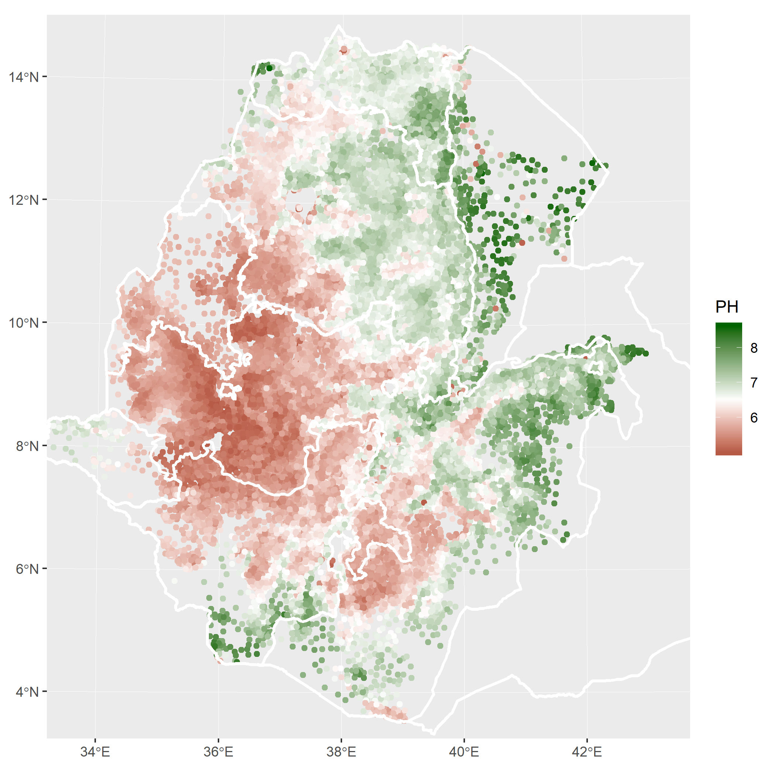

## Climatic Variables

We obtain climatic variables from the University of Idaho’s TerraClimate data. TerraClimate provides monthly estimates of surface water balance at 1/24th of a degree (~4km) spatial resolution.[2] Measures of water balance are particularly relevant to this study because it provides an estimate of water available to plants by looking at the balance between water gained from precipitation and runoff, and that lost to evaporative demand.

The amount of waster moving through a system is driven by two forces: (1) the supply of water through rainfall and (2) the demand for water, driven primarily by energy from the sun, which allows for evaporation and movement of water through plants but is also affected by wind, vapor pressure, and soil properties. Here we use a measure called climatic water deficit (CWD) that is the evaporative demand exceeding available soil moisture[3] and can be seen as proxy for drought and water stress [Mann plos 1].

To proxy the effects of rainshadows we simulate orthographic uplift and the resulting rainshadow by simulating the movement of air on an east-west trajectory and comparing the current elevation to the maximum observed elevation. A pixel at 1000m to the west of a mountain with a maximum elevation 1500m would have a rainshadow index value of 500. To avoid rainshadows extending far to west of a mountain the ‘observed maximum’ is multiplied by 0.999 each pixel to the west of the maximum. This results in rainshadows that largely decay between 50-75km. Although this is certainly an oversimplification of a complex process, we believe it provides a reasonable representation of rainshadow effects given the lack of any better data product.

# Results and Discussion

## Agricultural Output - Overcoming pH with Fertilizer

In this section we explore the relationship between soil pH and agricultural productivity as measured by wheat, barley, and maize output per hectare. *For some analysis we focus on wheat as an example crop as it has similar characteristics to most primary crops.* We use sub-kebele level yield data obtained from the AgSS and soil acidity data from EthioSIS, pooling data from the 2010-2016 growing seasons.

To start, we examined the response of output per hectare (OPH) for the three crops in response to changes in pH. Looking at Figure 2 below, we plot OPH against mean pH, where each dot is a unique observation from a sub-kebele for a given year. The colored lines are the result of loess smoothers tracing the non-linear relationship between the two variables. Loess Regression is the most common method used to smooth volatile data. It is a non-parametric methods where least squares regression is performed in localized subsets of data.

*Figure* 2*: Response of Wheat OPH to Changes in pH*

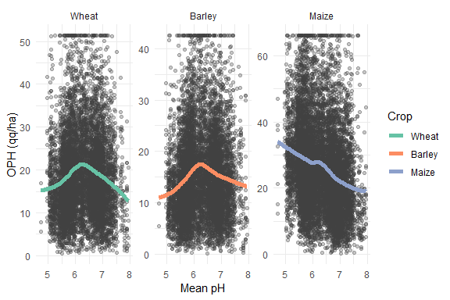

As expected, we see a concave response of OPH to pH for wheat and barley peaking near 6.5. Maize on the contrary prefers lower pH, here we see a significant downward trend (p < 0). *The results for Maize are not surprising as maize productivity is less sensitive to acidic soils.*

To see if farmers are adapting for highly acidic soils by applying more fertilizer, we plot intensity of fertilizer use (kg/ha) against soil pH. Again we use a loess smoother to track the localized relationship between these two variables.

*Figure* 3*: Response of Intensity of Fertilizer Use to Changes in pH*

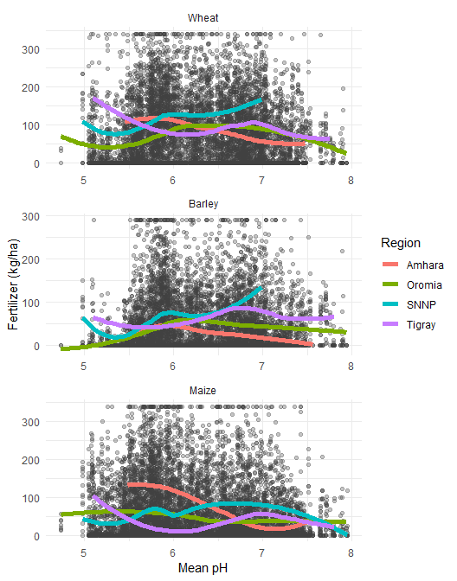

Looking at all crops in figure 3 we can see that there is a great degree of variability in the correlation between fertilizer use intensity and pH level across regions and crops. Farmers in some regions may be using significant amounts of fertilizer in order to compensate for the lack of neutral soils. We can look in more detail at this relationship for wheat in Figure 4.

*Figure* 4*: Wheat Response of Intensity of Fertilizer Use to Changes in pH*

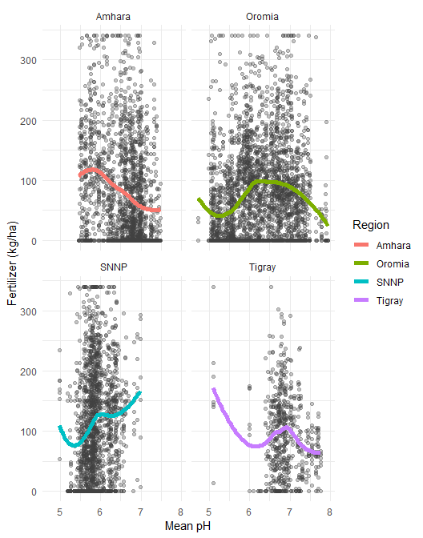

Looking above, in Amhara, lower pH corresponds to significantly higher utilization of fertilizer in wheat (p < 3.627322e-35), implying that for each one unit decrease in pH (more acidic) farmers apply 45.8 an additional Kg/ha of chemical fertilizers. In Tigary, we see a handful of sub-kebles applying large amounts of fertilizer to acidic soils, but across the entire sample N application increases with pH (p < 0.045). Meanwhile Oromia appear to target additional N fertilizers to areas with ideal pH, and SNNP appears to significantly increase N applications with higher alkalinity (p < 1.088721e-38).

Amhara has a unique The application of additional nitrogen fertilizers to acidic soils to increase yields is particularly problematic, as N application *induces significant additional acidification*. Farmers utilizing greater than average amounts of fertilizer may now be suffering from issues related to N induced acidification. *The application of additional N in highly alkaline soils may be a reasonable approach as induced acidity may improve soil quality, however some types of fertilizers and soil amendments can actually make the soil more alkaline (Kennedy 1986,* [*https://www.cropnutrition.com/fertilizers-and-soil-acidity*](https://www.cropnutrition.com/fertilizers-and-soil-acidity)*).*

This variety of regional responses to pH likely reflects local policy and extension approaches to address lower than expected yields. Regardless, the effectiveness of these strategies will depend on the cost of continued fertilizer applications, relative to that of lime applications ever 5-7 years or other soil treatments.

*Table* 2*: Wheat Median Fertilizer Use and Yields by Acidity Level and Region*

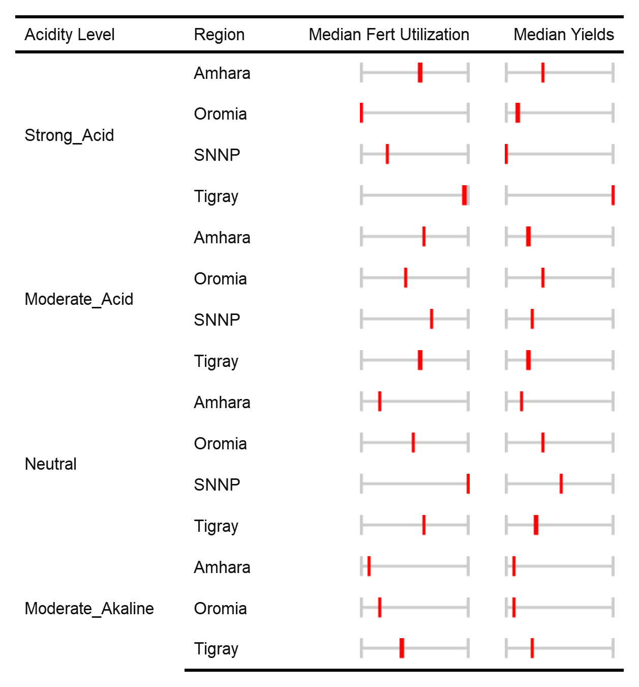

When we look at Table 2 for wheat, there is a great deal of inter-regional differences between acidity, fertilizer use, and median yields. One take away is that reasonable yields can be obtained from imperfect soils - at great cost - through the application of large amounts of fertilizer. For instance, Tigray has obtained extremely high yields in high acidity areas, but only through the application of 2.34 times average amount of fertilizer. These applications will likely prove self-defeating as most N application induces greater acidification. Alternatively, substantial fertilizer application in neutral soils, like in SNNP, does not necessarily equate to significant increases in yields. This may point to the need for other interventions such as blended fertilizers focusing on other nutrients. Finally and importantly, moderately alkaline soils appear to be as harmful as strongly acidic soils, at least in the case of wheat.

For the *Amhara region* the relationship between median fertilizer utilization and soil acidity becomes clear. Farmers may be compensating for acid soils by applying significant amounts of fertilizer with no substantive improvement in wheat yields. Or alternatively, regions like Oromia may be diverting resources away from highly acidic areas, effectively abandoning these lands to low productivity. Later, we will examine how cost effective lime is compared to fertilizers in these four regions.

## Agricultural Output - Response of Wheat OPH to pH

In order to examine the marginal effect of wheat output per hectare to soil acidity, we need to control for the effects of other variables such as rainfall, soil properties, elevation, and policy difference amongst others. To do this we will run a pooled regression on all sub-kebeles for 2010-2016 with year and agricultural zone fixed effects. This regression allows us to examine how a one unit increase in fertilizer or pH effects wheat yields while controlling for other potential determinants of productivity.

### Variable Definitions

We control for a variety of independent variables including the mean pH, our primary variable of interest. We also include for the marginal effect of fertilizer utilization, measured in kg/ha, **the mean annual precipitation level in mm/3weeks, elevation and the effects of agricultural extension (development agents)**. To control for the highly non-linear nature of these relationships, most variables are applied with basis splines. This effectively creates a piece-wise polynomial of degree three, as such three coefficients will be estimated for each b-spline variable and will be denoted with bs(,n) where n is the degree.

*Table* 3*: Variable Definitions*

The results from the regression are as follows in table 4.

*Table* 4*: Regression on Wheat Output Per Hectare*

##   
## Regression on Wheat Output Per Hectare  
## ==================================================================  
## Dependent variable:   
## ------------------------------------  
## WHEAT_OPH_w BARLEY_OPH_w MAIZE_OPH_w  
## (1) (2) (3)   
## ------------------------------------------------------------------  
## PH 2.89*** -0.85 3.20***   
## (0.65) (0.55) (0.79)   
## CEC 0.21 -1.05*** -0.62**   
## (0.31) (0.27) (0.27)   
## log(SOC + 1) 1.06** 3.11*** 4.48***   
## (0.52) (0.47) (0.53)   
## log(SND + 1) -2.85*** 0.69 -3.03***   
## (0.80) (0.72) (0.83)   
## log(WHEAT_EXT_AREA_p + 1) 2.19***   
## (0.46)   
## log(WHEAT_IMSEED_p + 1) 2.14***   
## (0.79)   
## log(WHEAT_IRG_AREA_p + 1) -0.13   
## (2.85)   
## log(WHEAT_DAMAGE_AREA_p + 1) -13.16***   
## (0.77)   
## log(BARLEY_EXT_AREA_p + 1) 1.27***   
## (0.49)   
## log(BARLEY_IMSEED_p + 1) 1.90   
## (2.08)   
## log(BARLEY_IRG_AREA_p + 1) -0.87   
## (1.98)   
## log(BARLEY_DAMAGE_AREA_p + 1) -10.01***   
## (0.63)   
## log(MAIZE_EXT_AREA_p + 1) 4.51***   
## (0.67)   
## log(MAIZE_IMSEED_p + 1) 10.70***   
## (0.77)   
## log(MAIZE_IRG_AREA_p + 1) -1.94   
## (1.58)   
## log(MAIZE_DAMAGE_AREA_p + 1) -15.05***   
## (0.71)   
## factor(PSNP_Dum)1 0.27 0.25 0.24   
## (0.29) (0.27) (0.31)   
## factor(AGP_Dum)1 1.11*** 1.11*** 0.26   
## (0.30) (0.27) (0.32)   
## PH:CEC -0.004 0.18*** 0.11***   
## (0.05) (0.04) (0.04)   
## ------------------------------------------------------------------  
## Year Dummy Yes Yes Yes   
## AgroEco Dummy Yes Yes Yes   
## Region Dummy Yes Yes Yes   
## splines Yes Yes Yes   
## ------------------------------------------------------------------  
## Observations 7,013 5,951 9,633   
## Adjusted R2 0.23 0.22 0.29   
## Log Likelihood -25,025.31 -20,173.52 -36,804.39   
## UBRE 73.61 51.51 121.91   
## ==================================================================  
## Note: *p<0.1; **p<0.05; ***p<0.01  
## [1] "Wheat Splines"  
## # A tibble: 5 x 5  
## term edf ref.df statistic p.value  
## <chr> <dbl> <dbl> <dbl> <dbl>  
## 1 s(PH) 4.23 4.63 6.93 7.71e- 6  
## 2 s(WHEAT_FERT_PER_AREA_w) 2.63 2.90 30.3 1.83e-17  
## 3 s(CEC) 6.94 7.72 4.88 1.35e- 5  
## 4 s(pdsi) 7.90 8.58 5.35 4.25e- 7  
## 5 s(elevation) 6.07 7.17 7.71 2.51e- 9  
## [1] "Barley Splines"  
## # A tibble: 5 x 5  
## term edf ref.df statistic p.value  
## <chr> <dbl> <dbl> <dbl> <dbl>  
## 1 s(PH) 4.64 4.77 8.05 7.44e- 7  
## 2 s(BARLEY_FERT_PER_AREA_w) 2.46 2.77 28.5 6.32e-16  
## 3 s(CEC) 3.66 4.73 2.72 1.24e- 2  
## 4 s(pdsi) 5.88 6.89 2.99 4.28e- 3  
## 5 s(elevation) 3.55 4.50 22.0 3.24e-19  
## [1] "Maize Splines"  
## # A tibble: 5 x 5  
## term edf ref.df statistic p.value  
## <chr> <dbl> <dbl> <dbl> <dbl>  
## 1 s(PH) 3.43 4.11 12.8 1.48e-10  
## 2 s(MAIZE_FERT_PER_AREA_w) 2.20 2.53 23.5 1.05e-12  
## 3 s(CEC) 4.55 5.58 4.88 1.95e- 3  
## 4 s(pdsi) 5.89 6.90 4.46 6.75e- 5  
## 5 s(elevation) 3.37 4.26 19.3 1.45e-15

Looking at the results of interest we can see that variables have the expected sign and are statistically significant at critical knots (indicating the importance of non-linear estimation). As expected highly acidic soils (low pH) show low levels of productivity, increasing significantly with higher pH, until some inflection point. Fertilizer shows significant positive effects at low levels of utilization, increasing significantly (but not statistically significantly) until some inflection point.

To isolate the marginal effect of pH on wheat OPH we can hold all other variables at their mean (or fixed effects variables to a specific year and zone, here 2010 and zone number 302) while letting the variable of interest vary.

*Figure* 6*: Trace of marginal response of wheat OPH to changes in pH*

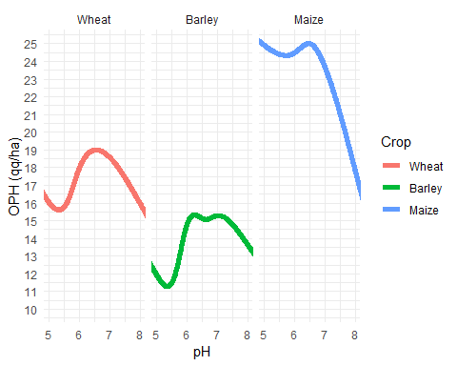

Looking at Figure 6 above we can see that moving pH from 5.5 to 6.5 corresponds to a 21.01% increase in yields while holding fertilizer utilization, rainfall, and other variables of interest at their means. These curves will be used in the next section to calculate the economic net benefit of application of lime (to increase pH) to soils. The gain obtained from moving soil pH from 5.5 to 6.5 for all crops is presented in Table 5 below.

*Table* 5*: Output per hectare gains from changing pH from 5.5 to 6.5*

| Crop | OPH.Gain | OPH.Percent.Gain |
| --- | --- | --- |
| Wheat | 3.30 | 21.01 |
| Barley | 3.47 | 29.80 |
| Maize | 0.59 | 2.43 |

We can also trace the impact of increasing fertilization rates for wheat, barley and maize in Figure 7 below.

*Figure* 7*: Marginal response of wheat OPH to changes in fertilizer application holding pH at 5.5*

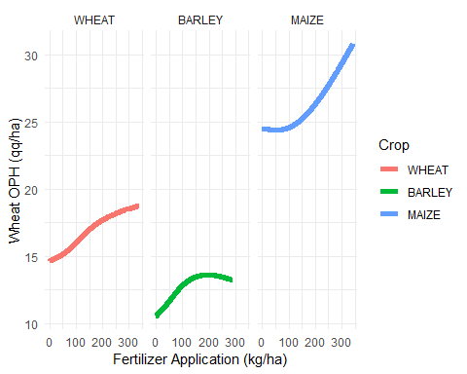

Looking at Figure 7 for wheat, we can see that adding an additional 100 kg per ha of fertilizer corresponds to a 1.38 qq/ha increase in yields while holding pH at 5.5, and rainfall, and other variables of interest at their means. This curve can then be used to calculate the economic net benefit of application of fertilizer.

## Economic Net Benefits of Lime Application

Calculating the estimated increase in wheat OPH corresponding to changes in pH we can estimate for the average plot how much it would cost to reduce acidity from a pH of 5.5 to 6.5 through the application of lime for one hectare.

Based on expert opinion from soil scientists, we can estimate the cost of lime to move the pH one unit, *from 5.5 to 6.5*, with 3 metric tons of lime:

$Cost=3∗P_{}$

Where $P_{}$ is the farmers price of one MT of lime, assuming that the lime have average calcium and/or magnesium content as other lime in Ethiopia. For Amhara the average farm gate price of lime is estimated as 2,000 birr per MT (73 dollars). This mean price includes transportation costs from lime crushing facilities to distribution centers in Amhara, but does not include the ‘last-mile’ transport or application costs. Given these caveats, the cost of increase pH one unit is estimated to be birr or 218 dollars.

Considering both the OPH response curve and the cost of lime application, changing the pH from 5.5 to 6.5 will cost 6,000 birr but will produce an additional 3.3 qq/ha or a 21.01% increase in yields for a five year period. Although this is a simplification we assume that the benefits of lime application are constant across a five year period. More realistically, experts indicate that the full benefits of lime application would not be obtained until the second year and would decline over a 5-7 year period. These complexities, while important, are outside the scope of this simplified analysis.

## Comparable Economic Benefits of Fertilizer

Using the response curve estimated in Figure 7 we can estimate the amount of fertilizer that would be required to obtain the same increase in yields obtained from the application of lime to highly acidic soils (pH of <=5.5). We estimate that to obtain the same 3.3 qq/ha increase in wheat yields estimated from lime application using fertilizers alone in soils with a pH of 5.5, it would take 223 of fertilizer. To maintain these gains each year, we estimate costs of 3,085.52 birr where each kg of fertilizer is assumed to cost 13.82 birr. To simplify the analysis we ignore the additional acids created from N fertilization.

## Current Cost of Future Lime and Fertilizer Expenditures

To calculate the total costs and benefits of lime and chemical fertilizers it is critical to note that fertilizers require annual applications while lime is only applied once every five years. Here we assume that the benefits of a single lime application are uniform across a five year period, when a new application is required. Fertilizer applications on the other hand are assumed to be require every year to maintain yield benefits. Fertilizer applications therefore need to be thought of as a repeated costs over a five year period, the present value of these costs therefore must be calculated.

The present value of a future cost can be calculated using a few pieces of information: 1) the cost paid each year, 2) the discount rate, and whether or not the cost is incurred at the beginning or end of the year. Here we assume that that annual costs of fertilizer remain constant at 3,085.52 birr, a discount rate of 15%, which accounts for the typical rate of return of an alternative investment, and we assume the costs are incurred at the beginning of each planting season. The current value (cost) of a series of future expenditures is as follows:

$PV=\sum_{t=0}^{T}{F}V\frac{1}{}$

Where in this case, PV is the current value of future expenditures, FV is the annual cost of fertilizer, *i* is the discount rate, and *T* is the number of years payments are made. As such we can estimate the current value of applications of lime and fertilizer required to obtain the same 3.3 qq/ha increase in wheat yields estimated above.

*Table* 7*: Wheat: Current value of lime and fertilizer applications required for 3.3 qq/ha yield increase*

| Crop | Application | Present.Value | Expected.Yield.Increase | x.cost.of.lime |
| --- | --- | --- | --- | --- |
| All | Lime | -6000 | - | 1 |
| Wheat | Fertilizer | -11895 | 3.3 | 1.98 |
| Barley | Fertilizer | -10373 | 3.47 | 1.73 |
| Maize | Fertilizer | -7234 | 0.59 | 1.21 |

From table 7 we can see that, holding change in yield constant, that the present cost of fertilizer use for wheat is 1.98 times that of a single lime application. As such lime can provide substantial savings to both small and large farms. It should be noted however that there are additional benefits to treating acidic soils with lime instead of compensating with nitrogen. Benefits of liming not easily captured in this study include:

* Reductions in additional acidification through N application
* Supplies Ca and Mg to plants
* Reduced toxicity to plants of Al and Mn
* More rapid mineralization of organic N and greater availability of P
* Stimulation of microbial activity
* Greater availability of micro-nutrients

The impacts of these applications vary significantly by both actual pH level and location. There is a great deal of variability even between regions in terms of policy interventions, but also in terms of the actual pH levels. For instance “moderately” acidic soils in Amhara, Oromia and SNNP are at the median 0.48, 0.58, 0.67 units below 6.5 respectively, while Tigary is only 0.07. Therefore the benefits of mitigating “moderately” acidic soils is far more beneficial in Amhara than in Tigray.

To examine some of this variability we break down the expected increase in yields (OPH) from raising the pH of each sub-kebele to 6.5 by crop and region below:

*Table* 8*: Median impact of increasing pH from actual to 6.5 in qq/ha for moderately acidic soils*

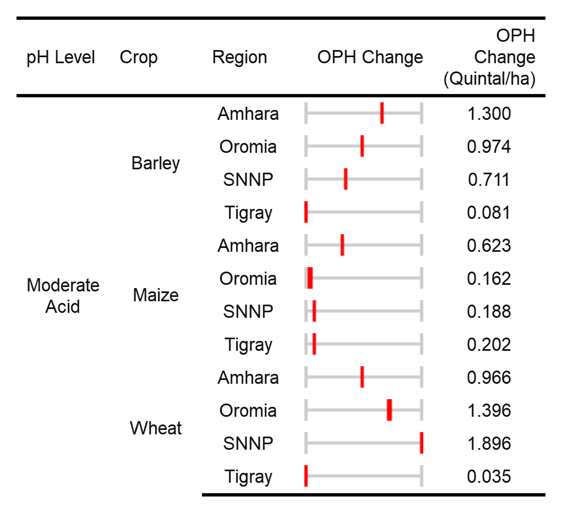

As we can see there is a great deal of variability between crops, with the highest gains in output from wheat and barley, and minimal to zero gains from maize (Table 8). These differences are largely driven by difference in each plant’s response to pH level. It is also driven by the planting location its respective soil properties, like aluminum concentrations that mitigate or aggravate the impact of a low pH balance.

Within a given crop, for instance wheat, variability in yield response can largely be explained by the region’s distance from a median pH of 6.5. As explained earlier, the pH in Amhara, SNNP, and Oromia are at the lower end of “moderately” acidic, therefore gains can be substantial (0.97 q/ha). Meanwhile Tigray’s “moderately” acidic soils are extremely close to a pH of 6.5, therefore raising the pH provides very little benefit (0.04 q/ha)

*Table* 9*: Median impact of increasing pH from actual to 6.5 in qq/ha for highly acidic soils*

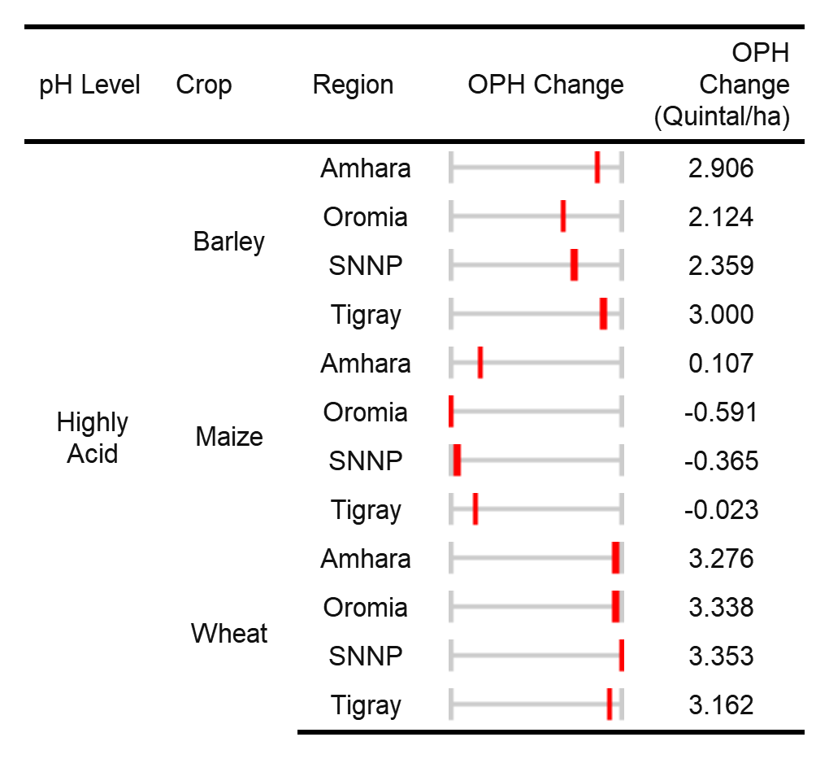

Looking at Table 9 above for highly acidic soils, we see for both barley and wheat substantial yield gains are obtainable by properly adjusting the pH balance. The median gains for wheat and barley are 3.31 and 2.63 (q/ha), respectively. This uniform yield response across regions can be explained by the overriding influence of a pH significantly below certain levels.

Following the approach shown in Table 7 we can calculated the present value of the amount of fertilizer needed to match the yield gains obtained by increasing the pH to 6.5. Again we break this down by acidity class, region and crop.

*Table* 10*: Median fertilizer requirements to match lime application for acidic soils*

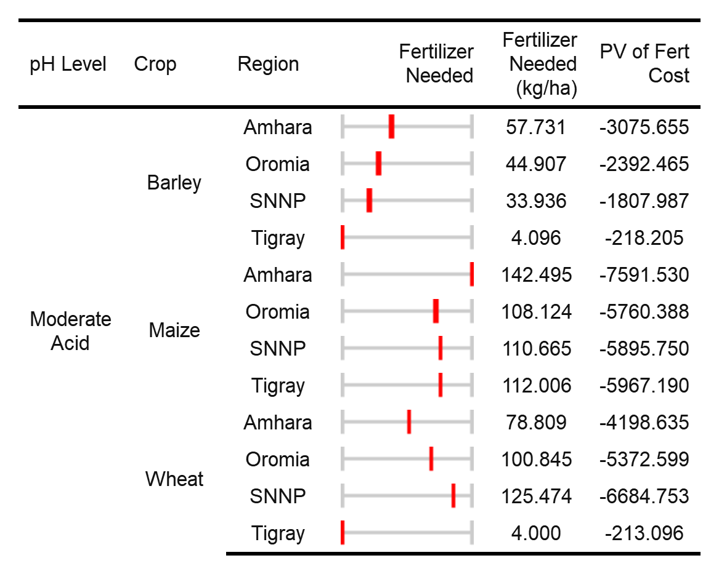

Table 10 demonstrates for mildly acidic soils - from a purely economic standpoint - that the application of fertilizer and lime are roughly equivalent for both maize and wheat. In the case of barley, lime may prove more expensive. The results from maize in this case are a bit surprising given its relatively muted response to changes in pH, but looking at Figure 7 we see that the model estimates an even lesser response from increases in fertilizer applications. As such, although the OPH responses are relatively low, lime applications for maize in mildly acidic soils might be economically preferable to fertilizer. In the case of barley, the estimated yield response to fertilizer is high enough to undermine the economic benefits of lime application. As will be noted later, there are however a number of non-financial benefits to soil remediation and pH balance.

*Table* 11*: Median fertilizer requirements to match lime application for highly acidic soils*

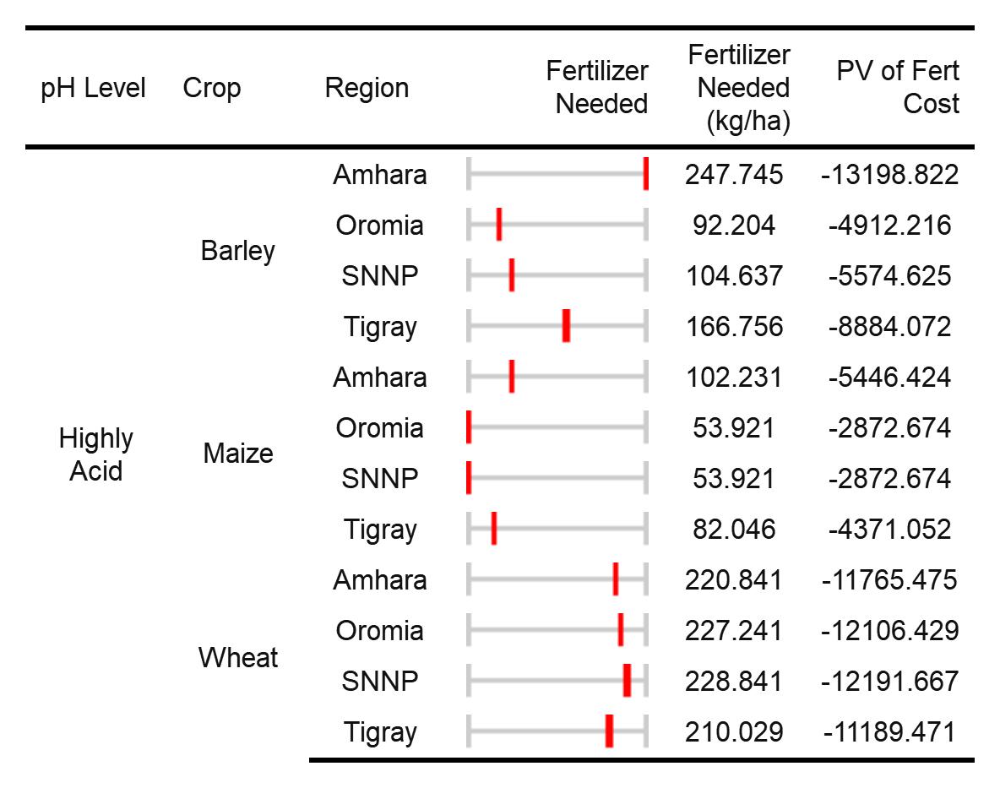

For highly acidic soils the economic gains of lime applications become clear, especially for wheat in all regions, and barley grown in Amhara and Tigray (Table 11). Across all regions the present value of lime application for wheat in highly acidic soils is 1.97 times that of fertilizer applications.

*The benefits of lime application however extend well beyond simple yield gains, and are worth repeating.* The benefits of lime application include: avoiding induced acidification through N application, increased Ca Mg and P supply, reduced mineral toxicity, stimulation of microbial activity, and more efficient uptake of N and availability, amongst others.

# Conclusions

Ethiopia’s growing regions span an unusually broad set of climatic spaces, spanning a variety of zones from rain-forests, Mediterranean ecosystems, to semi-arid deserts. Given the well documented sensitivity to changes due to climate change, Ethiopia must look for ways to enhance the productivity of all its lands, especially those now considered marginal. This broadening of the climatic space that is productively used for agriculture will enhance household and national resiliency.

Although not well understood until recently, Ethiopia is plagued acidic soils. Soils with low pH can significantly suppress agricultural yields and may prompt the abandonment of otherwise productive lands. Ethiopia’s soils likely became acidic due to long periods of weathering, erosion, intensive use, as well as the additional acidity induced by the application of N fertilizers.

In this study we approach estimating the economic and agricultural viability of soil remediation, through the application of lime, through data-driven methods. We utilize observations of agricultural yields for wheat, maize, and barley from the AgSS survey for the 2010-2016 growing seasons. We control for a variety of confounding effects such as weather, other soil properties, management practices, and government interventions. We find that moderately and highly acidic soils significantly undermine yields for both wheat and barley. Moreover we find evidence on a region by region basis for the economic viability of soil remediation through the application of lime, especially in highly acidic areas. This economic viability extends even to maize, which is usually considered resilient to the detrimental impacts of low pH, when compared to the cost of yield gains through N fertilizer application. Taken as a whole we find substantial real-world evidence that soil remediation can increase yields and economic outcomes for farmers across its acidic regions.

# References

Froese, Paul S, Arron H Carter, and Michael O Pumphrey. 2015. “Recommended Crop Species and Wheat Varieties for Acidic Soil.”

Mosaic. 2018. “Soil pH.” *Soil Acidity*. Mosaic. <http://www.cropnutrition.com/efu-soil-ph>.

Vitosh, M. L. 1998. “WHEAT Fertility and Fertilization.” *Extension Bulletin E-2526*. Michigan State University.[4]

1. Beyond the nation, Ethiopia has four official levels of administrative areas. These include, in order of geographic size, regions, zones, woredas and kebeles. There are approximately 12 regions, 88 zones, 690 woredas and 15,000 kebeles. For our purposes, we use the sub-kebele, not recognized as a geographic region for administrative purposes, but commonly used for government statistical sampling and are roughly based on population. There are over 75,000 sub-kebeles in the country.
2. <http://www.climatologylab.org/terraclimate.html>
3. Major J. Potential evapotranspiration and plant distribution in western states with emphasis on California. AMER ASSOC Adv SCI PUBL. 1967;86.
4. Dsfesf